Job Hazard Analysis

Task/Equipment: | Servicing Supply and Exhaust Units in Chiller Room
Department: | Powerhouse
Analyzed By: | Bill Partin & Bryana Borders
Date: | 4/23/19

Personal Protective Equipment Required:



Heavy Leather Gloves
Ear Protection

Hard Hat

Trainings Required*/Recommended:

Ladder Training*, OSHA 10

Equipment/Tools/Chemicals Required for the Job:

Hand tool, garden hose, grease gun
Tasks/Steps | Hazards Present | Safety Measures and Controls
Climb enclosed ladder located in chiller room onto roof | Ladder fall | Enclosed ladder in place and follow ladder safety protocol
Open power disconnects to both exhaust and supply units and lock out | No hazards present | N/A
Remove covers from both exhaust and supply units and set aside | Finger cuts and abrasions | Use heavy leather gloves
Remove filters from filter bank of supply unit | Finger cuts and abrasions | Wear heavy leather gloves
tension drive belts on both units | Finger pinch | Wear heavy leather gloves
Grease motor and bearings and test for bearing wear | Finger pinch | Wear heavy leather gloves
Use a garden hose to wash filters and return to filter bank | No hazards present | N/A
Replace covers on both supply and return units and secure | Finger pinch | Wear heavy leather gloves
Remove lock out equipment and power up units and test operation | No hazards present | N/A

Additional Information:

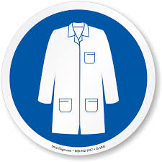
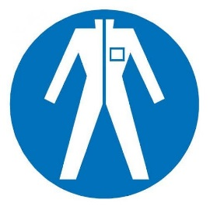
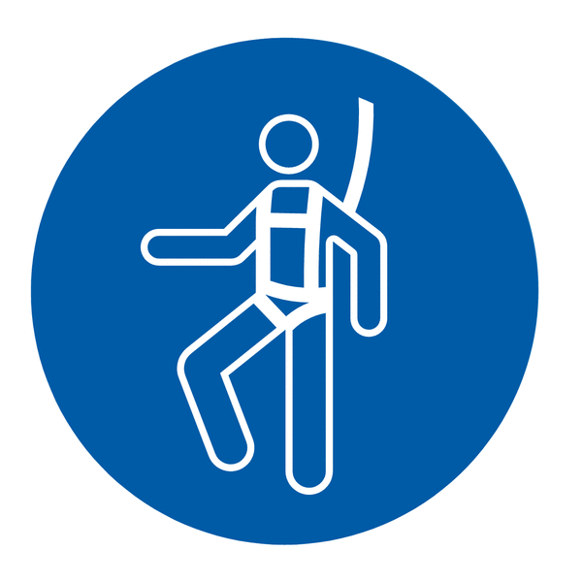

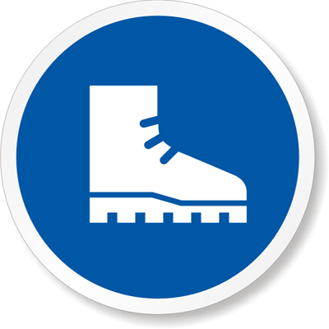



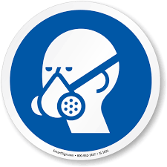


Lab Coat
Protection Suit
Fall Protection Harness
High Vis Vest
Safety Shoes
Splash Goggles
Cryogenic Gloves
Dust Mask
Respirator
Face Shield
Safety Glasses

