Job Hazard Analysis

Task/Equipment: | Removal of Burner, Summer Boiler
Department: | Powerhouse
Analyzed By: | Bill Partin & Bryana Borders
Date: | 4/12/19
Personal Protective Equipment Required:


Heavy Leather Gloves


Hard Hat

Trainings Required*/Recommended:

Proper ladder use*, OSHA 10

Equipment/Tools/Chemicals Required for the Job:

Hand wrench, washers, nuts, pipe wrench, screw driver, ladder and flash light
Tasks/Steps | Hazards Present | Safety Measures and Controls
- Open main power disconnects, and turn off control switch at burner panel. Secure using lockout tag out protocol | No hazards present | N/A
- Shut off main gas valves (2) and shut off pilot gas valve. Secure with lock-out tag-out protocol | No hazards present | N/A
- Attach chain fall to burner housing and support burner | Ladder fall | Proper ladder use
- Disconnect Gas line from burner at union | No hazards present | N/A
- Loosen and remove hex nuts holding burner to mounting flange | Finger pinch | Use heavy leather gloves
- Disconnect and remove gas pressure switch and store in a safe place | No hazards present | N/A
- Remove main flame and pilot scanner and secure | No hazards present | N/A
- Disconnect all pilot lines and set aside | No hazards present | N/A
- Remove all vent lines and set aside | Ladder fall | Proper ladder use
- Remove burner support stanchion and set aside | Falling objects | Stay clear and position an assistant to operate chain fall
- Remove gas recirculation piping and set aside | Ladder fall | Proper ladder use
- Remove burner muffler and set aside | No hazards present | N/A
- Move burner back from boiler along support-rail flame | Falling object | Stay from under burner at all times
- Inspect furnace and combustion chamber | Ladder fall | Proper ladder use
- Cordon off area with red caution tape | Falling objects | Stay clear

Additional Information:

- This is a two person task

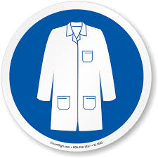
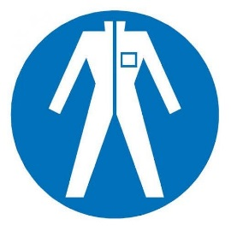
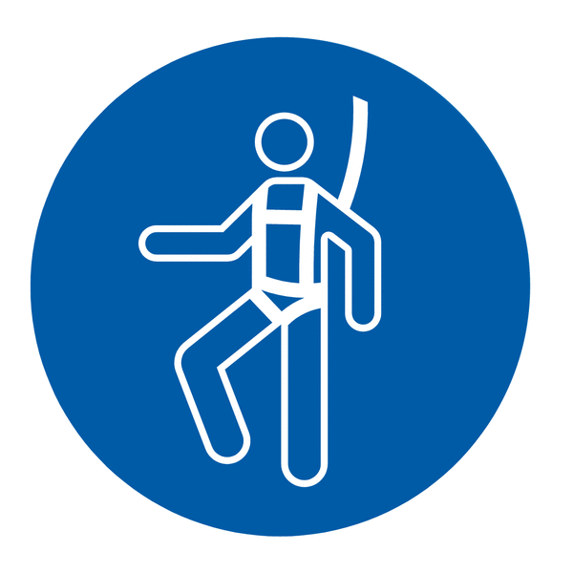
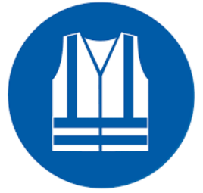
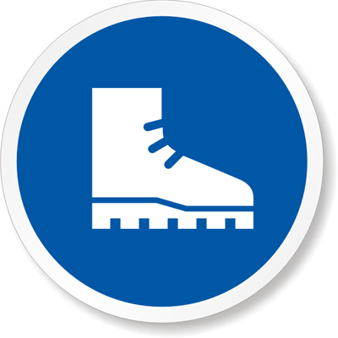
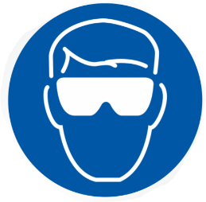


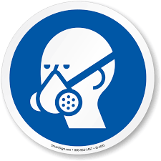



Lab Coat
Protection Suit
Fall Protection Harness
High Vis Vest
Safety Shoes
Splash Goggles
Cryogenic Gloves
Dust Mask
Respirator
Face Shield
Safety Glasses
Ear Protection

