Job Hazard Analysis

Task/Equipment: | Reinstalling Burner Summer Boiler
Department: | Powerhouse
Analyzed By: | Bill Partin & Bryana Borders
Date: | 4/12/19
Personal Protective Equipment Required:

Insert Picture of Task



Hard Hat
Heavy Leather Gloves

Trainings Required*/Recommended:

Proper Ladder Use*, OSHA10

Equipment/Tools/Chemicals Required for the Job:

Hand wrench, washers, nuts, pipe wrenches, screw driver, ladder, flashlight
Tasks/Steps | Hazards Present | Safety Measures and Controls
- Remove caution tape | No Hazards Present | N/A
- Move burner along support-rail frame | Falling object | Do not go underneath the burner
- Remount burner muffler | Falling object | Do not go underneath the burner
- Replace clamps washers and hex nuts and secure | Finger pinch | Use Heavy leather gloves
- Reinstall burner support stanchion | Falling objects | Do not go underneath the burner
- Reinstall gas recirculating piping | No Hazards present | N/A
- Reconnect main gas line at union | No Hazards present | N/A
- Reinstall gas pressure safety switch | No Hazards present | N/A
- Reinstall main flame scanner | No Hazards present | N/A
- Reinstall gas pilot lines | No Hazards present | N/A
- Reinstall vent lines | No Hazards present | N/A

Additional Information:

- This is a two person task

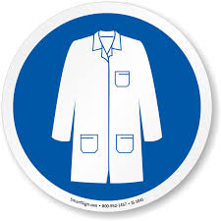
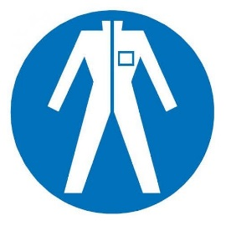
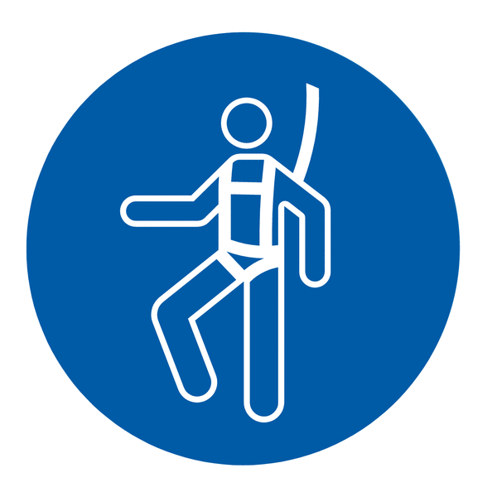

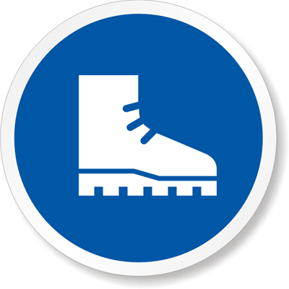



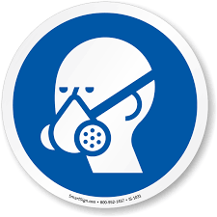



Lab Coat
Protection Suit
Fall Protection Harness
High Vis Vest
Safety Shoes
Splash Goggles
Cryogenic Gloves
Dust Mask
Respirator
Face Shield
Safety Glasses
Ear Protection

