Job Hazard Analysis
Personal Protective Equipment Required:
Task/Equipment: | Cleaning and Winterizing Cooling Tower
Department: | Powerhouse
Analyzed By: | Bill Partin & Bryana Borders
Date: | 4/12/19

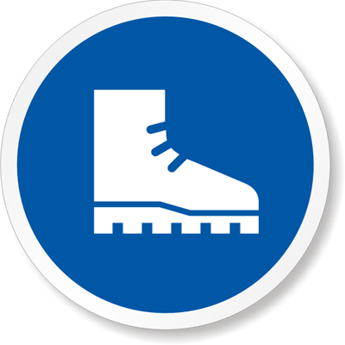

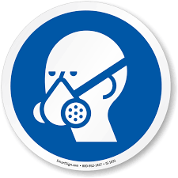
Rubber Boots
Slip Resistant
Chemical Resistant Gloves Gloves
Full Face Respirator


Heavy Leather Gloves
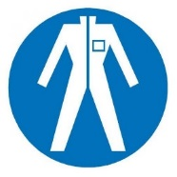
Waterproof Coveralls

Trainings Required*/ Recommended:

Hazardous communication*, ladder safety, eye safety, respirator use

Equipment/Tools/Chemicals Required for the Job:

Goodway TFC-200 machine, Goodway Scalebreak-Gel, Scalebreak neutralizer, 6-ft ladder, hand tools, PH meter

Steps | Hazards Present | Safety Measures and Controls
- Turn tower fan control off at tower control panel. Open main power disconnect to cooling tower and secure with lockout protocol | No hazards present | N/A
- Open both North and South fan disconnect at cooling tower and secure with lock out protocol | No hazards present | N/A
- Isolate make-up water to tower by closing the 2 inch make-up ball valve | Ladder fall | Proper ladder use training
- Connect Scalebreak chemical drum to TCH-200 machine per manufacture’s instruction | Chemical inhalation, chemical splash, chemical skin contact, chemical eye contact, Slip and fall | Properly wear a full face respirator, chemical resistant gloves and protective coveralls
- Apply Scalebreak chemical to cooling tower fill using manufacturer’s directions and allow to set for 1 hour. | Chemical inhalation, chemical splash, chemical skin contact, chemical eye contact, slip and fall | Properly wear a full face respirator, chemical resistant gloves, rubber boots, wear protective coveralls
- Use Goodway TCH-200 machine to wash tower fill per manufacturer’s instructions | Chemical inhalation, chemical splash, chemical skin contact, chemical eye contact, slip and fall | Properly wear a full face respirator, chemical resistant gloves and protective coveralls
- Add scale break neutralizer chemical to tower basin per manufacturer’s instructions to neutralize basin water | Chemical inhalation, chemical splash, chemical skin contact, chemical eye contact, slip and fall | Properly wear a full face respirator, chemical resistant gloves, rubber boots and protective coveralls
- After PH has dropped (use PH meter) to acceptable levels ,open tower drain valve and allow sump basin to drain completely | Chemical contact with hands, eye, and skin. Slip and fall | Properly wear a full face respirator, chemical resistant gloves, rubber boots and protective coveralls
- Post another person outside the tower, enter using a six foot ladder and remove screen-strainers from sump suction | Ladder fall, finger cuts | Use proper ladder use protocol, wear heavy leather gloves
- Remove screens and clean with garden hose | Wet feet and hands could cause a loss of grip and a slip and fall | Use water proof gloves and rubber boots
- Sweep out all loose scale, dirt and debris from floor of cooling tower and dispose of | Slip and fall, wet surface | Use rubber boots
- Leave drain valve open to prevent freeze-up over the winter months | No hazards present | N/A
Additional Information: Two person task


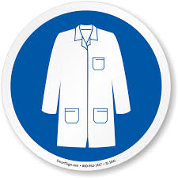
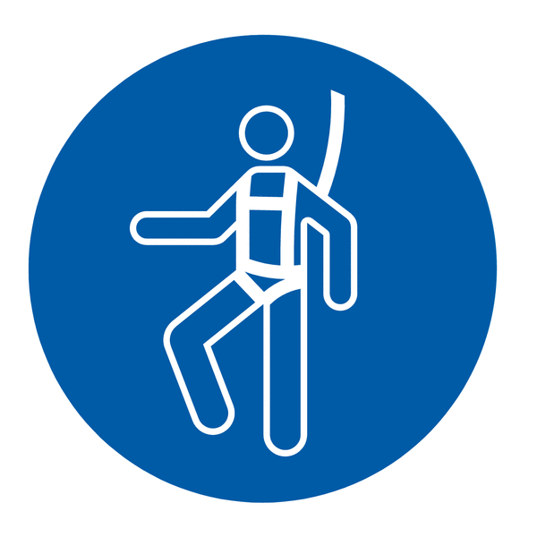




Safety Glasses
Lab Coat
Fall Protection Harness
High Vis Vest
Dust Mask
Hard Hat
Ear Protection

