Job Hazard Analysis

Task/Equipment: | Chemical testing and handling
Department: | Powerhouse
Analyzed By: | Bill Partin & Bryana Borders
Date: | 5/3/19

Personal Protective Equipment Required:




Face Shield
Latex Gloves
Dust Mask
Insert Picture of Task

Safety Glasses

Trainings Required*/Recommended:

Safe chemical handling

Equipment/Tools/Chemicals Required for the Job:

Dolly
Tasks | Hazards Present | Safety Measures and Controls
Adding eternal boiler treatment/condensate treatment chemical to feed tanks | Chemical splash eye/skin contact | Use full face shield, extra-long rubber gloves and long sleeve shirt; use dolly to transport heavy chemical barrels
Adding oxygen scavenger powder ( sulfite) to DA feed tank | Inhalation on powdered chemical, contact with skin and eyes; back strain from moving oxygen scavenger powder | Use full face shield, rubber gloves, particulate respirator; use dolly to transport heavy chemical barrels
Adding salt to brine tank | Back and muscle strain due to lifting salt bags 40-50 lbs. | Ask for assistance when lifting bags
Chemical plant testing/titration | Chemical to skin and eye contact | Use rubber gloves and safety glasses

Additional Information:

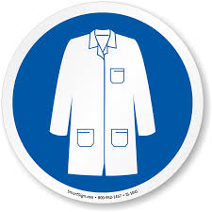
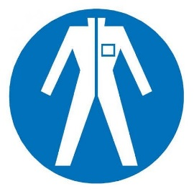



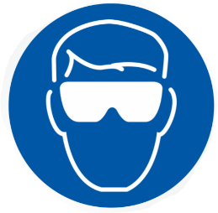

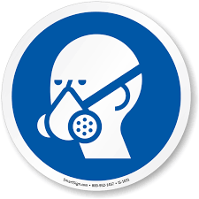


Lab Coat
Protection Suit
Fall Protection Harness
High Vis Vest
Safety Shoes
Splash Goggles
Cryogenic Gloves
Respirator
Hard Hat
Safety Glasses
Ear Protection

