Task/Equipment: | Reassembling Winter Boiler After Annual Inspection
Department: | Powerhouse
Analyzed By: | Bryana Borders & Bill Partin
Date: | 4/12/19

Job Hazard Analysis

Personal Protective Equipment Required:



Heavy Leather Gloves
Hard Hat

Trainings Required*/Recommended:

Proper ladder use training*, OSHA 10

Equipment/Tools/Chemicals Required for the Job:

Pipe wrenches, socket wrenches, screw drivers, hand wrenches, sanding cloth, hammer, rope, flashlight, flood light
Tasks/Steps | Hazards Present | Safety Measures and Controls
- Reinstall manway covers with new gaskets and discard old gaskets (hammer may be used) | Finger pinch and finger/hand smash from hammer | Use heavy leather gloves to protect from pinching. Keep hands away from the area where blunt force is applied
- Replace all cross tees and inspection plugs | Fall from ladder | Follow proper ladder use protocol
- Replace gasket and reinstall water level safety float and secure bolts | No Hazards Present | N/A
- Check that the bottom blowdown valves are closed and remove lock-out device from valves | No Hazards Present | N/A
- Close fire-side access door, replace bolts and secure | Wrist twist | Operate impact wrench carefully and use heavy leather gloves for grip
- Remove lock-out device from main power disconnect and close | No Hazards Present | N/A
- Close main boiler gas cock and leave handle in the vertical position | No Hazards Present | N/A
- Re-open OS&Y valve on top of boiler, leave non-return closed until boiler is put online | Ladder fall | Follow proper ladder use protocol
- Re-enable chemical feed pump if applicable | No Hazards Present | N/A
- Reopen surface blowdown stop valve closest to the boiler and remove tag | No Hazards Present | N/A

Additional Information:

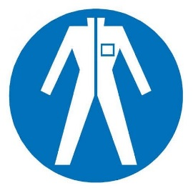
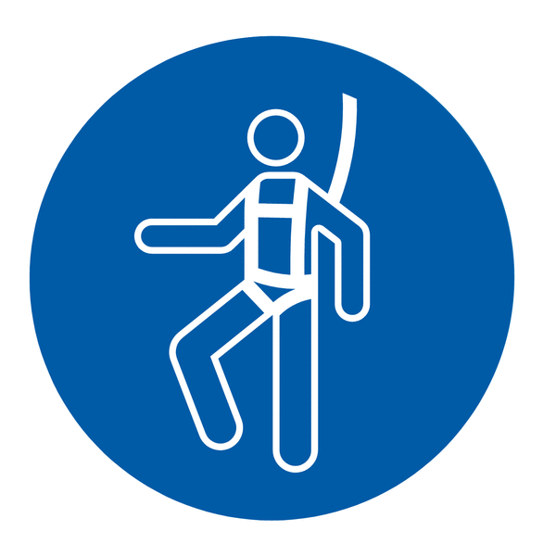

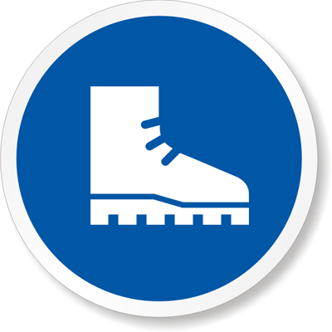



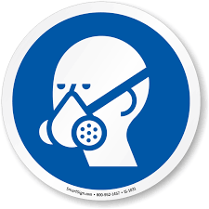



Protection Suit
Fall Protection Harness
High Vis Vest
Safety Shoes
Splash Goggles
Latex Gloves
Dust Mask
Respirator
Face Shield
Safety Glasses
Ear Protection

