Job Hazard Analysis

|  |  |
| --- | --- |
| Task/Equipment: | Chemical testing and handling |
| Department: | Powerhouse |
| Analyzed By: | Bill Partin & Bryana Borders |
| Date: | 5/3/19 |

**Personal Protective Equipment Required:**



Face Shield



Latex Gloves



Dust Mask

Insert Picture of Task



Safety Glasses

**Trainings Required*/Recommended:**

Safe chemical handling

**Equipment/Tools/Chemicals Required for the Job:**

Dolly

|  |  |  |
| --- | --- | --- |
| **Tasks** | **Hazards Present** | **Safety Measures and Controls** |
| Adding eternal boiler treatment/condensate treatment chemical to feed tanks | Chemical splash eye/skin contact | Use full face shield, extra-long rubber gloves and long sleeve shirt; use dolly to transport heavy chemical barrels |
| Adding oxygen scavenger powder ( sulfite) to DA feed tank | Inhalation on powdered chemical, contact with skin and eyes; back strain from moving oxygen scavenger powder | Use full face shield, rubber gloves, particulate respirator; use dolly to transport heavy chemical barrels |
| Adding salt to brine tank | Back and muscle strain due to lifting salt bags 40-50 lbs. | Ask for assistance when lifting bags |
| Chemical plant testing/titration | Chemical to skin and eye contact | Use rubber gloves and safety glasses |

**Additional Information:**

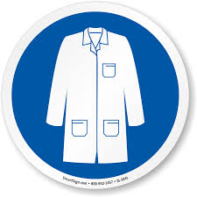

Lab Coat

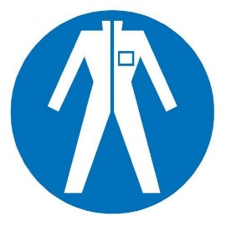

Protection Suit



Fall Protection Harness



High Vis Vest



Safety Shoes



Splash Goggles



Cryogenic Gloves

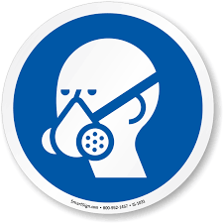

Respirator



Hard Hat



Safety Glasses



Ear Protection