Job Hazard Analysis

|  |  |
| --- | --- |
| Task/Equipment: | Reassembling Summer Boiler After Inspection |
| Department: | Powerhouse |
| Analyzed By: | Bill Partin & Bryana Borders |
| Date: | 4/12/19 |

**Personal Protective Equipment Required:**



**Hard Hat**



**Heavy Leather Gloves**

**Trainings Required*/Recommended:**

Ladder Training*, **OSHA 10**

**Equipment/Tools/Chemicals Required for the Job:**

Screw driver, hand tools, socket wrenches, hammer, ladder, Pipe wrenches, anti-seize compound, flash light, flood light

|  |  |  |
| --- | --- | --- |
| **Tasks/Steps** | **Hazards Present** | **Safety Measures and Controls** |
| 1. Replace manway covers (may need to use a hammer) and install new gaskets | Finger pinch and finger/hand could be smashed by the hammer | Wear heavy leather gloves to protect fingers from being pinched. Keep hands and fingers away from blunt force from the hammer |
| 1. Reinstall all inspection tees and plugs with thin coat of anti-seize compound | No hazards present | N/A |
| 1. Reinstall both low water cutouts with new gaskets if necessary | No hazards present | N/A |
| 1. Re-enable chemical feed pump if applicable | No hazards present | N/A |
| 1. Open main stop/non return | Ladder fall | Use proper ladder protocol |
| 1. Close main disconnect after boiler is filled for service | No hazards present | N/A |

**Additional Information:**

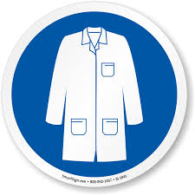

Lab Coat

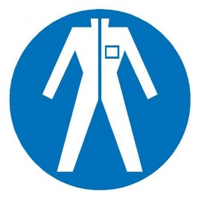

Protection Suit

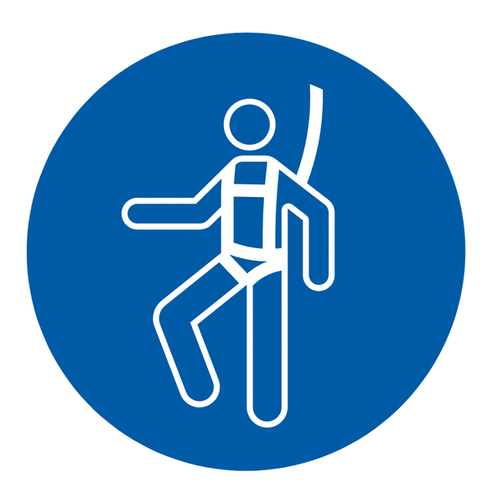

Fall Protection Harness



High Vis Vest



Safety Shoes



Splash Goggles



Cryogenic Gloves



Dust Mask



Respirator



Face Shield



Safety Glasses



Ear Protection