Job Hazard Analysis

|  |  |
| --- | --- |
| Task/Equipment: | Cleaning Condenser Tubes on Chillers |
| Department: | Powerhouse |
| Analyzed By: | Bill Partin & Bryana Borders |
| Date: | 4/24/2019 |

**Personal Protective Equipment Required:**

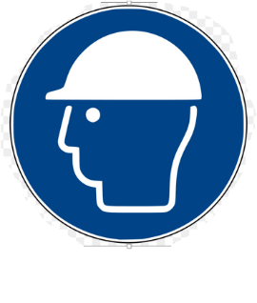

**Hard Hat**



**Heavy Rubber Gloves**

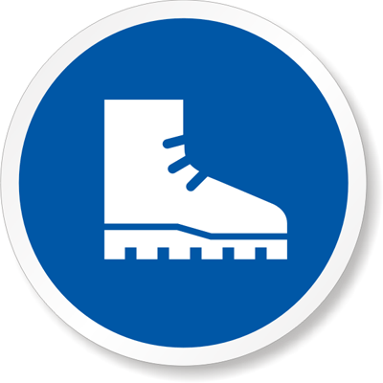

**Rubber Boots**

**Trainings Required*/Recommended:**

Hazardous Communication

**Equipment/Tools/Chemicals Required for the Job:**

Goodway tube cleaning machine, tube brushes, hand wrenches

|  |  |  |
| --- | --- | --- |
| **Steps** | **Hazards Present** | **Safety Measures and Controls** |
| 1. Attach garden hose to Goodway machine and lay flat | No hazards present | N/A |
| 1. Plug in machine to 120 volt outlet | Electrical shock hazard | Make sure the outlet and plug stays dry |
| 1. Operate machine using foot petals | Twisted wrist, wet feet cause a slip and fall | Use heavy rubber gloves and rubber boots to keep hand and feet from slipping. A hard hat can prevent head trauma from slip and fall when worn correctly |
| 1. Replace brush every two rows | Slip and fall | Use rubber boots |
| 1. Detach garden hose and oil cable | No hazards present | N/A |

**Additional Information:**

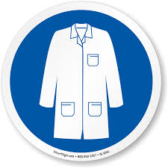

Lab Coat

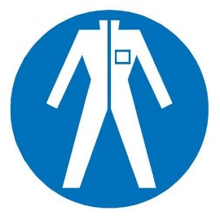

Protection Suit

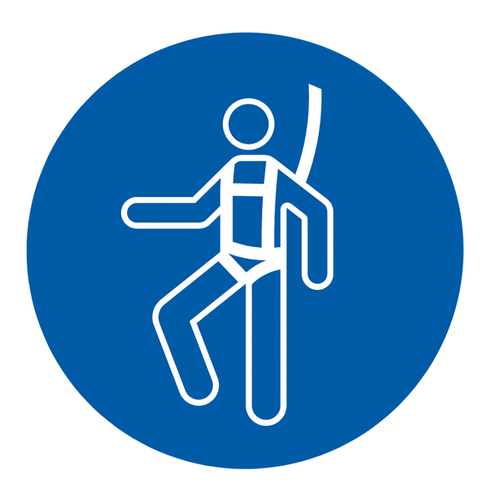

Fall Protection Harness



High Vis Vest



Splash Goggles



Cryogenic Gloves



Dust Mask

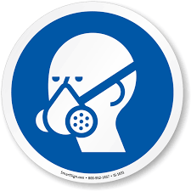

Respirator



Face Shield



Safety Glasses



Ear Protection