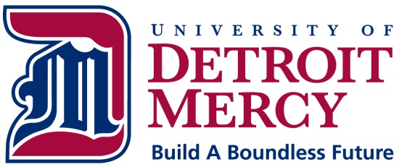

INSTITUTIONAL REVIEW BOARD

ADVERTISING FOR STUDY VOLUNTEERS
Institutional Review Boards (IRBs) are responsible for ensuring the equitable selection of research volunteers (21 CFR 56.111 (a) (3). In fulfilling this responsibility, IRBs should review the methods that investigators use to recruit volunteers. One method of recruiting volunteers is through advertisements. Advertising for research volunteers is not in and of itself an objectionable practice. However, when advertising is to be used, the IRB should review the information contained in the advertisement, and the mode of its communication, to determine that the procedure for recruiting volunteers affords adequate protection.
FDA requires that an IRB review and have authority to approve, require modifications in, or disapprove all research activities covered by the IRB regulations (21 CFR 56.109). FDA expects an IRB to review all the research documents and activities that bear directly on the rights and welfare of the volunteers of proposed research. The project protocol, the consent form, and the investigator's brochure have consistently been cited as specific examples of documents that the IRB should review.
Advertisements used to recruit volunteers should be seen as an extension of the informed consent and volunteer selection processes. (See 21 CFR 50.20, 21 CFR 50.25, and 21 CFR 56.111 (a) (3).) Institutions should, therefore, require IRB review of such advertisements. IRB review is necessary to ensure that the information is not misleading to volunteers, especially when a study will involve persons with acute or severe physical or mental illness or persons who are economically or educationally disadvantaged. The IRB is responsible for assuring that appropriate safeguards exist to protect the rights and welfare of research volunteers (21 CFR 56.111 (b)).
Generally, FDA believes that any advertisement to recruit volunteers should be limited to:
- the name and address of the clinical investigator;
- the purpose of the research and, in summary form, the eligibility criteria that will be used to admit volunteers to the study;
- a straightforward and truthful description of the benefits (e.g., payments or free treatment) to the volunteer from participation in the study; and
- the location of the research and the person to contact for further information.
If the research involves a drug or devise, no claim should be made, either explicitly or implicitly, that the drug or devise is safe or effective for the purposes under investigation, or that the drug or devise is in any way equivalent or superior to any other drug or devise. Such representation would not only be misleading to volunteers but would also be a violation of the FDA's regulations concerning the promotion of investigational drugs (21 CFR 312.7(a) and of investigational devices (21 CFR 812.7(d).

Source: FDA Announcement -- February, 1989.

