Advising Notes in SSB and INB

As we move to a paperless environment for student records, Advising Notes can now be entered into Banner using SSB. Notes haven’t been used widely since we went live with Banner in Fall 2009 because they were only accessible in INB.

Anyone who has a role of Advisor in TitanConnect can view or add advising notes. This includes individuals such as faculty advisors, Dean’s Offices, UAS, Registrar’s Office, Athletic Compliance and the Admissions Office. If someone is not designated as an advisor a message will appear indicating they have been denied access.

Advising notes are important to monitor a student’s academic advising and can be very useful when a student changes college/schools or their major. It improves transparency and efficiency in advising and opens communications between a variety of offices as it relates to our students.

To use Advising Notes
Access Titan Connect the same way you would normally enter Self-Service Banner in Faculty Services/Faculty and Advisors. Click on Student Information Menu. You can either go to ID Selection first or Click on Advisor Notes and then enter the Student ID.
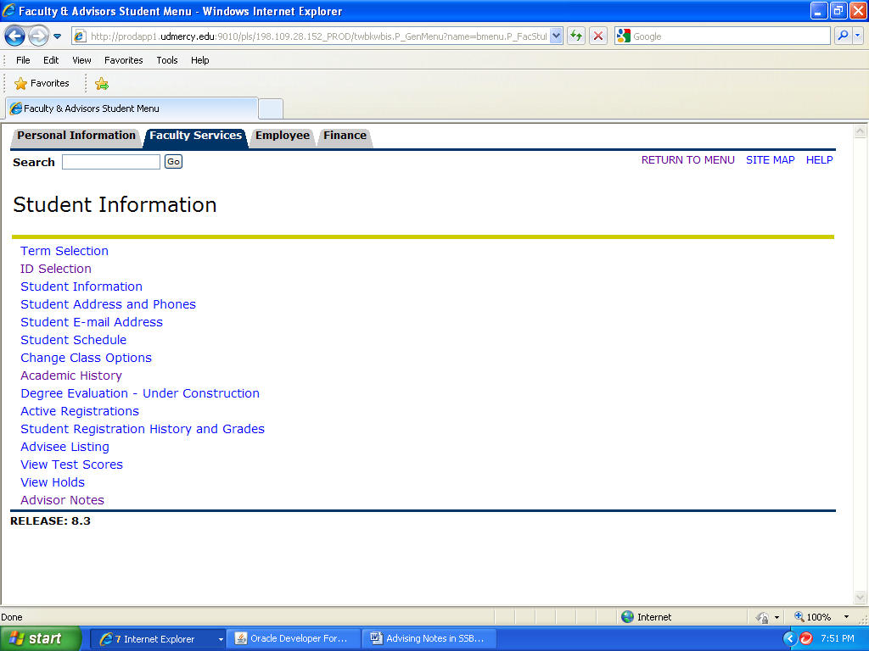

Here is a sample of an advisor note that was entered using SSB:

When the Originator says “WEB” that means it was entered in SSB. You will see the date that the advisor note was added along with the Titan Connect username of the person who added the note.

If you want to add a new note at then just begin typing in the open box below the last note.

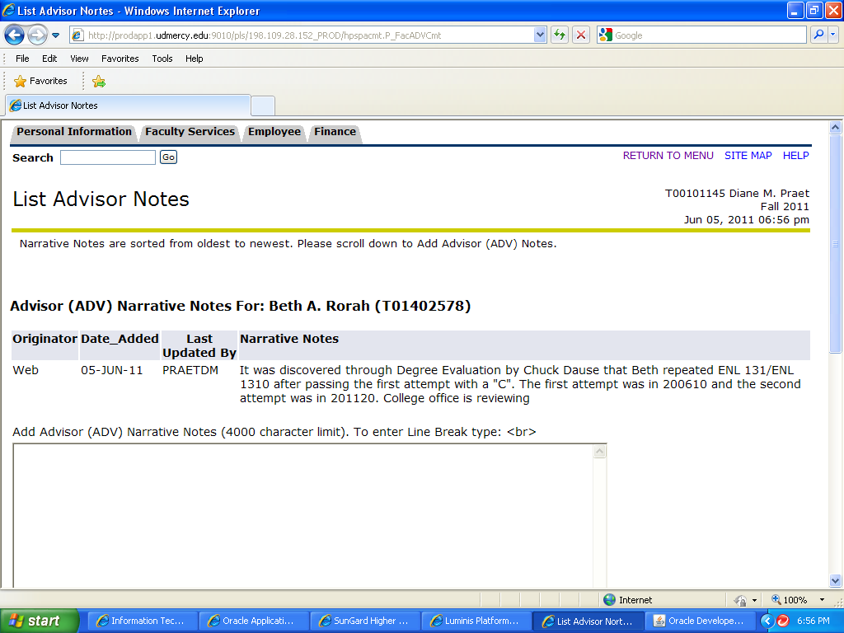

Here is the same advisor note as it appears in INB on SPACMNT. You will see that the Comments section is blank for this note. Only advising notes entered in the Narrative Comments area will display on SSB. Notes entered in the Comments text box….DO NOT DISPLAY in SSB.

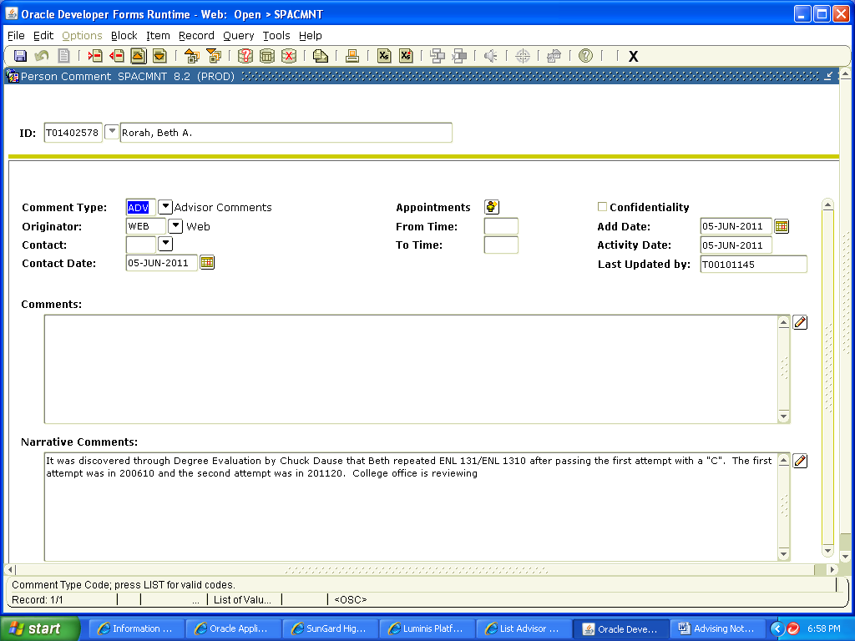

Here is another Advising Note that was originally entered in INB:

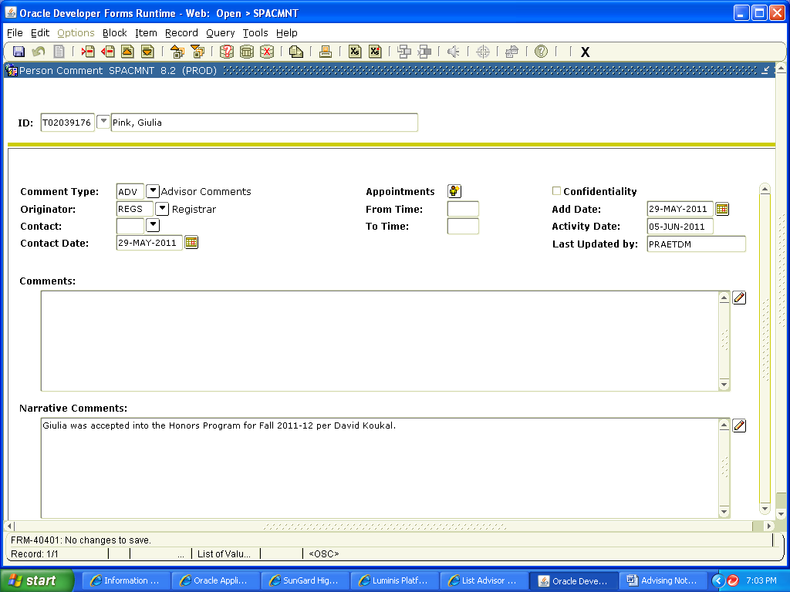

Here is how it looks it SSB: Notice instead of WEB for Originator it says REGISTRAR because the note was entered on SPACMNT in INB and not in SSB.

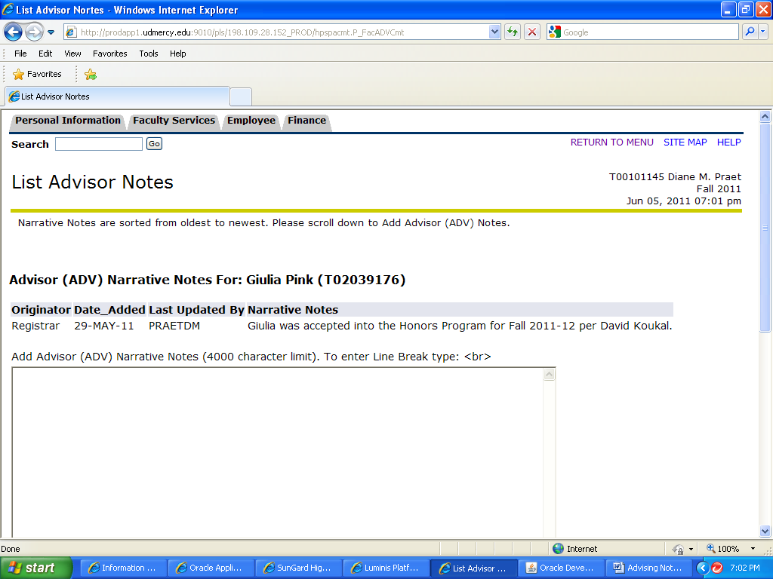

Other Helpful Tips for Using Advising Notes

Entering Advising Notes in SSB
- Do not enter the name of any other student in an advising note other than the student’s record you are adding the note to.
- Notes entered in SSB or INB are subpoenable.
- A student requesting a copy of their educational record has the right to see the Advising Notes. They are not private and are part of the student record.
- Formal sentences are not required. Phrases can be used as long as they can be understood by both the author as well as others.
- If you want your phrases or sentences to be separated then use <br> at the end of the line and then another line will start.
- Once your note has been added, if you need to add additional information or correct the original note then a new note should be added.
- You can clip or copy notes from Word and paste them in Advising Notes.

Entering Advising Notes using INB on SPACMNT
- The Comment Type must be ADV for Advisors to see them in Self-Service.
- Always choose the Originator when filling in any Comment so the Advisors know what area they came from.
- Any Comments entered in the box on top will not be displayed in Self-Service.
- The Narrative Comments box on the bottom will always be displayed in Self-Service for the Comment Type of ADV.
- Do not enter the name of any other student in an advising note other than the student’s record you are adding the note to.
- Notes entered in SSB or INB are subpoenable.
- A student requesting a copy of their educational record has the right to see the Advising Notes. They are not private and are part of the record.
- Formal sentences are not required. Phrases can be used as long as they can be understood by both the author as well as others.
- If you want your phrases or sentences to be separated then use <br> at the end of the line and then another line will start.
- Once your note has been added, if you need to add additional information or correct the original note then a new note should be added.
- You can clip or copy notes from Word and paste them in Advising Notes.
D. Praet Associate Vice President and University Registrar 6/2011

