Ford Community corps partnerships at udm
PROPOSAL Template 2023-2024
Deadline will be Friday September 22, 2023 at 11:59pm

The Institute for Leadership and Service (The Institute) is seeking bold and creative ways to use the great resources of the University of Detroit Mercy to serve our community. The Ford Motor Company Fund has provided financial support to assist the Institute in fostering the strategic partnerships which form the centerpiece of this new program. The Ford Community Corps program meets Five Core Principles including programming that allow students to match interest with need in the community, with projects that are created and implemented in the real world, that link academics and service together and implement strategic service, while expanding Ford’s nonprofit partnerships by leveraging existing connections. The primary goal of this program is to support faculty and students interested in developing a Service-Learning project to meet the needs of an agency or target population in metropolitan Detroit. The objectives of the program are to:

Enhance student leadership skills development through practical experiences of serving those in need.

Broaden students’ classroom learning through direct community engagement.

Improve the capacity of community-based, human service organizations by creating partnerships between these organizations, Ford and UDM.
- Increase the students’ awareness of service opportunities in the community and Ford Motor Company’s commitment to community engagement.

Assist faculty in identifying and using best practices in service-learning.

GRANT AWARDS AND REQUIRED TASKS:

FACULTY/STAFF: A $500 stipend for integrating the service project into a course for the Winter term of 2024. STUDENTS: Will receive up to $1500 for conducting and leading the Service-Learning project and assisting the faculty member in the Service-Learning course.

NOTE: LEAD 2000 is a prerequisite for this grant program. All student leaders who receive the grant must enroll in LEAD 4000/PYC 5750 for the Fall 2023 semester (or have already taken it earlier.) If the student is unable to participate in LEAD 4000, please contact the Institute before submitting this proposal.

PROPOSAL REQUIREMENTS:

The Faculty/Staff member and Student Leader must submit a joint proposal of a Service-Learning project to obtain the grant. The proposal will be evaluated by the Curriculum of Service Sub-committee of the Institute based on these criteria (listed according to priority):

Fit with the objectives of the Ford Community Corps Five Core Principles, including quality of community engagement, quality of service learning engagement, quality of project planning and value added. (More details available on the FCCP webpage)

Linkage between the service-learning outcomes and the Social Change Model adopted by the Institute.
- Student’s previous leadership and service coursework and experience.

Ford Community corps partnerships at udm
Application & Proposal 2023-2024
Deadline will be Friday September 22, 2023 at 11:59pm

Please submit a complete application & proposal (page one to page three) to The Institute for Leadership & Service at Briggs 212 or electronically to TheInstitute@udmercy.edu. If you have questions when filling out the form, please contact the Institute at 313-993-2003.

Faculty Information
Last Name |  |  |  | First |  |  |  |  | M.I.
Department
Phone |  |  |  | E-mail Address
Course Applying For (Winter 2024 Term)  please include course number and name |  |  |  |  |  |  |  | Approx. Class Size
If you are proposing for this project to be a part of a course that will not occur in the Winter 2024 term, indicate term and Course Name/#. NOTE: Prior approval required for this |  |  | Semester(s) |  | Course Name/# |  |  | Approx. Class Size
If this project is not course-based: What will be your source of volunteers? (Note: the oversight committee needs to be convinced that this project will have a reliable source of volunteers.)

Service Learning Course Details
In the section below, please:
- List at least two Service-Learning Outcomes that you hope to attain for the UDM students who will be enrolled in the Service-Learning Course that you have indicated above.
- Detail the classroom strategies and assessment methods used to achieve and measure these SL outcomes. Use the rows in the table below to align the Strategies and Assessment Methods with the particular Outcome they will achieve/measure.
- We ask for Service-Learning outcomes because this is the Institute's motivation for providing the FCCP grants. Namely, we want to encourage faculty-student teams to develop goals that are in line with the Social Change Model (http://www.udmercy.edu/institute/about/pdf/InstituteConceptualModel.pdf). See Appendix
*To assist you in filling out this section, we have included a list of outcomes that have developed from the Social Change Model, and sample Outcome/Strategy/Assessment logic models in the appendix. Please contact us if you want additional assistance.

Service-Learning Outcomes |  | Classroom Strategies |  |  |  |  | Assessment Method

PROPOSED WORKLOAD:
How many hours per week do you expect the Student Leader to be working on the project during the project semester?
  - 1-5 hours/week
  - 5-10 hours/week
  - 10-15 hours/week
  - 15-20 hours/week
*The University does not permit undergrads to work more than 20 hours/week total for all on-campus employment.

STudent Leader Information
NOTE: The Student Leader must register for LEAD 4000/PYC 5750 for Fall 2023 if they receive this grant. If the student is unable to participate in the course, please contact the Institute before submitting this proposal.
Last Name |  |  | First Name |  |  |  |  | M.I.
Major |  |  | Expected Graduation Year
E-mail |  |  | Phone Number
Have you taken LEAD 2000? |  |  | YES |  |  | NO
Are you registered for LEAD 4000/PYC 5750 for Fall 2023? |  |  | YES |  |  | NO
How many credit hours do you plan to take in the Fall 2023 in addition to LEAD 4000?
Other responsibilities:
List the number of credit hours that you plan to carry during the semester(s) of the projects, number of work hours outside of the FCCP hours, as well as other commitment (family, clubs, etc...).

agency/Service REcipients information
Agency Name |  |  |  |  | and/or
Service Recipients |  | Approx. Number of Service Recipients
Contact Person |  | Position/Role
Phone |  | Email
Please briefly describe your understanding of the service recipients’ needs and assets, and explain how your partnership will address these needs build upon existing assets.
Note: If you will be directly working with service recipients without a specific agency, please elaborate the situation in this proposal section.

Proposal NARRATIVE (APPRoXIMATELY 500 words)
For new projects, please include:
- A narrative description of the project.
- How will the project enhance the classroom learning, or provide a structured learning activity for non-course-based projects.
- How the project will provide some lasting benefit for the agency/organization or group of people with whom you are partnering, for example: serving a meal at a soup kitchen does not enhance the capacity of the soup kitchen, but helping the soup kitchens expand their volunteer pool would provide lasting benefit.
- Please also explain how the students participating in this project will reflect on their experience.

For returning projects, please include:
- What you learned and how you plan to change/improve your project to achieve more outcomes.

DELIVERABLES
“Deliverables” are tangible items produced in your project that will be of benefit to the agency you are serving. As a general rule, the Deliverables must include at least 6 community engagement events each of which involve at least 7 Detroit Mercy students (or equivalent impact) and contribute some lasting benefit for the agency or people being served – more than simply supplying volunteers. (Some projects might be more oriented toward delivering technical expertise or work product. That might modify the norm of community engagement events, but not eliminate it. It would be best to consult the Institute staff in these cases.)

Examples of “deliverable” include; presentations that benefit the agency (provide the number of presentations you commit to doing), reports to an agency about some kind of analysis that you did, outcomes of work projects for an agency (like a garden planted or rainwater catchment system installed), etc.

Please list the deliverables to which you can commit to producing as a team.

CONFIRMATION AND AUTHORIZATION

The student listed below understands and is able to fulfill his/her duties as explained on the cover page and including registering for LEAD 4000/PYC 5750 or has approval for alternative arrangements.
Student Leader
Name (Please Print)
Student Leader Signature |  | Date

The faculty member listed below understands the commitment as outlined on the cover page and is able to complete the project as outlined in the “Narrative” and “Deliverables” sections above.
Faculty Member Name (Please Print) |  | Title
Faculty Member Signature |  | Date
The Dean and Chair persons listed below have read this proposal and agree that the faculty member listed on page two will be able to include the project outlined in this proposal as a part of the course listed on that page assuming enough students register.
Dean’s Approval  (Please Print Name) |  | College/School
Dean’s Signature |  | Date
Chair’s Approval  (Please Print Name) |  | Department
Chair’s Signature |  | Date
The agency contact listed below has obtained authorization and commits the agency to participate in the project outlined in this proposal and commits to providing brief feedback twice during the semester(s) of the project to the Detroit Mercy coordinator.
Agency Contact’s Name (Please Print Name) |  | Title
Agency Contact’s Signature |  | Date

Appendix i

The Social Change Model

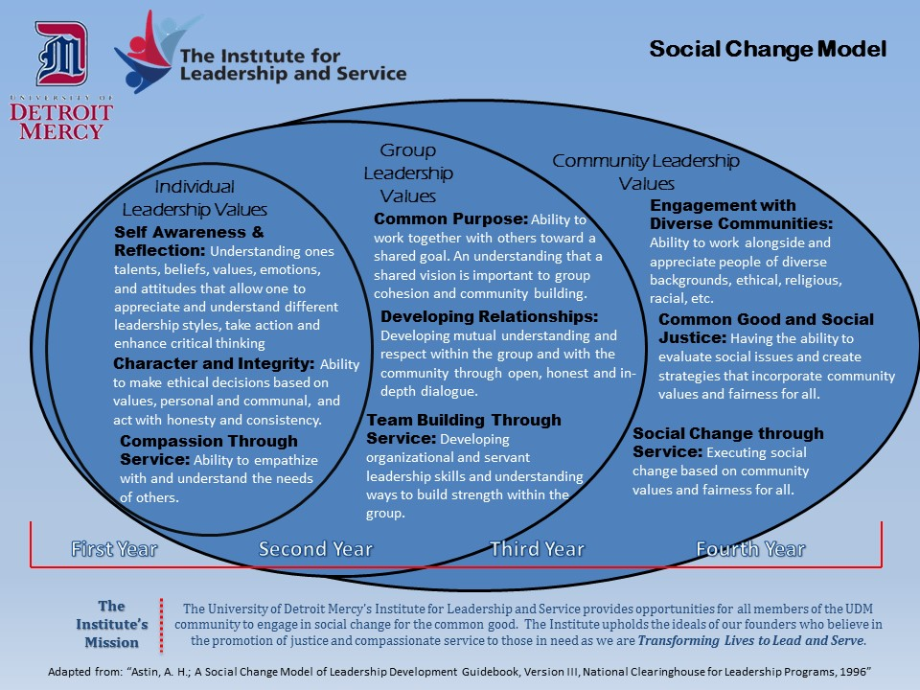
Appendix ii

Examples of Service-Learning Outcomes, Classroom Strategies and Student Assignments
Do not list all your Outcomes in this proposal, only "Service-Learning Outcomes":
- "Service-Learning Outcomes” are the student development goals that are possible only with the service element in place. A good SL Outcome will be able to complete the following sentence: “As a result of this service-learning class and especially due to the fact that the student will be involved in service, the students will be able to …”
- The Institute has developed Outcomes that fit with the Social Change Model. These are listed below. You do not have to use these, but they might help you identify outcomes for you project.
- Provide a separate row for each Service-Learning Outcome that you propose (as seen on the next page). In that same row, provide Classroom Strategies and Assessment Methods that will be utilized to engage students and assess their attainment of that particular outcome.

Institute Student Outcomes: Arising out of Values of the Social Change Model
As a result of the FCCP project, students will be able to…
- Value #1: Self Awareness & Reflection- Demonstrate proficient use of reflection by drawing insight from their service experience and making connections with other parts of their experience, the mission of UDM and/or their faith traditions.

- Value #2: Character & Integrity- Demonstrate an ability to make ethical decisions based on values, personal and communal, and act with honesty and consistency.

- Value #3: Compassion Through Service- Demonstrate compassion for all people without exception.

- Value #4: Common Purpose-
  - Demonstrate an ability to hear others’ points of view and work together toward a shared vision.
  - Demonstrate an understanding of the importance of group cohesion and community building for achieving a shared vision.

- Value #5: Developing Relationship- Demonstrate an ability to develop a deeper understanding of and respect for group members and community members through open, honest and in-depth dialogue.

- Value #6: Team Building Through Service- Demonstrate organizational and servant leadership skills and understanding ways to build strength within the group.

- Value #7: Engagement With Diverse Communities- Demonstrate increased cultural competence.

- Value #8: Common Good and Social Justice- Demonstrate the ability to develop a plan to remediate marginalization that considers the main factors that cause it.

- Value #9: Social Change Through Service- Demonstrate progress toward remediation of an instance of marginalization.
Appendix iii
Service Learning Course Details Examples

Service-Learning Outcomes | Classroom Strategies | Student Assessment
Students will increase their ability to reflect on their experience. Though this second outcome cannot be required, it is also hoped that students will experience compassion for those whom they serve. | Students will be required to enter a Blackboard journal entry immediately after every service experience including the following:  - What was my immediate reaction during and after the service experience? How did I feel? What thoughts did I have?  - How do I think the people whom I served were feeling? What were they thinking while we work interacting with them?  Students will be required to write a three page reflection paper on what they learned from the service experience and how it related to the course material. | Student assessment will be based on the quality of the students’ reflection and based on the rubric below.
Students will increase their ability to identify critical social issues facing residents of struggling urban areas, especially Detroit. | In pre-service reflection session, students will be asked to identify the social issues facing residents of the area in which the students will work.  As part of the written post-service reflection students will be asked:  - Why were our services needed? What social issues impacted those whom we served?  - How has your understanding changed regarding the social issues facing those whom we served? | Student assessment will be based on students’ ability to clearly identify issues. The standard for this will be established in classroom presentations.
Students will learn how to advocate for persons who lack clout in our political system. | Students will identify some person, organization, or agency that has the power to make a positive change in the lives of the people that we served in our project. Then they will write a letter proposing some change that could positively impact the lives of those served. | Students will be evaluated on how well they incorporated the perspective of those served in coming up with their proposal and how well they researched the issue so as to have a real impact.

Reflection Assessment Rubric
Passing (70-78%) | Fair (78-85%) | Well Done (86-93%) | Excellent (94-100%)
Student referred to actual events and people and made some effort to articulate personal reactions. | Student articulated personal reaction in a clear way. | Student shows evidence of careful thought about his/her reactions, the implications of these and make some connection with course material | Student was able to draw some insight from the experience, and make clear connections with other parts of their experience and the course material.

