Job Hazard Analysis

|  |  |
| --- | --- |
| Task/Equipment: | Reinstalling Burner Summer Boiler |
| Department: | Powerhouse |
| Analyzed By: | Bill Partin & Bryana Borders |
| Date: | 4/12/19 |

**Personal Protective Equipment Required:**

Insert Picture of Task



**Hard Hat**



**Heavy Leather Gloves**

**Trainings Required*/Recommended:**

Proper Ladder Use*, OSHA10

**Equipment/Tools/Chemicals Required for the Job:**

Hand wrench, washers, nuts, pipe wrenches, screw driver, ladder, flashlight

|  |  |  |
| --- | --- | --- |
| **Tasks/Steps** | **Hazards Present** | **Safety Measures and Controls** |
| 1. Remove caution tape | No Hazards Present | N/A |
| 1. Move burner along support-rail frame | Falling object | Do not go underneath the burner |
| 1. Remount burner muffler | Falling object | Do not go underneath the burner |
| 1. Replace clamps washers and hex nuts and secure | Finger pinch | Use Heavy leather gloves |
| 1. Reinstall burner support stanchion | Falling objects | Do not go underneath the burner |
| 1. Reinstall gas recirculating piping | No Hazards present | N/A |
| 1. Reconnect main gas line at union | No Hazards present | N/A |
| 1. Reinstall gas pressure safety switch | No Hazards present | N/A |
| 1. Reinstall main flame scanner | No Hazards present | N/A |
| 1. Reinstall gas pilot lines | No Hazards present | N/A |
| 1. Reinstall vent lines | No Hazards present | N/A |

**Additional Information:**

* This is a two person task

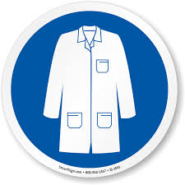

Lab Coat

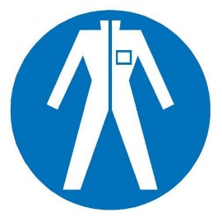

Protection Suit

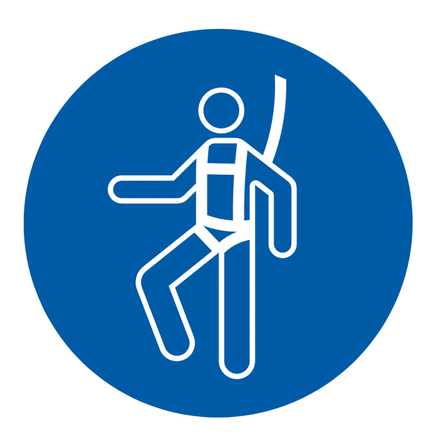

Fall Protection Harness



High Vis Vest

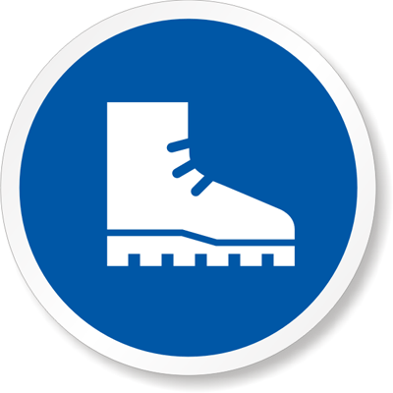

Safety Shoes



Splash Goggles



Cryogenic Gloves



Dust Mask

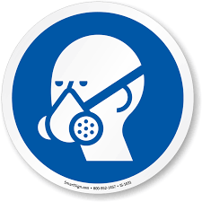

Respirator



Face Shield



Safety Glasses



Ear Protection