Job Hazard Analysis

|  |  |
| --- | --- |
| Task/Equipment: | Cleaning Suction Strainers |
| Department: | Powerhouse |
| Analyzed By: | Bill Partin & Bryana Borders |
| Date: | 4/12/19 |

**Personal Protective Equipment Required:**



**Heavy Leather Gloves**



**Hard Hat**

**Trainings Required*/Recommended:**

Proper use of impact tool*, OSHA 10

**Equipment/Tools/Chemicals Required for the Job:**

Socket wrenches, hand wrenches and rotary impact tool

|  |  |  |
| --- | --- | --- |
| **Tasks/Steps** | **Hazards Present** | **Safety Measures and Controls** |
| 1. Turn off pump at control panel | No hazards present | N/A |
| 1. Isolate strainers by closing suction and discharge stop valves | No hazards present | N/A |
| 1. Connect a hose to strainer blow down tap and run to floor drain | No hazards present | N/A |
| 1. Open drain valve and allow strainer cavity to drain and cool | Skin Burn | Use heavy leather gloves and allow strainer flange to cool |
| 1. Remove bolts from strainer flange and lower flange to floor | If you use an impact tool, this could cause wrist twist | Use heavy leather gloves for grip |
| 1. Remove wire mesh strainer | Finger cuts, sharp edges | Wear heavy leather gloves to prevent cuts |
| 1. Clean strainer using soap and water | No hazards present | N/A |
| 1. Replace strainer into cavity | Finger cut, sharp edges | Use heavy leather gloves |
| 1. While one person holds flange in place the other lines up and puts bolts in place | Finger pinch | Use heavy leather gloves |
| 1. Secure bolts using socket wrench or impact tool | Wrist twist | Be careful using wrenches and impact tool, use heavy leather gloves for grip |
| 1. Close drain valve | No hazards present | N/A |
| 1. Reopen isolation valves at suction and discharge stops | No hazards present | N/A |
| 1. Turn pump on at control panel and check for leaks | No hazards present | N/A |

**Additional Information:**

* Two Person Task

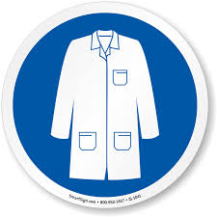

Lab Coat

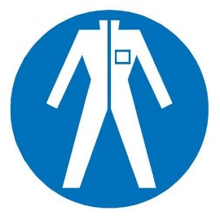

Protection Suit

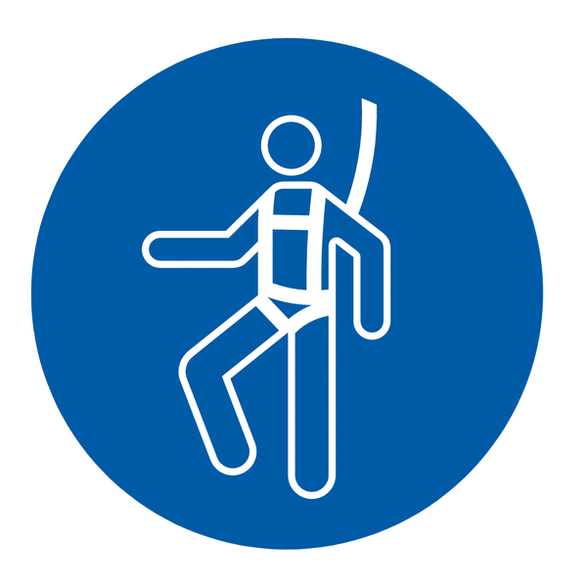

Fall Protection Harness



High Vis Vest

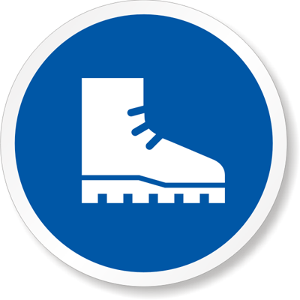

Safety Shoes

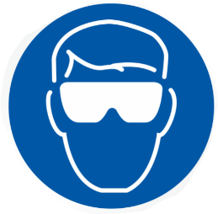

Splash Goggles



Cryogenic Gloves



Dust Mask

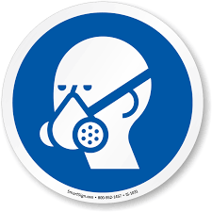

Respirator



Face Shield



Safety Glasses



Ear Protection