Job Hazard Analysis

**Personal Protective Equipment Required:**

|  |  |
| --- | --- |
| Task/Equipment: | Cleaning and Winterizing Cooling Tower |
| Department: | Powerhouse |
| Analyzed By: | Bill Partin & Bryana Borders |
| Date: | 4/12/19 |

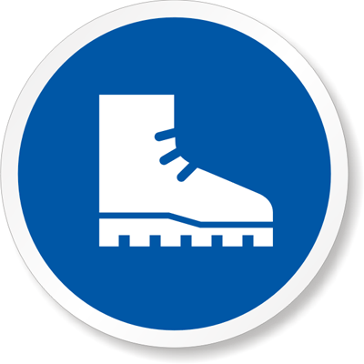

**Rubber Boots**

**Slip Resistant**



**Chemical Resistant Gloves Gloves**

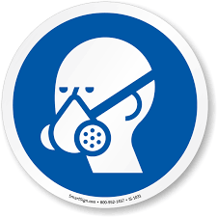

**Full Face Respirator**



**Heavy Leather Gloves**

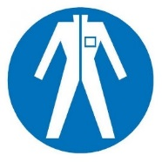

**Waterproof Coveralls**

**Trainings Required*/ Recommended:**

Hazardous communication*, ladder safety, eye safety, respirator use

**Equipment/Tools/Chemicals Required for the Job:**

Goodway TFC-200 machine, Goodway Scalebreak-Gel, Scalebreak neutralizer, 6-ft ladder, hand tools, PH meter

|  |  |  |
| --- | --- | --- |
| **Steps** | **Hazards Present** | **Safety Measures and Controls** |
| 1. Turn tower fan control off at tower control panel. Open main power disconnect to cooling tower and secure with lockout protocol | No hazards present | N/A |
| 1. Open both North and South fan disconnect at cooling tower and secure with lock out protocol | No hazards present | N/A |
| 1. Isolate make-up water to tower by closing the 2 inch make-up ball valve | Ladder fall | Proper ladder use training |
| 1. Connect Scalebreak chemical drum to TCH-200 machine per manufacture’s instruction | Chemical inhalation, chemical splash, chemical skin contact, chemical eye contact, Slip and fall | Properly wear a full face respirator, chemical resistant gloves and protective coveralls |
| 1. Apply Scalebreak chemical to cooling tower fill using manufacturer’s directions and allow to set for 1 hour. | Chemical inhalation, chemical splash, chemical skin contact, chemical eye contact, slip and fall | Properly wear a full face respirator, chemical resistant gloves, rubber boots, wear protective coveralls |
| 1. Use Goodway TCH-200 machine to wash tower fill per manufacturer’s instructions | Chemical inhalation, chemical splash, chemical skin contact, chemical eye contact, slip and fall | Properly wear a full face respirator, chemical resistant gloves and protective coveralls |
| 1. Add scale break neutralizer chemical to tower basin per manufacturer’s instructions to neutralize basin water | Chemical inhalation, chemical splash, chemical skin contact, chemical eye contact, slip and fall | Properly wear a full face respirator, chemical resistant gloves, rubber boots and protective coveralls |
| 1. After PH has dropped (use PH meter) to acceptable levels ,open tower drain valve and allow sump basin to drain completely | Chemical contact with hands, eye, and skin. Slip and fall | Properly wear a full face respirator, chemical resistant gloves, rubber boots and protective coveralls |
| 1. Post another person outside the tower, enter using a six foot ladder and remove screen-strainers from sump suction | Ladder fall, finger cuts | Use proper ladder use protocol, wear heavy leather gloves |
| 1. Remove screens and clean with garden hose | Wet feet and hands could cause a loss of grip and a slip and fall | Use water proof gloves and rubber boots |
| 1. Sweep out all loose scale, dirt and debris from floor of cooling tower and dispose of | Slip and fall, wet surface | Use rubber boots |
| 1. Leave drain valve open to prevent freeze-up over the winter months | No hazards present | N/A |

**Additional Information:** Two person task



Safety Glasses

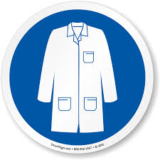

Lab Coat

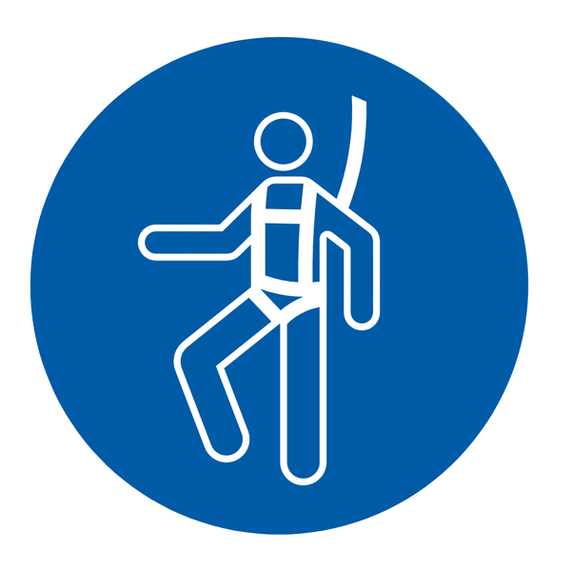

Fall Protection Harness



High Vis Vest



Dust Mask



Hard Hat



Ear Protection