Job Hazard Analysis

|  |  |
| --- | --- |
| Task/Equipment: | Removing Condenser Head From Chiller |
| Department: | Powerhouse |
| Analyzed By: | Bill Partin & Bryana Borders |
| Date: | 4/11/18 |

**Personal Protective Equipment Required:**



**Heavy Leather Gloves**

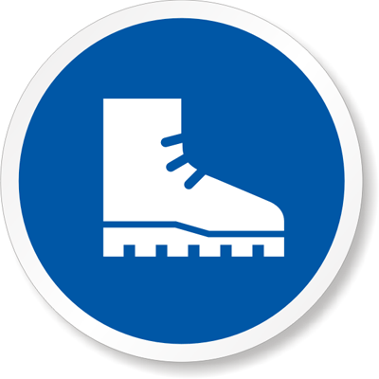

**Steel-Toe Boots**



Safety Shoes

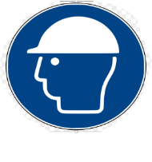

**Hard Hat**

**Trainings Required*/Recommended:**

Proper use of chain fall and hydraulic lift

**Equipment/Tools/Chemicals Required for the Job:**

Rotary impact tool, chain fall, hydraulic lift

|  |  |  |
| --- | --- | --- |
| **Tasks/Steps** | **Hazards Present** | **Safety Measures and Controls** |
| 1. Attach chain fall or hydraulic lift to lift hook at top of head | Injury from swinging lift hook | Hold the lift hook while transporting or lowering |
| 1. Remove bolts from perimeter of head | Wrist twist | Careful use of impact tool, wear heavy gloves |
| 1. Raise lifting device to support head | Head could fall on someone’s foot if the hook isn’t secured correctly | Double check to make sure the hook is secured on the condenser head. |
| 1. Position one person to guide head away from condenser while the other operates the lift device | Heavy swinging object could hit someone | Be careful when operating the lift. Proper training required |
| 1. When head is clear of condenser, lower to floor and lay flat | Foot injury due to heavy steel head falling | Wear steel-toe boots |
| 1. Manually move head to a safe storage location | Heavy swinging object could hit someone | Be careful while operating a lift. Proper training required |
| 1. Remove O-ring and wipe clean with a cloth ,store in a clean place for reuse | No hazards associated with this step | N/A |
| 1. Scrape and clean loose scale from head surfaces | Tolls used to scrape head surfaces could puncture the skin | Use heavy duty gloves while cleaning the head surface |
| 1. Inspect condenser tubes for scale or corrosion | No hazards Present | N/A |

**Additional Information:**

* This task must be done with 2 people

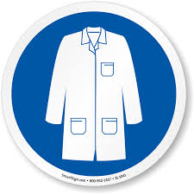

Lab Coat

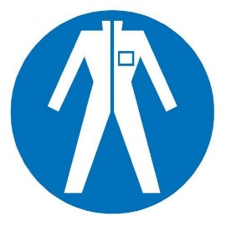

Protection Suit

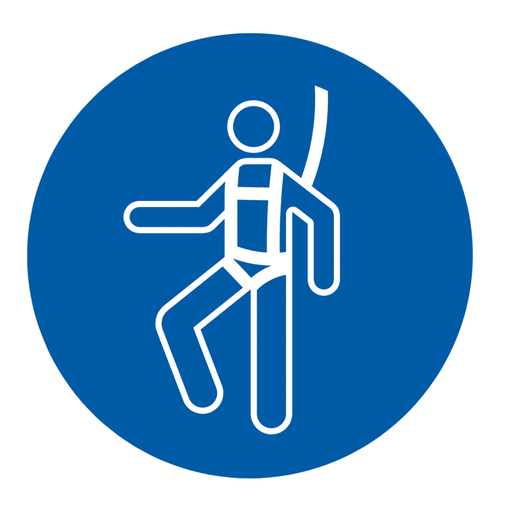

Fall Protection Harness

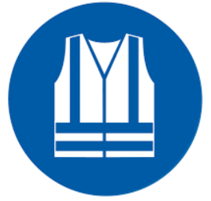

High Vis Vest

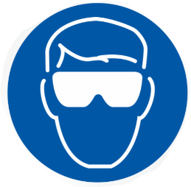

Splash Goggles

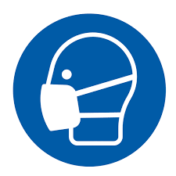

Dust Mask

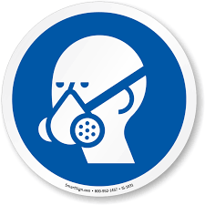

Respirator

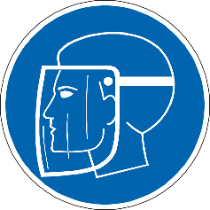

Face Shield

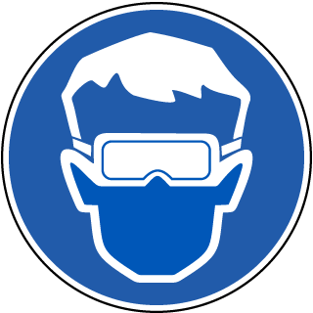

Safety Glasses



Ear Protection