|  |  |
| --- | --- |
| Task/Equipment: | Reassembling Winter Boiler After Annual Inspection |
| Department: | Powerhouse |
| Analyzed By: | Bryana Borders & Bill Partin |
| Date: | 4/12/19 |

Job Hazard Analysis

**Personal Protective Equipment Required:**



**Heavy Leather Gloves**



**Hard Hat**

**Trainings Required*/Recommended:**

Proper ladder use training*, OSHA 10

**Equipment/Tools/Chemicals Required for the Job:**

Pipe wrenches, socket wrenches, screw drivers, hand wrenches, sanding cloth, hammer, rope, flashlight, flood light

|  |  |  |
| --- | --- | --- |
| **Tasks/Steps** | **Hazards Present** | **Safety Measures and Controls** |
| 1. Reinstall manway covers with new gaskets and discard old gaskets (hammer may be used) | Finger pinch and finger/hand smash from hammer | Use heavy leather gloves to protect from pinching. Keep hands away from the area where blunt force is applied |
| 1. Replace all cross tees and inspection plugs | Fall from ladder | Follow proper ladder use protocol |
| 1. Replace gasket and reinstall water level safety float and secure bolts | No Hazards Present | N/A |
| 1. Check that the bottom blowdown valves are closed and remove lock-out device from valves | No Hazards Present | N/A |
| 1. Close fire-side access door, replace bolts and secure | Wrist twist | Operate impact wrench carefully and use heavy leather gloves for grip |
| 1. Remove lock-out device from main power disconnect and close | No Hazards Present | N/A |
| 1. Close main boiler gas cock and leave handle in the vertical position | No Hazards Present | N/A |
| 1. Re-open OS&Y valve on top of boiler, leave non-return closed until boiler is put online | Ladder fall | Follow proper ladder use protocol |
| 1. Re-enable chemical feed pump if applicable | No Hazards Present | N/A |
| 1. Reopen surface blowdown stop valve closest to the boiler and remove tag | No Hazards Present | N/A |

**Additional Information:**

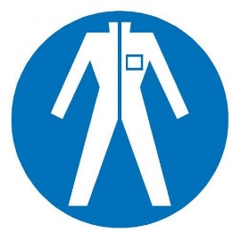

Protection Suit

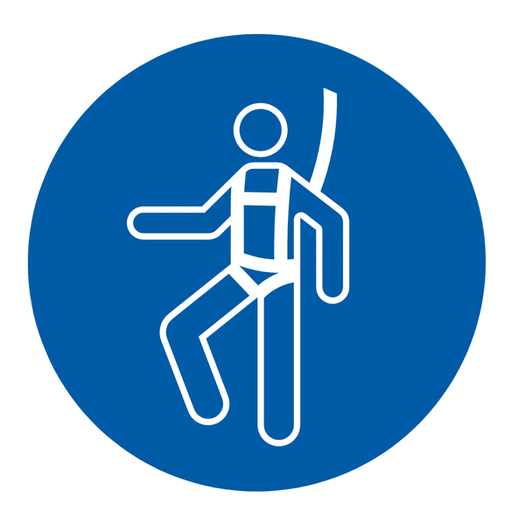

Fall Protection Harness



High Vis Vest

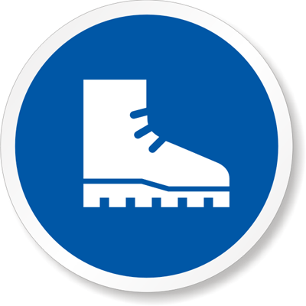

Safety Shoes



Splash Goggles



Latex Gloves



Dust Mask

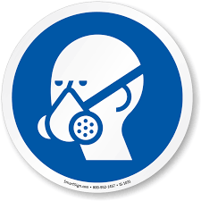

Respirator



Face Shield



Safety Glasses



Ear Protection