Job Hazard Analysis

|  |  |
| --- | --- |
| Task/Equipment: | Fluid Change for Control Compressor |
| Department: | Powerhouse |
| Analyzed By: | Bill Partin and Bryana Borders |
| Date: | 4/16/19 |

**Personal Protective Equipment Required:**



**Heavy Leather Gloves**

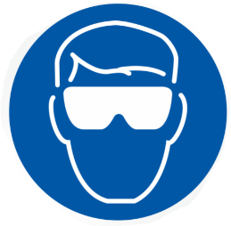

**Splash Goggles**



**Hard Hat**

**Trainings Required*/Recommended:**

Lock out tag out*

**Equipment/Tools/Chemicals Required for the Job:**

Compressor fluid, air filter, socket wrench, screw driver, filter wrenches, hand tools, funnel, oil/fluid absorbing compound

|  |  |  |
| --- | --- | --- |
| **Steps** | **Hazards Present** | **Safety Measures and Controls** |
| 1. Start standby compressor | No hazards present | N/A |
| 1. check to insure water flow to drain from water-cooled standby compressor or cooling fan is running for air cooled compressor | Finger cuts and water splash-back into eyes | Wear heavy leather gloves and splash goggles |
| 1. Push stop button on control pad to stop compressor being serviced | No hazards present | N/A |
| 1. Open main power disconnect at 3-phase distribution panel and secure using lock-out tag-out protocol | Skipping this step could cause severe burns to skin and eyes in step 6 | Follow lockout tag out protocol |
| 1. Isolate the compressor pneumatically and relieve system of air pressure until control panel pressure indicator reads zero | Skipping this step could cause severe burns to skin and eyes in step 6 | Control panel is there to show the current pressure. Wait until that hits zero before moving on to the next step. |
| 1. Remove fill tube cap | Skin burns, eye and facial injury | Close and secure pneumatic pressure isolation valve using lock-out protocol .Verify that all system pressure has been dissipated before opening system to service. Wear safety googles and heavy leather gloves |
| 1. Open drain valve and remove plug , Allow reservoir to drain completely | Skin burns | Wear heavy gloves |
| 1. Replace drain plug and close drain valve | No hazards present | N/A |
| 1. Fill fluid reservoir with fresh fluid to proper level | No hazards present | N/A |
| 1. Replace reservoir fill-cap and secure | No hazards present | N/A |
| 1. Reopen pneumatic isolation valve | No hazards present | N/A |

**Additional Information:**

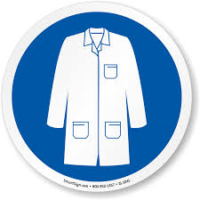

Lab Coat

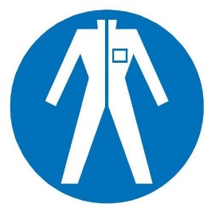

Protection Suit

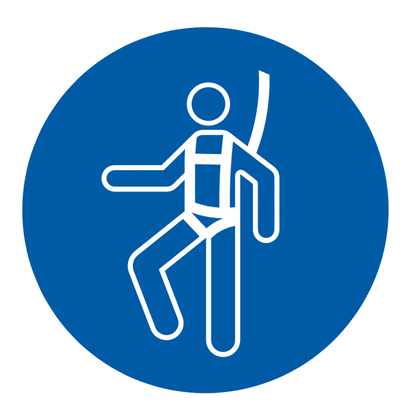

Fall Protection Harness

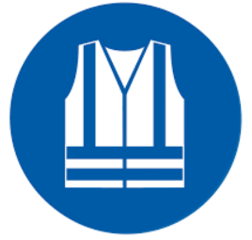

High Vis Vest

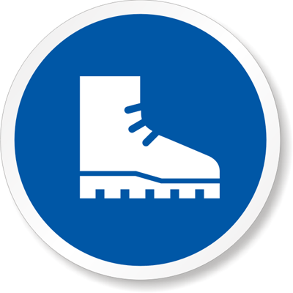

Safety Shoes



Cryogenic Gloves

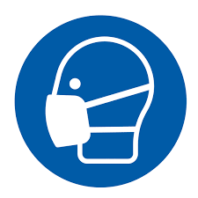

Dust Mask

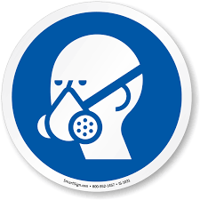

Respirator



Face Shield



Safety Glasses



Ear Protection