CHEMICAL HYGIENE PLAN

October 27, 2022
uNIVERSITY OF DETROIT MERCY

Contents
I. Operating Procedure 3
A. General 3
B. Laboratory Safety and Hygiene Practices 4
C. Housekeeping 5
D. Chemical Procurement 6
E. Chemical Storage and Distribution 6
F. Compressed Gases 8
G. Cryogenic Liquids 8
H. Waste Minimization and Disposal 11
I. Accidents – Procedures and Contact Information 12
J. Spills 13
II. Facility, Safety and Control Measures 14
A. Laboratory Design 14
B. Ventilation and Engineering Controls 15
C. Safety Equipment and Inspections 17
D. Personal Protective Equipment (See appendix C on PPE requirements) 18
E. Administrative controls 19
III. Safe Work Practices 25
A. Job Hazard Assessment 25
B. Chemical Hazard Awareness 25
IV. Training 29
A. Training for Employees 29
B. Training for Students 30
C. Access to Information 30
V. Responsibilities 31
A. Department Chair or Dean 31
B. Chemical Hygiene Officer 31
C. Laboratory Manager 32
D. Laboratory Staff 32
E. Students 33
Appendices A-I 34
A. Policy on Non-Compliance 35
B. Hazardous, Universal, and Medical Waste Management Plan 44
C. Personal Protective Equipment 54
D. Labeling and Inspection Tag 66
E. Safety Data Sheets 0
F. Compressed Gas 88
G. Chemical Storage Compatibility Table 94
H. Emergency Eyewash/ Shower Inspection Procedure 97
I. Asphyxiation Symptoms 100

I. Operating Procedures

General

  - The Chemical Hygiene Plan (CHP) applies to all University of Detroit Mercy laboratories which adhere to all the following:

    - Chemical manipulations are carried out on a laboratory scale and in containers of a size that can be easily and safely manipulated by one person.
    - Multiple chemical procedures are used.
    - Protective laboratory procedures and equipment are necessary to minimize the potential for employee and student exposure to hazardous chemicals.
    - The procedures involved are not part of a production process whose function is to produce commercial quantities of materials, nor do the procedures in any way simulate a production process.

  - Staff and students shall follow the Chemical Hygiene Plan to promote their health and safety.

  - The laboratory supervisor or the Chemical Hygiene Officer (CHO) is to be contacted with any safety questions, concerns, or to report unsafe conditions.

  - Unauthorized persons are not allowed in the laboratory. Student assistants and students enrolled in University of Detroit Mercy courses in the specific course may participate in laboratory exercises.

  - Plan safety procedures before beginning any operation.

  - Always follow standard operating procedures.

  - Always read the Safety Data Sheets (SDSs) and the label before using a chemical.
  - Know the location and proper use of safety equipment.

  - Make others aware of special hazards associated with your work.

  - Report all injuries, accidents, incidents and near misses to the laboratory manager. In the event of questionable or certain non-conformance situations, please see the Compliance Policy and Corrective Measures form for instruction in appendix A.

  - Properly dispose of chemical waste. See appendix B for disposal requirements.

  - Generally, textbooks, laboratory manuals, job hazard assessments, standard operating procedures and other instructional materials designate the safety precautions needed for a particular laboratory activity. These precautions shall be followed in conjunction with the Chemical Hygiene Plan.

Laboratory Safety and Hygiene Practices
  - Individuals in the laboratory
Eating, drinking, smoking, gum chewing, applying cosmetics, and taking medicine in laboratories where hazardous chemicals are used or stored is prohibited.
    - Horseplay in University of Detroit Mercy laboratories is forbidden and may result in disciplinary action.
    - Touching, smelling, tasting, and other inappropriate close contact with chemicals is forbidden.
    - Never pipette by mouth. Always use a bulb or other device for suction.
    - Wear appropriate Personal Protective Equipment (PPE) at all times.
    - Confine long hair and loose clothing, wear full length pants and tops, and always wear shoes that fully cover the foot.
    - Use appropriate ventilation when working with hazardous chemicals.
    - Hands are to be washed with soap and water immediately after working with any laboratory chemicals, even if gloves have been worn.
    - Food, beverages, cups, and other drinking and eating utensils cannot be stored in areas where hazardous chemicals are handled or stored. If food is being used for experimental purposes, it must be clearly labeled that it is not edible
    - Operation of hotplates, running water, and open flames shall not be left unattended.

  - Students in the laboratory
    - Report all accidents, injuries, chemical spills, equipment malfunctions, and glass breakage to the instructor immediately, no matter how trivial they may seem. The Department of Public Safety will evaluate cuts, burns, accidental ingestion of chemicals, or inhalation of fumes.
    - Learn the location of the fire extinguisher, eye wash station, first aid kit, and safety shower.
    - Must perform only authorized experiments.
    - Must only carry out laboratory work under the direct supervision of an instructor or designated staff member.
    - Shall read lab directions ahead of time and follow all verbal and written instructions.

Housekeeping

  - All laboratory areas must be kept clean and orderly.

  - Keep pathways clear by placing extra items (books, bags, etc.) in designated areas or under the worktables. If under the tables, ensure that these items cannot be stepped on.

  - Place all chemical and biological wastes in appropriate, segregated receptacles that are properly labeled. See instructor if labels are missing, defaced, or unclear.

  - Only water may go down the drain unless instructed otherwise by the instructor.

  - Notify the instructor of any lab spills as soon as possible.

  - Never block access to emergency equipment, safety showers and eyewash stations, or exits.

  - Keep all cabinets and drawers closed when not in use to avoid catching and bumping hazards.

  - Do not store chemical containers on the floor.

Chemical Procurement

  - Efforts are to be made to order chemicals in small quantities and purchased only in the quantity sufficient for the declared use.

  - Chemicals will only be accepted with adequate labeling and corresponding Safety Data Sheets. If received without Safety Data Sheets, this information is to be obtained from the chemical provider before the chemical is put into service.

  - Chemical invoices are to be reviewed and compared to the actual shipment for accuracy.

  - Chemical SDS information is to be reviewed for proper handling, storage, and disposal before a substance is received and placed in storage for use.

  - All chemicals received are to have a unique ID number associated with that chemical.

Chemical Storage and Distribution

  - All chemicals shall be kept in tightly closed, sturdy, and appropriate containers.

  - Chemicals shall be stored based on the reactive nature and compatibility group of the chemicals. Chemical incompatibility is a required section of the SDS and is to be referenced before placing in storage. See the chemical compatibility chart in appendix G

  - Large containers and containers with reactive chemicals, such as acids and bases, shall be on low shelves, 5 ft. or lower in height.

  - All flammable chemicals shall be stored in approved storage containers and in approved flammable chemical storage cabinets.

  - All expired chemicals must be disposed of properly

  - No combustible material, such as paper products, shall be stored in the chemical storage rooms. No trash/recycling receptacles shall be kept in the chemical storage rooms.

  - All storage areas shall be securely locked when not in use. Storage and preparation areas shall only be accessible to those persons authorized to access the chemicals.

  - Chemicals shall not be distributed for purposes other than instruction within the science departments without the prior approval of the CHO. Chemicals transferred to other locations off campus shall be accompanied by their applicable SDS information. All University employees who transfer and receive chemicals shall have appropriate training in their use, storage, and disposal.

  - Refrigerators used to store flammable chemicals shall be of explosion proof or of lab safe design.

  - Chemicals transported in elevators shall be protected from breakage and carried in secondary containers, such as unbreakable tubs, that will contain spills. All chemicals transported in elevators shall be carried by cart, not by hand. The elevator shall not be used by the public during transportation of significant quantities (over 100 grams) of chemicals.

Compressed Gases
  - A compressed gas is defined as any material or mixture having in the container either an absolute pressure greater than 276 kPa (40 lb/in²) at 21°C (70°F), or an absolute pressure greater than 717 kPa (104 Ib/in²) at 54°C (130°F), or both; and any liquid flammable material having a Reid vapor pressure greater than 276 kPa (40Ib/in²) at 38°C (100°F).

  - Gas cylinders shall only be moved from one location to another with the protection cap securely in place. A wheeled gas cylinder carrier is preferred when moving a cylinder. Cylinders shall be moved by tilting and rolling them on their bottom edges.

  - Both full and empty cylinders shall only be stored where they may be securely restrained by straps, chains, or a suitable stand.

  - An “Empty” label shall be placed on a cylinder and the cylinder shall be considered empty when there is still a slight positive pressure in it.

  - An empty cylinder shall be returned to the designated compressed gas accumulation area as soon as possible after having been emptied or when it is no longer needed.

  - Cylinders shall not be exposed to temperatures above 50°C/122 ° F.

  - Store flammable gases separately from oxidizer gases.

Cryogenic Liquids
According to the National Institute of Standards and Technology a cryogenic liquid is defined as any liquid with a normal boiling point below ‐150°C (123K). This includes, but not limited to Nitrogen, Helium, Oxygen, and Argon. Most cryogenic liquids are odorless, colorless, and tasteless when vaporized. When cryogenic liquids are exposed to the atmosphere, the boil-off gases condense moisture in the air, creating a highly visible fog.
General
  - Cryogenic liquids shall only be used in well ventilated areas. All cryogenic liquids produce large volumes of gas when they vaporize, thus replacing air and potentially causing asphyxiation or lead to an explosion (symptoms of asphyxiation is in appendix I).
  - All handling any cryogenic liquid, should consult an SDS for the specific material prior to work. Students must be supervised when handling any cryogenic liquid.
  - Always handle cryogenic liquids carefully to avoid skin burns and frostbite. Exposure that may be too brief to affect the skin of the face or hands may damage delicate tissues, such as the eyes.
  - Boiling and splashing always occur when charging or filling a container with cryogenic liquid or when inserting objects into these liquids. Perform these tasks slowly to minimize boiling and splashing. Use wooden or rubber tongs to withdraw objects immersed in a cryogenic liquid.
  - Never touch uninsulated pipes or vessels containing cryogenic liquids. Skin will stick to extremely cold materials. Even nonmetallic materials are dangerous to touch at low temperatures.
  - Cryogenic gloves are for indirect or splash protection only, they are not designed to protect against immersion into cryogenic liquids.
  - Never tamper or modify safety devices such as cylinder valve or regulator of the tank.
  - Placing an air monitoring device in storage of flammables and asphyxiates is highly recommended.
  - Only authorized and trained personnel should maintain and operate the liquid helium, liquid nitrogen or liquid argon storage facility and its components. Safety concerns should be reported immediately.
Transport
  - Always wear proper PPE and always use proper containers designed for the transport and use of cryogenic liquids. Never use a container which has defects.
  - When transferring into a secondary container, do not fill the secondary container to more than 80% of capacity.
  - Do not ride with cylinders in elevator or other non-ventilated spaces.

Waste Minimization and Disposal

University of Detroit Mercy is considered a small quantity generator according to Michigan Hazardous Waste Rules. Under the Resource Conservation and Recovery Act (RCRA), while a waste minimization program is not required, a good faith effort is required and acknowledged by the following certification stated in 40 CFR Part 262.27 and located in section 15 of the Uniform Hazardous Waste Manifest: “I am a small-quantity generator. I have made a good faith effort to minimize my waste generation and select the best waste management method that is available to me and that I can afford.”

  - Employees shall minimize generation of hazardous waste by:

    - Using microscale labs and selecting less hazardous materials.
    - Ordering chemicals in quantities that are likely to be consumed in one year or less.
    - Avoiding the inadvertent accumulation of hazardous waste. Potential waste materials are surplus, old, and/or unnecessary chemicals.

  - All hazardous materials shall be disposed of in accordance with Michigan Hazardous Waste Management rules.

    - Only non-hazardous, non-vaporous, non-fuming, non-flammable, aqueous solutions between pH 5 and pH 9 may be poured down the drain.
    - Hazardous waste shall never be placed in any common solid trash container.
    - Twice annually hazardous waste is appropriately packaged, labeled, and transported offsite to a RCRA permitted Treatment, Storage and Disposal Facility (TSDF) for analysis and treatment.
    - Waste is generated and contained near the point of generation, which never exceeds the 55gal satellite accumulation requirements.
    - Unlabeled containers apparently containing liquid and/or solid chemicals shall be treated as hazardous waste and disposed of using the procedures described above.

Accidents – Procedures and Contact Information
Refer to SDS first aid instructions on specific chemical exposure and spills. Below are general instructions for chemical exposure, which may not apply to all situations.
  - Eye Contact: Promptly flush eyes with large amounts of water for a prolonged period (15 minutes), occasionally lifting the lower and upper lids. Seek medical attention.

  - Ingestion: Try to determine the chemical ingested. Contact Public Safety to seek medical attention immediately.

  - Skin Contact: For both solid and liquid chemical contact, dust off excess solid if applicable, promptly flush the affected area with water, and remove any contaminated clothing. If irritation persists after washing, seek medical attention.

  - Inhalation: Move the exposed person to fresh air at once. If breathing has stopped, perform artificial respiration. When breathing is difficult, properly trained personnel may assist the affected person. Contact public safety and/or seek medical attention.

  - Clean-up: Promptly clean up spills using appropriate personal protective equipment (PPE), equipment, and proper disposal. Locate appropriate spill cleanup kits in areas where minor spills may occur.

Department of Public Safety Contact Information-24 Hour Emergency
You can reach the DPS from any campus phone by dialing:
McNichols Campus – 1234
Corktown Campus and Riverfront Law School – 1123
Non-University Telephones dial (313) 993-1123

Spills

  - Any spill or release of a hazardous chemical, biological or radioactive material must be reported to the Department of Public Safety, except for small volume spills in teaching and research laboratories that would normally be cleaned up by trained University personnel in accordance with applicable state and federal regulations.
  - If the chemical spill is judged to present an immediate hazard, pull the fire alarm alerting others in the building and evacuate the building. Call the Department of Public Safety and inform them of the hazardous chemical spill.
  - If hazardous vapors are present, pull the fire alarm to alert the building and evacuate the building. Call Public Safety and inform them of the hazardous vapors that are present. Only the Department of Public Safety personnel trained in the use of respirators may enter the area.
  - If a volatile, flammable material is spilled, immediately extinguish flames such as Bunsen burners and evacuate the area. Consult the SDS for appropriate cleanup procedures. If the quantity exceeds the employee’s ability or training to handle the spill, evacuate and seal the area, pull the fire alarm, and contact the Department of Public Safety.
  - If there is no immediate danger (flammability, toxicity, reactivity, corrosivity), cleanup procedures listed on the SDS shall be followed. Appropriate PPE shall be used.
  - A spill kit shall be maintained in each laboratory working with chemicals. It will be clearly marked “Spill Kit - For Safety Emergency Only.” Spill kits shall be inspected and stocked frequently by the storeroom manager.
  - If the spill is a hazardous chemical, all the materials involved in the cleanup will be considered to be hazardous waste and must be disposed of as such.

II. Facility, Safety and Control Measures

Laboratory Design

- All work surfaces (e.g., bench tops, counters, etc.) must be impervious to the chemicals and materials used in the laboratory.

- Wet laboratory areas must have chemically resistant, impermeable, slip resistant flooring.

- Doors should have view panels to prevent accidents caused by opening the door into a person on the other side and to allow individuals to see into the laboratory in case of an accident or injury. Doors should open in the direction of egress.
- There must be adequate in-laboratory storage cabinets to store reagents and chemicals and to provide segregation of incompatible materials. Storage design is to be based on projected quantities and waste management practices.
  - Storage of hazardous waste should be no higher than 5ft from the floor.
  - If hazardous chemicals are stored in an enclosed cabinet, the cabinet must be free of corrosion and the chemical shall be stored according to the recommendation listed on the SDS for that chemical.

- The laboratory shall have a means of securing specifically regulated materials such as controlled substances regulated by the Drug Enforcement Administration and radioactive materials, select agents, etc. (i.e., lockable doors, lockable cabinets etc.), where applicable.

- Each laboratory using hazardous materials, whether chemical, biological, or radioactive, should contain a sink for hand washing.

Ventilation and Engineering Controls

  - A laboratory ventilation system should include the following characteristics and practices:

    - Heating and cooling should be adequate for the comfort of workers and operation of equipment.
    - A negative pressure differential must exist between the amount of air exhausted from the laboratory and the amount supplied to the laboratory to prevent uncontrolled chemical vapors from leaving the laboratory.
    - The air in chemical laboratories is to be continuously replaced so that concentrations of odoriferous or toxic substances do not increase during the workday.
    - Laboratory air should not be recirculated but exhausted directly outdoors.
    - Ventilation must be inspected and maintained on a yearly basis. There should be no areas where air remains static or areas that have unusually high airflow velocities.

  - Fume hoods are ventilated, enclosed workspaces intended to capture, contain and exhaust harmful or dangerous fumes, vapors and particle matter generated by procedures conducted with hazardous chemicals.

    - Fume hoods are provided in each laboratory and provide extra protection via a hood sash.
    - Fume hoods should be inspected on a yearly basis (smoke test, face velocity, calibrate flow monitor).

  - Biological Safety Cabinets (BSC)

    - BSCs are designed to provide personnel, environmental, and product protection when appropriate practices and procedures are followed. Three kinds of biological safety cabinets, designated as Class I, II and III, have been developed to meet varying research and clinical needs.

      - Class I BSC

        - Provides personnel and environmental protection but does not provide product protection.
        - Similar in terms of air movement to a chemical fume hood but has a HEPA filter in the exhaust system to protect the environment.
        - Unfiltered room air is drawn in through the work opening and must maintain an inward flow with a minimal velocity of 75 linear feet per minute.
        - Class I BSCs are used specifically to enclose equipment or procedures with potential to generate aerosols.

      - Class II BSC

        - The Class II BSCs provide personnel, environmental, and product protection.
        - All Class II cabinets are designed for work involving microorganisms assigned to biosafety levels 1, 2, 3 and 4.
        - Room air is drawn through the face opening of the cabinet at a minimum measured inflow velocity of 100 fpm

      - Class III BSC

        - The Class III BSC was designed for work with highly infectious microbiological agents and for the conducting of hazardous operations and provides maximum protection for the environment and the worker.
        - Both supply and exhaust air are HEPA filtered.
        - Exhaust air must pass through two HEPA filters, or a HEPA filter and an air incinerator, before discharge directly to the outdoors.
        - Class III cabinets are not exhausted through the general laboratory exhaust system.

    - A BSC must be routinely inspected and tested by training personnel, following strict protocols, to verify that it is working properly. This process is referred to as certification of the cabinet and must be performed annually.

Safety Equipment and Inspections

  - Managers and Professors shall ensure that adequate emergency equipment is available in the laboratory and inspected periodically to ensure that it is functioning properly. Records of these inspections shall be kept by each department.
  - Emergency equipment items available include eyewash station and safety shower, fire extinguishers of the appropriate type, telephone, fire blanket, and identification signs, where applicable.
  - Laboratories may or may not have a basic first aid kit present. The need is dependent on the type of hazards and level of risk associated in the laboratory. A fully stocked first aid kit is in the laboratory manager’s office and is inspected regularly.
  - Multipurpose ABC type fire extinguishers are available in each laboratory, as well as class D and clean room fire extinguishers where necessary.
  - Eyewash and Shower Stations

    - Plumbed eyewash stations provide at least 0.4 GPM of tepid, potable water for 15 minutes.

      - Plumbed eyewash stations are activated weekly for maintenance and documented on an inspection tag.
      - Eyewash units are inspected annually for compliance.

    - Self-contained eyewash stations provide at least 0.4 GPM of tepid, potable water for 15 minutes.

      - Weekly inspections are required according to manufacturer’s specifications and documented on an inspection tag.
      - Annual inspections are required for compliance.

    - Shower stations provide a tepid, potable water supply at a minimum of 20 GPM for 15 minutes.
      - Showers are activated weekly for maintenance and documented on an inspection tag.
      - Annual inspections are required for compliance.

  - Inspection tags must contain the following information:

    - Date
    - Initials of inspector
    - Additional comments, if any, pertaining to the function of the inspected system.

Personal Protective Equipment

  - The Occupation Safety and Health Administration (OSHA) requires PPE to meet the following ANSI (American National Standards Institute) standards:
    - Eye and Face Protection (USA Standard for Occupational and Educational Eye and Face Protection)
    - Head Protection
    - Foot Protection
    - For hand protection, there is no ANSI standard for gloves, but OSHA recommends that selection be based upon the tasks to be performed and the performance and construction characteristics of the glove material. For protection against chemicals, glove selection must be based on the chemicals encountered, the chemical resistance, and the physical properties of the glove material.

  - It is the responsibility of the University to provide appropriate safety and emergency equipment for employees and students.

  - Protective apparel must be compatible with the required degree of protection for the substances being handled.

  - Chemical splash safety goggles must be worn at all times when working with chemicals and when a splash hazard exists. Eyeglasses, even with side shields, do not provide adequate protection against chemical splashes.
  - A face shield (in addition to safety goggles) are to be used when there exists a possibility of explosion or implosion.

  - Protective eyewear must be worn when working with lasers or other wavelengths of light that are damaging to the eye.

  - Gloves that are appropriate to the degree of hazard must be worn at all times when handling hazardous material.

  - Lab coats or aprons made of chemically inert materials must be worn in the laboratory.

Administrative controls

  - Inventory Control and Safety Data Sheets (See appendix E for SDS information)

    - A chemical inventory is maintained and updated regularly by the laboratory manager.
    - Unneeded items are to be discarded or returned to the storeroom.
    - Chimera is used to maintain updated SDS information and is immediately available to all personnel in the science departments.
    - Safety Data Sheets (SDSs)
SDSs are intended to provide comprehensive information about a substance or mixture for use in workplace chemical management.

      - Before starting any task, the SDS to the specific chemical being handled is to be consulted.
      - The format of an SDS includes:

        - Identification
        - Hazard(s) identification
        - Composition/information on ingredients
        - First-aid measures
        - Fire-fighting measures
        - Accidental release measures
        - Handling and storage
        - Exposure controls/personal protection
        - Physical and chemical properties
        - Stability and reactivity
        - Toxicological information
        - Ecological information
        - Disposal considerations
        - Transport information
        - Regulatory information
        - Other information

  - Standard Operating Procedures (SOPs)

For laboratory work at University of Detroit Mercy which involves the use of Hazardous Chemicals, standard operating procedures have been provided to reduce potential safety and/or health hazards caused by such use. These procedures include various engineering control measures such as laboratory fume hoods, maintenance procedures including testing proper function of equipment, and the use of appropriate Personal Protective Equipment (PPE) and the maintenance of such equipment. See Appendix G and H for SOP forms.

  - Hazard Identification and Labels

For all labeling of chemicals in secondary containers and for re-labeling purposes, HMIS (Hazardous Materials Information System) labels are used to notify employees in the workplace of associated hazards. The NFPA (National Fire Protection Association) fire diamond label is intended for emergency response personnel and are placed in all areas where fire hazards exist. Both labeling systems must be consistent with OSHA’s revised Hazard Communication Standard 2012, which is currently in alignment with the new Global Harmonization Standard (GHS).
HMIS – New Version
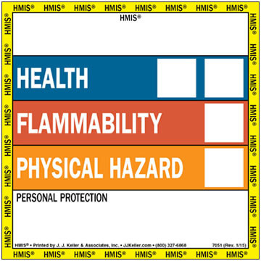
HMIS – Old Version
NFPA
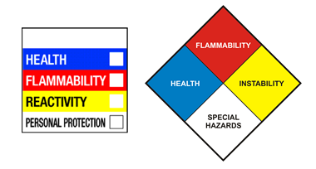
Both HMIS and NFPA labeling systems scale hazards numerically from 0 (least hazardous) to 4 (extremely hazardous). See appendix D for GHS and HMIS/NFPA information and labeling practices.

Labeling requirements are as follows:

    - The existing label on a container entering the workplace from a supplier must not be removed, altered, or defaced.
    - If a chemical is transferred to a secondary container, the new container shall have an adequate identifying label to include:

      - The identity of the chemical
      - The concentration
      - Appropriate hazard warnings (HMIS, NFPA labeling, etc.)
      - Portable containers must comply with the labeling requirements listed above if any of the following events occur:

        - The material is not used within the work shift of the individual who makes the transfer,
        - The worker who made the transfer leaves the work area,
        - The container is moved to another work area and is no longer in the possession of the worker who filled the container,

        - Labels on portable containers are not required if the worker who made the transfer uses all the contents during the work shift.

    - Flammable cabinets and cabinets containing acids and bases must be labeled appropriately.
    - Refrigerators must be labeled prohibiting food, beverage, and other consumables of the like. Labeling must also warn of hazards associated within the unit.

  - Signs and Posters

    - Emergency contact phone numbers are posted by every phone or on every door where hazardous chemicals are used or stored.
    - Signs are posted indicating the location of exits, evacuation routes, safety showers, eyewash stations, fire extinguishers, and other safety equipment if not already visible.

  - Inspection, Incident, and Training Reporting

    - Inspection reports

      - Reports must be completed and retained by the Environmental Coordinator.
      - Safety equipment must be marked to indicate the date and the results of the last inspection conducted by the lab managers or other experienced professional.
      - Records indicating the dates of repairs and regular maintenance of safety equipment are to be retained by the lab managers.

    - Training records will be retained by each department.

    - Incident reports will be completed by the Department of Public Safety.

    - Medical and Exposure records will be retained by the Wellness Center for students and HR for employees.

    - Waste disposal records will be retained by each department and the Environmental Coordinator.

  - Exposure Monitoring

    - If there is reason to believe that exposure levels for a regulated substance have exceeded the action level or permissible exposure limit, the Department of Public Safety shall ensure that the employee or student exposure to that substance is measured.
    - If a substance has an exposure monitoring requirement and if there is reason to believe that exposure levels for that substance routinely exceed the action level or in the absence of the action level, the permissible exposure level (PEL), the Department of Public Safety must be notified immediately.
    - If an employee is exposed to levels of a hazardous chemical exceeding the established PEL or TLV (threshold limit value) or shall the employee exhibit signs of symptoms of such exposure, the employee shall be provided appropriate medical treatment by contacting the Department of Public Safety.

III. Safe Work Practices

Job Hazard Assessment

A Job Hazard Analysis (or Assessment) is a technique that focuses on job tasks to identify hazards before they occur. It focuses on the relationship between the worker, the task, the tools, and the work environment. The goal is to recognize workplace hazards and eliminate or control them as early as possible to help prevent injuries and illnesses.
A JHA is required by OSHA under the following regulation:
1910.132(d) (2)
“The employer shall verify that the required workplace hazard assessment has been performed through a written certification that identifies the workplace evaluated; the person certifying that the evaluation has been performed; the date(s) of the hazard assessment; and, which identifies the document as a certification of hazard assessment.”
A Job Hazard Analysis for each task shall be completed in writing by employees and kept on file in the office of both the laboratory manager and the CHO. When completing the Job Hazard Analysis form (See appendix G for JHA instructions and report form), the following should be considered:

  - What can go wrong?
  - What are the consequences?
  - How could it arise?
  - What are other contributing factors?
  - How likely is it that the hazard will occur?

Chemical Hazard Awareness

A health hazard as defined by OSHA is “a chemical for which there is statistically significant evidence based on at least one study conducted in accordance with established scientific principles that acute or chronic health effects may occur in exposed employees. The term ‘health hazard’ includes chemicals which are carcinogens, toxic or highly toxic agents, reproductive toxins, irritants, corrosives, sensitizers, hepatotoxins, nephrotoxins, neurotoxins, agents which act on the hematopoietic system and agents which damage the lungs, skin, eyes, or mucous membranes.” Chemicals pose both health and physical hazards. To recognize these hazards, an understanding of chemical exposure, chemical ‘phases,’ associated health effects, toxicity and chemical symptoms are essential.

  - Routes of exposure:
Chemicals enter the body in the following ways:
    - Inhalation: Breathing in vapors, gas or dust in the air is the easiest and fastest means of exposure to chemical substances because these substances are readily absorbed in the respiratory tract.
    - Absorption (skin contact): The most common path for chemical exposure is on the skin or in the eyes. Skin damage may occur, and/or consequently be absorbed through the skin into the bloodstream.
    - Ingestion: Ingestion of chemical substances usually occurs accidentally or unknowingly. This can happen when chemicals have spilled or settled onto food, beverages, cigarettes, beards, or hands.
    - Injection: Though less common in most workplaces, it can occur when a sharp object (e.g., a needle) punctures the skin and injects a chemical (or virus) into the bloodstream.
    - Once chemicals have entered your body, some can move into your bloodstream and reach internal “target” organs, such as the lungs, liver, kidneys, or nervous system.

  - Chemical Phases

    - Chemicals take several phases, some more noticeable than others. They can be in the form of solids, liquids, dusts, vapors, gases, fibers, mists, and fumes.

      - Solids and liquids are easier to recognize since they can be seen.
      - Dust and mist may or may not be visible, depending upon their size and concentration.
      - Fumes, vapors, and gases are usually invisible.
  - Health Effects
    - Toxicity

Toxicity is defined as the degree to which a substance (a toxin or poison) can harm humans or animals. The toxicity of a substance is influenced by several factors but not limited to:
      - Route of exposure
      - Dose
      - Duration of exposure
      - Frequency of exposure
      - Species

    - Acute and Chronic Health Effects
Acute effects are short-term, immediate side effects from chemical exposure. They may be minor, like nose or throat irritation, or they could be serious, like eye damage or passing out from chemical vapors.
    - Chronic effects are long-term effects that arise from years of chemical exposure and are usually permanent or long term.
    - Symptoms of Chemical Exposure
The following table lists some common chemical exposure symptoms and their possible causes.

Exposure Area | Symptoms | Possible Causes
Head | Dizziness, headache | Solvents, paint, ozone, smoke (including tobacco)
Eyes | Red, watery, irritated, grainy feeling | Smoke, gases, various dusts, vapors from paint and cleaners
Nose and Throat | Sneezing, coughing, sore throat | Smoke, ozone, solvents, vapors from paint and cleaners
Chest and Lungs | Wheezing, coughing, shortness of breath, lung cancer | Metals fumes, various dusts, smoke solvents, vapors from paint and cleaners
Stomach | Nausea, vomiting, stomachache, diarrhea | Some metal fumes, solvents, paint vapors, long-term lead exposure
Skin | Redness, dryness, rash, itching, skin cancer | Solvents, chromium, nickel, detergents and cleaners, paint on skin
Nervous System | Nervousness, irritability, sleeplessness, tremors, loss of balance or coordination | Long-term solvent exposure, long-term lead exposure
Reproductive System | For men: Low sperm count, damage to sperm  For women: Irregularities in menstruation, miscarriage, damage to egg or fetus | Lead, toluene, some other solvents, ethylene oxide gas

IV. Training

Training for Employees

  - The University shall provide employees with information and training on the hazards of chemicals present in their work area.

  - The University shall provide Right-To-Know training opportunities for all laboratory employees at risk. The goal is to assure that all individuals at risk are adequately informed about the work in the laboratory, the risks, and what to do if an emergency occurs.

    - Employees shall be trained on potential biological and chemical hazards in the laboratory and on the Chemical Hygiene Plan. This training shall be provided to all employees who work in the laboratory, as well as those who are required to enter a laboratory where chemical exposure may occur.
    - Employees shall be trained in measures to protect themselves from exposure to hazardous chemicals and biological agents, including the location and proper use of protective equipment and emergency equipment.
    - All laboratory employees shall be trained to read and understand the SDS.
    - All employees shall be trained in labeling and storage procedures.

  - The training programs exhibit the following qualities:

    - Commitment to workplace safety.
    - Identifying hazards and assessing risk.
    - Development of written programs and processes. The following are some common regulations required by OSHA to have written programs.
      - Hazard Communication Program.
      - Respiratory Protection Program.
      - Personal Protective Equipment.
      - Bloodborne Pathogens Program.
    - Educating employees.
    - Investigate/report all accidents and incidents.
    - Yearly evaluations of safety processes.

Training for Students

  - Faculty shall provide a safe environment for student learning by providing safety training to students.

  - At the beginning of the term and prior to laboratory activities, class time shall be devoted to safe laboratory practices.

  - Instruction in laboratory safety shall be provided to all students enrolled in laboratory classes. Students enrolling after safety instruction have taken place shall receive instruction prior to being permitted to engage in laboratory activities.

  - The extent of student training shall be based on their course of study, the laboratory facility, University policies, the Chemical Hygiene Plan, and the level of chemical handling and potential exposure to hazardous chemicals.

  - Safety training will include the importance and the content of the label and of safety data sheets. As appropriate, the student shall also be introduced to other sources of chemical safety information.

Access to Information

  - Employees and students shall be informed of the location, availability, and content of the “Laboratory Standard” 29 CFR Part 1910 and the Chemical Hygiene Plan.

  - Employees and students shall be informed of the location, availability, and use of personal protective equipment and emergency equipment as outlined in the Chemical Hygiene Plan.

  - Employees shall know the location and availability of the SDS.

  - Medical records shall be furnished upon request within 24 hours.

V. Responsibilities

Department Chair or Dean

  - Assumes responsibility for personnel engaged in the laboratory use of hazardous chemicals.

  - Provides the CHO with the support necessary to implement and maintain the CHP.

  - After receipt of laboratory inspection report from the CHO, the laboratory supervisors meet with the CHO to discuss cited violations and to ensure timely actions to protect trained laboratory personnel and facilities and to ensure that the department remains in compliance with all applicable federal, state, university, local and departmental codes and regulations.

  - Provides budgetary arrangements to ensure the health and safety of the departmental personnel, visitors, and students.

Chemical Hygiene Officer

  - Establishes, maintains, and revises the Chemical Hygiene Plan.

  - Creates and revises safety rules and regulations.

  - Monitors procurement, use, storage, and disposal of chemicals.

  - Conducts regular inspections of the laboratories, preparation rooms, and chemical storage rooms, and submits detailed laboratory inspection reports to administration.
  - Maintains inspection and personnel training records.

  - Monitors inventory and SDS records.

  - Assists in developing and maintaining adequate facilities.

  - Seeks ways to improve the Chemical Hygiene Plan.

Laboratory Manager

  - Understands applicable environmental health and safety rules, including the contents of the CHP.
  - Identifies hazardous conditions or operations in the laboratory and notifies the CHO and other laboratory staff.

  - Collaborates with the CHO to establish SOPs and hazard assessments to effectively control or reduce hazards.

  - Ensures that all laboratory personnel that work with hazardous chemicals receive appropriate training.

  - Ensures that appropriate PPE (e.g., laboratory coats, gloves, eye protection, etc.,) and engineering control equipment (e.g., chemical fume hood, BSC) are made available, in good working order, and being used properly.

  - Actively enforces all applicable safety procedures and ensures that the CHP is followed by lab staff and all visitors.

Laboratory Staff

  - Ensure that students comply with the CHP and do not operate equipment or handle hazardous chemicals without proper training and authorization.
  - Always wear PPE that is compatible to the degree of the hazard of the chemical.
  - Follow all pertinent safety rules when working in the laboratory to set an example.
  - Review laboratory procedures for potential safety problems before assigning to students.

Students

  - Read, understand, and follow all safety rules and regulations that apply to the area.

  - Plan and conduct each operation in accordance with the institutional chemical hygiene procedures.

  - Promote good housekeeping practices in the laboratory or work area.

  - Notify the instructors of any hazardous conditions or unsafe work practices.

  - Use PPE as appropriate for each procedure that involves biological or chemical hazards.
Back to Table of Contents

End of Document

Appendices A-I

Policy on Non-Compliance

Policy on Non-Compliance
Corrective Measures
Policy
University of Detroit Mercy is responsible for upholding all federal, state, and local regulations governing the health and safety of individuals. This is a policy for responding to situations of potential non-compliance and applies to all individuals, departments, and facilities on university campuses.
The University is committed to the health and safety of the community and makes continuous efforts to recognize unsafe conditions, correct deficiencies and implement changes for the well-being of the students, staff and faculty. In the event an alleged violation is recognized, the proper authorities must be notified immediately and a Corrective Measures form must be completed upon notification. This form is to be turned in to the office of the Environmental Coordinator in the Facility Operations department.
Definitions
Non-compliance: Refers to the failure to comply with laws, regulations, organizational policies, and procedures.
Continuing non-compliance: The occurrence of the same or similar non-compliance after an appropriate corrective action has been instituted.
Serious non-compliance: The failure to comply with corrective actions once implemented and which increases health and safety risk to the community.

Procedure
- Discovery of alleged violation. This is usually through complaints, rumors, site investigations, and/or audits. This should be brought to the attention of a supervisor, faculty member, Chemical Hygiene Officer, Environmental Coordinator, etc. who will determine if the accusation warrants further investigation.
- Reporting allegations of non-compliance. Section 1 of the Corrective Measures form is to be completed and turned in to the Environmental Coordinator in the Facility Operations department for further review.
- Violation claim is investigated. The Environmental Coordinator reviews pertinent regulations and is responsible for completing the remaining sections of the Corrective Measures form.
- Determination of validity. The Environmental Coordinator determines the validity of the alleged violation claim. If no violation occurred, this is documented in detail on the Corrective Measures form and the allegation is closed. In the event the allegation is valid, the violation is determined to be either Non-compliant, Continuing, or Serious. If possible, temporary measures are put in place until a permanent solution is implemented.
- Discussion with department heads/supervisors to determine root causes, and corrective action recommendations are made and decided upon. These more likely will include:
  - Training
  - Engineering Controls
  - Administrative Controls
- Determine time frame to resolve non-compliance. A reasonable time frame is set to obtain or return to a state of compliancy. A copy of the Corrective Measures form is distributed to the Dean, Chair, and area of violation.
- Depending on seriousness, a follow-up investigation could be immediate or 3-6 months post resolution. A follow-up investigation is completed by the Environmental Coordinator and determines if the offending department remains compliant. It also determines the effectiveness of the corrective actions. Adjustments may be made at this time and documented on the Corrective Measures form.
  - The follow-up investigation may return the following results:
    - Continuing non-compliant
      - A determination of the cause will be evaluated. The initial resolution to the non-compliancy will be reassessed and corrective actions may be adjusted. This information will be documented on the Corrective Measures form. Repeat offenders will be subject to an authority above the Environmental Coordinator.
    - Serious non-compliant
      - Once initially deemed serious non-compliant and rectified with corrective actions, any follow-up investigations must pass compliancy. This information will be documented on the Corrective Measures form. Offenders will be immediately subject to an authority above the Environmental Coordinator.

Corrective Measures
Please complete section 1 of this form and submit to the Environmental Coordinator in the Facility Operations department.
Section 1
Date: ___________________ Prepared by: ____________________________________________
Contact information, Phone and/or email (optional): _____________________________________________________________
Please provide the location of the complaint in question.
Building ________________________________ Floor(s) ______ Room/Location_________________________________________________________________
Please describe situation: _________________________________________________________________________________________________________________________________________________________________________________________________________________________________________________________________________________________________________________________________________________________________________________________________________________________________________________________________________________________________________________________________________________________________________________________________________________________________________________________________________
Remaining sections to be completed by the Environmental Coordinator

Section 2
Violation Inquiry Results: ________________________________________________________________________________________________________________________________________________________________________________________________________________________________________________________________________________________________________________________________________________________________________________________________________________________________________________________________________________________________________________________________________________________________________________________________________________________________________________________________________________
□ *Inquiry shows no sign of violation.
Date: _______________ Signature:___________________________________________________
Environmental Coordinator
□ Inquiry shows the following violation: (circle)

Non-compliant
Continuing
Serious

Regulation in Violation: (circle one)

EGLE

OSHA

EPA

Other: ______________

Regulation Cited: ________________________________________________________________________________________________________________________________________________________________________________________________________________________________________________________________________________________________________________________________________________________________________________________________________________________________________________________________________________________________________________________________________________________________________________________________________________________________________________________________________________

Date ________________ Signature__________________________________________________ Environmental Coordinator
Section 3
Discussion with department. Date: ___________________
Root cause:
____________________________________________________________________________________________________________________________________________________________________________________________________________________________________________________________________________________________________________________________________________________________________________________________________________________________________________________________________________________________________________________________________________________________________________________________________________________________________________________________________________________________________________________________________________________________________________________________________________________________________________________________________________________________________________________________________________________________________________________________________________________________________________________________
Corrective actions:
____________________________________________________________________________________________________________________________________________________________________________________________________________________________________________________________________________________________________________________________________________________________________________________________________________________________________________________________________________________________________________________________________________________________________________________________________________________________________________________________________________________________________________________________________________________________________________________________________________________________________________________________________________________________________________________________________________________________________________________________________________________________________________________________
Tentative resolution date _________________

Attendance # _____ Signature_____________________________________________________
Environmental Coordinator

Print name:

1.______________________________
2.______________________________ 3.______________________________
4.______________________________
5.______________________________

Signature__________________________________
Signature__________________________________
Signature _________________________________
Signature__________________________________
Signature__________________________________

Section 4
Follow-up Date _____________________

Follow-up result: (circle)

Compliant
Non-compliant
Continuing Serious

Investigation details:
_____________________________________________________________________________________________________________________________________________________________________________________________________________________________________________________________________________________________________________________________________________________________________________________________________________________________________________________________________________________________________________________________________________________________________________________________________________________________________________________________________________________________________________________________________________________________________________________________________________________________________________________________________
Corrective action modifications, if any.
________________________________________________________________________________________________________________________________________________________________________________________________________________________________________________________________________________________________________________________________________________________________________________________________________________________________________________________________________________________________________________________________________________________________________________________________________________________________________________________________________________________________________________________________________________________________________
□ No further review necessary.
□ Further review necessary. Explain:
_______________________________________________________________________________________________________________________________________________________________________________________________________________________________________________________________________________________________________________________________________________________________________________________________________________________________________________________________________________________________________________________________________________________________________________________________________________________________________________________________________________________________________________________________________________________________________________________________________________________________________________________________________________________________________________________________________________________________________________________________________________________________________________________________

Date _________________ Signature ______________________________________________________
Environmental Coordinator

Hazardous, Universal, and Medical Waste Management Plan

Hazardous, Universal, and Medical Waste Management Plan

Purpose
The purpose of the Waste Management Plan (WMP) is to provide guidance to university personnel in hazardous and universal waste recognition and their respective disposal requirements. The University of Detroit Mercy (Detroit Mercy) aims to achieve a less hazardous and healthy environment for its students, faculty and staff through recycling and waste minimization.
Generator Status
The University of Detroit Mercy is a generator of Hazardous waste, Medical, and Universal waste.
- Hazardous waste is a waste with properties that make it potentially dangerous or harmful to human health or the environment. It includes both chemical and biological waste. Hazardous waste must be treated to both federal and state waste treatment regulations. Both federal and state hazardous waste regulations are the same in the State of Michigan.
- Universal waste is a specific hazardous waste material which, if the generator chooses, may be disposed of by alternate treatment options such as through recycling or reclamation. Since universal waste IS hazardous, if the generator chooses NOT to treat universal waste under the less stringent universal waste management practices, then it MUST be treated as a hazardous waste at a Treatment, Storage and Disposal Facility (TSDF) and all hazardous waste management requirements apply.
Hazardous Waste Generator Status
Detroit Mercy is a Small Quantity Generator (SQG) of Hazardous Waste, which generates between 100kg (220 lbs.) and 1000kg (2200 lbs.) of hazardous waste per month (accumulation to never exceed 13,200 lbs.) and is subject to, but not limited to, the following regulations:
- Part 111, Hazardous Waste Management, of the Natural Resources and Environmental Protection Act 1994 PA 451 (NREPA).
- Resource Conservation and Recovery Act at 40 CFR part 265 Subpart C.
- Land disposal restriction requirements at 40 CFR 268.
Universal Waste Generator Status
Detroit Mercy is considered a Small Quantity Generator of Universal Waste, which accumulates less than 5,000 kilograms (11,000 lbs.) total of all universal wastes at any time.
- Hazardous waste treated as Universal waste are exempt from the more stringent regulations listed above for hazardous waste.
- Universal waste is not included in the Hazardous waste generator status determinations.
- If generators choose not to dispose of these materials as universal waste, they must be disposed of as hazardous waste. However, the amount of these materials may increase the hazardous waste generator status of the facility.

- Medical Waste is regulated by the Medical Waste Regulatory Act in the State of Michigan under Public Health Code Act 368. Some medical waste can be treated for disposal in a sanitary landfill. Medical waste has a 90-day storage requirement which becomes effective at the moment waste is added to the container.
Waste Characterization
Hazardous waste generated at Detroit Mercy is collected, transported, analyzed and characterized by a certified outside company, who also provides DOT Labels, manifests (with the applicable waste treatment codes) and LDRs.
Aside from the obvious chemical and biological hazardous waste generated in the science departments, many other departments across the Detroit Mercy campuses also generate hazardous waste. Some applicable common hazardous wastes are listed in the following table.

Table 1. Typical Hazardous Wastes Generated by Small Businesses.
TYPE OF BUSINESS/PROCESS | HOW GENERATED | TYPICAL WASTES | WASTE CODES
Dry-cleaning and Laundry Plants | Commercial dry-cleaning processes | Still residues from solvent distillation, spent filter cartridges, cooked powder residue, spent solvents, unused perchloroethylene. | D001, D039, F002, F005, U210
Furniture/Wood Manufacturing and Refinishing | Wood cleaning and wax removal, refinishing/stripping, staining, painting, finishing, brush cleaning and spray brush cleaning | Ignitable wastes, toxic wastes, solvent wastes, paint wastes | D001, F001-F005
Construction | Paint preparation and painting, carpentry and floor work, other specialty contracting activities, heavy construction, wrecking and demolition, vehicle and equipment maintenance for construction activities | Ignitable wastes, toxic wastes, solvent wastes, paint wastes, used oil, acids/bases | D001, D002, F001-F005
Laboratories | Diagnostic and other laboratory testing | Spent solvents, unused reagents, reaction products, testing samples, contaminated materials | D001, D002, D002, F001-F005, U211
Vehicle Maintenance | Degreasing, rust removal, paint preparation, brush cleaning, paint removal, tank cleanout, installing lead acid batteries, oil and fluid replacement | Acids/bases, solvents, ignitable wastes, toxic wastes, paint wastes, batteries, used oil, unused cleaning chemicals | D001, D002, D006, D007, D008, D035, F001-F005, U002, U080, U134, U154, U159, U161, U220, U228, U239
Printing and Allied Industries | Plate preparation, stencil preparation for screen printing, photo processing, printing, cleanup | Acids/bases, heavy metal wastes, solvents, toxic wastes, ink, unused chemicals | D002, D006, D008, D011, D019, D035, D039, D040, D043, F001-F005, U002, U019, U043, U055, U056, U069, U080, U112, U122, U154, U159, U161, U210, U211, U220, U223, U226, U228, U239, U259, U359
Equipment Repair | Degreasing, equipment cleaning, rust removal, paint preparation, painting, paint removal, spray booth, spray guns, and brush cleaning | Acids/bases, toxic wastes, ignitable wastes, paint wastes, solvents | D001, D002, D006, D008, F001-F005
Pesticides End-Users/Application Services | Pesticide application and cleanup | Used/unused pesticides, solvent wastes, ignitable waste, contaminated soil (from spills), contaminated rinse water, empty containers | D001, F001-F005, U129, U136, P094, P123
Educational and Vocational Shops | Automobile engine and body repair, metalworking, graphic arts-plate preparation, woodworking | Ignitable wastes, solvent wastes, acids/bases, paint wastes | D001, D002, F001-F005
Photo Processing | Processing and developing negatives/prints, stabilization system cleaning | Acid regenerates, cleaners, ignitable wastes, silver | D001, D002, D007, D011
Leather Manufacturing | Hair removal, bating, soaking, tanning, buffing, and dying | Acids/bases, ignitable wastes, toxic wastes, solvent wastes, unused chemicals | D001, D002, D003, D007, D035, F001-F005, U159, U228, U220
Courtesy of the EPA “Managing Your Hazardous Waste”.

It is an environmental crime to dispose of hazardous and universal waste without proper treatment.
“An environmental crime is the intentional, knowing, reckless, or criminally negligent violation of our environmental laws and regulations. Criminal liability for environmental violations can occur at any stage in the generation, treatment, transportation and disposal of pollution. Although one important basis for criminal prosecution of these crimes is Michigan’s Natural Resources and Environmental Protection Act, criminal prosecutions for these violations may also be brought under several different parts of state and federal criminal codes.” – Michigan Environmental Crimes Handbook for Law Enforcement Personnel; State of Michigan EGLE

Universal Waste materials are different in each state. These materials are considered Universal Waste in the State of Michigan.
- Batteries (including lead acid)
- Pesticides
- Mercury containing equipment
- Lamps (also cathode ray tubes)
- Pharmaceuticals
- Consumer electronics
- Antifreeze
Most universal wastes are recycled or reclaimed including batteries, lamps, mercury containing devices, antifreeze, and electronics.
Some universal waste require disposal, such as pharmaceuticals and pesticides.
For waste to be disposed of as ‘Universal Waste’, it must not be mixed with any other waste. Similarly, hazardous waste must never be mixed with any other waste. Once hazardous waste has been mixed with other materials, whether waste or not, the whole lot is considered hazardous and must be disposed of by the more stringent hazardous waste regulations.
Medical Waste includes the following:
- Sharps (needles, syringes, scalpels, tubing with needle attached.)
- Cultures and stocks (lab waste, biological production waste, live/attenuated vaccines, culture dishes, and related devices.)
- Pathological waste (human organs, tissues, body parts other than teeth, products of conception, or fluids removed during trauma or other surgical procedure, and not fixed in formaldehyde.)
- Liquid human and animal waste, including blood and blood products and body fluids, but not including urine or materials stained with blood or body fluids.
- Contaminated wastes from animals that have been exposed to agents infectious to humans, these being primarily research animals.
Container and Storage Requirements
Hazardous waste
- A SQG may accumulate as much as 55 gallons of non-acute hazardous waste and/or either one quart of liquid acute hazardous waste or 1 kg (2.2 lbs.) of solid acute hazardous waste in containers at or near any point of generation (Satellite Accumulation Area; SAA).
- Once the 55-gallon limit has been accumulated in the SAA, the generator has 3 days to remove the excess waste from the SAA to the Central Accumulation Area (CAA). If no CAA exists, the waste must be disposed of at a TSDF within 3 days of reaching the 55-gallon limit.
- Accumulated hazardous waste may be kept on-site up to 180 days in a Central Accumulation Area for a SQG. The total amount of accumulated waste must not exceed 13,200 lbs. (6,000 kg).
- Labeling requirements in the SAA and CAA:
  - A generator must label its containers in a SAA with the following:
    - The words “Hazardous Waste” or in case of medical waste, “Biological Waste”.
    - An indication of the hazards of the contents (for example, an HMIS or NFPA label. See appendix D of the Chemical Hygiene Plan for labeling information.)
  - Once the 55 gal limit in the SAA has been reached, this date is added to the container label.
  - The date the waste is added to the CAA is also added to the label. This date is the starting accumulation date at the CAA and the 180-day disposal requirement begins.
Universal Waste
- A SQG of Universal waste may accumulate this waste for up to 1 year from generation or receiving from another handler, but not to exceed 11,000 pounds of universal waste at any one time.
- Generator must manage universal waste to avoid release and are prohibited from disposing, diluting or treating universal waste.
- Containers must be kept closed (except for consumer electronics).
- Containers and storage areas must meet individual universal waste type labeling requirements.
- The SQG must demonstrate accumulation time. The following are recommended methods:
  - Place universal waste in designated accumulation area dated with the earliest date that the waste was placed in the area.
  - Maintain on-site inventory/tracking system identifying the date the waste was discarded/received and shipped.
  - Label each item with the date discarded/received.
- Universal Waste Labeling Requirements
  - The container must be labeled with the type of waste, options include the following:
    - “Universal Used Batteries”
    - “Used Antifreeze”
  - The date the container was first put into service, or one of the other methods listed above for demonstrating accumulation time.
  - Labels that warn and/or prohibit the mixing of waste.
Medical Waste
Detroit Mercy does not incinerate medical waste therefore section 13810 of the Public Health code does not apply. Methods listed below, other than autoclaving, are performed by a certified medical waste disposal service.
- Cultures and stocks of material contaminated with an infectious agent will be stored in closed, puncture-resistant containers, decontaminated by autoclaving or incineration, and disposed of in a sanitary landfill.
- Blood and blood products and body fluids shall be disposed of by 1 or more of the following methods:
  - Flushing down a sanitary sewer.
  - Decontaminating by autoclaving or incineration.
  - Solidifying.
  - If not in liquid form, transferring to a sanitary landfill.
- Pathological waste shall be disposed of by 1 or more of the following methods:
  - Incineration or cremation.
  - Grinding and flushing into a sanitary sewer.
  - Burial in a cemetery, if transported in leak-proof containers of sufficient integrity to prevent rupture.
  - Grinding until rendered unrecognizable, stored in closed, puncture-resistant, properly labeled containers, and, if not in liquid form, disposed of in a sanitary landfill.
- Sharps are to be disposed of by 1 of the following methods:
  - Placement in rigid, puncture-resistant containers that are appropriately labeled and transported to a sanitary landfill in a manner that retains the integrity of the container.
  - Incineration or decontamination and grinding that renders the objects unrecognizable. Ground sharps shall be placed in a sealed, rupture-resistant container and transported to a sanitary landfill.
- Animal waste contaminated with organisms infectious to humans shall be disposed of by incineration or by burial in a sanitary landfill in properly labeled, double containers that are leak-proof and puncture-resistant and are tightly sealed to prevent escape of fluids or material. Contaminated animal organs disposed of separately shall be rendered unrecognizable.

- Medical waste packaging requirements:
  - Sharps that are not ground or incinerated are to be disposed of in individual leak-proof, rigid, puncture-resistant containers that are secured to prevent release of contents. Sharps shall not be compacted or handled in a manner that can result in breakage of sharps container.
    - Labeling
      - Containers containing sharps are to be labeled “Sharps” in letters not less than 1 inch and a biohazard symbol.
  - Medical waste other than sharps are to be contained in bags (other than body pouches) or other containers that are impervious to moisture and have a strength sufficient to resist ripping, tearing, breaking, or bursting under normal conditions of usage or handling. The bags or containers shall be secured to prevent leakage during storage, handling, or transport.
    - Labeling
      - Bags and containers are to be labeled with the biohazard symbol or the words “medical waste” or “pathological waste” in letters not less than 1 inch.
  - Do not compact or mix medical waste with other waste materials before decontamination, incineration, and disposal.
  - If decontaminated waste is mixed with other solid wastes, clearly label the container to indicate that it contains decontaminated waste.
    - Label “Contains Decontaminated Waste”.

- Medical waste storage requirements
  - Medical waste is not to be stored on the premises of a producing facility for more than 90 days.
  - Medical waste is not to be accumulated and kept on-site in excess of 5000 pounds at any one time.
Important note: The medical waste information contained in this document is for reference and guidance only. It does not contain the information required of a medical waste management plan required under the Public Health Code, Act 368 of 1978, section 13817.
Waste Disposal Guidance
If your department generates any of the processing wastes from Table 1 or any of the Universal Wastes, or if you are unsure, please contact the Environmental Coordinator for proper waste management and disposal requirements.
Phone: (313) 993-1240
Email: facilityoperations@udmercy.edu

Personal Protective Equipment

Personal Protective Equipment

PPE (Personal Protective Equipment) is the final barrier against workplace hazards, behind engineering controls and administrative controls.

Before beginning a task:
- Make sure proper and functional engineering controls are in place.
- Consider the hazards of the task and determine safe practices. Assess that administrative controls have been updated or inspected regularly.
PPE is the last line of defense from hazards and is not to be the sole practice or control utilized for safety purposes.
OSHA 29 CFR 1910.132
Protective equipment, including personal protective equipment for eyes, face, head, and extremities, protective clothing, respiratory devices, and protective shields and barriers, shall be provided, used, and maintained in a sanitary and reliable condition wherever it is necessary by reason of hazards of processes or environment, chemical hazards, radiological hazards, or mechanical irritants encountered in a manner capable of causing injury or impairment in the function of any part of the body through absorption, inhalation, or physical contact.

OSHA 29 CFR 1910.132(d)(2)
The employer shall verify that the required workplace hazard assessment has been performed through a written certification that identifies the workplace evaluated; the person certifying that the evaluation has been performed; the date(s) of the hazard assessment; and, which identifies the document as a certification of hazard assessment.

Employers are required to train each employee who must use PPE on the following:
1. When PPE is necessary.
2. What PPE is necessary?
3. How to properly put on, take off, adjust and wear the PPE.
4. The limitations of the PPE.
5. Proper care, maintenance, useful life, and disposal of PPE.
PPE must be sized properly to prevent tripping, tearing, seam parting, or restricting worker movement.

Body Protection
Body protection includes those materials that protect the torso and extremities from dermal contact. They include full body suits, lab aprons, and lab coats. They also include hand, foot, face, and head protection which are discussed in other sections of this document.
Protective clothing is to be used when the following hazards are present:
Hazard | Protective Clothing
Chemical | - A variety of clothing, including lab coats and disposable body suits, made from neoprene, nylon, vinyl, polyvinyl chloride (PVC), and plastic materials protect from a variety of chemical splash hazards and contamination.  - Contact a provider who specializes in laboratory equipment and PPE to determine which material is best for the job.
Thermal | - Thermal PPE protects from heat stress, frostbite, and hypothermia due to temperature extremes.  - Some PPE examples include aluminum-based protection and heavy duty Kevlar.
Cut or Puncture | Slash resistant clothing is rated off of ISO 13997:1999 cut resistance levels, which range from Level 1 (minimal) to Level 5 (maximum) protection.  - The test determines resistance to cutting by sharp edges, such as knives, sheet metal parts, swarf, glass, bladed tools and castings.  - This test does not provide data on the resistance to penetration by pointed objects such as needles and thorns.  Minimal protection from puncture hazards is a concern with all types of PPE.  - Assess the hazards of the task, and with this knowledge contact a reputable PPE provider for advice on the correct PPE necessary to safely complete the job.  - Safe work practices may be the top protection depending on the task. Discuss with a supervisor or employee before beginning the job.  - Sturdy foot protection protects from falling sharp objects and step-on hazards such as nails.  - Mesh gloves and cut-resistance arm sleeves can provide protection when using cutting equipment.
Electrical/Flammability | - PPE for the electric power industry generally includes safety glasses, face shields, hard hats, safety shoes, insulating (rubber) gloves with leather protectors, insulating sleeves, and flame-resistant clothing (FRC).  Flame Resistant Clothing (FRC) will self-extinguish, therefore limiting the injury.  - Fabrics may be natural or synthetic.  - Designed to limit (not eliminate) burn injury.  - Flame resistance must be durable to launderings, wear, the environment, etc. for the service life of the garment  - FRC should be appropriate to hazard.  - Always the outermost layer.  - Worn correctly; zipped, buttoned, etc.  - All natural, non-melting undergarments.  - Clean, no flammable contaminants.  - Repaired correctly and removed from service when needed.  - FRC can also be necessary for electrical work. Such clothing protects from the effects of Arc Flash.  - Such FRC must have an “arc rating” or “arc thermal performance value (ATPV)” listed on the labeling.
Vibration | - Vibration-dampening PPE should be used when using vibrating tools (such as needle guns, grinders, chipping hammers).  - Vibration-dampening PPE can prevent nerve or tendon damage caused by exposure to vibrating equipment.

Hand Protection
Gloves shall be used anytime there is risk of chemical contact, infectious material is handled, or when there is a risk of flying debris and/or laceration. Gloves are made from a variety of materials and not all gloves protect from the same hazards equitably. The following is an overview of glove types and the protection they provide.
General Gloves for the Workplace
Type/Material of Glove | Hazard Protection
Metal Mesh, Leather, or Canvas Gloves | - Cuts and burns.  - Thick Leather/Canvas protect from sustained heat.  - Leather protects against sparks, moderate heat, blows, chips and rough objects.
Fabric Gloves | - Dirt, slivers, chafing and abrasions.  - NOT sufficient for use with rough, sharp or heavy materials.  - Plastic coating will strengthen fabric gloves, offering slip resistant qualities used for handling bricks and wire to chemical laboratory containers.
Aramid Fiber Gloves | - Heat and cold  - Cut and abrasive-resistant.  - Wears well.
Aluminized Gloves | - Reflective and insulating against heat; requires an insert to protect against heat and cold.

Common Gloves Used for Chemical Protection
Butyl Rubber Gloves | - HNO₃, H₂SO₄, HCL, Red Fuming HNO₃, rocket fuels, and peroxide.  - Resists oxidation and ozone corruption  - Resists abrasion and remains flexible at low temperatures
Natural Latex* or Rubber Gloves | - Comfortable and pliable  - Resists abrasions by sandblasting, grinding, and polishing.  - Protects from most water solutions of acids, alkalis, salts, and ketones.
Neoprene Gloves | - Good pliability, finger dexterity, high density, and tear resistance.  - Protects from hydraulic fluids, gasoline, alcohols, organic acids, and alkalis.
Nitrile Rubber Gloves | - Protects from chlorinated solvents such as TCE and PCE.  - Resists abrasion, puncturing, snagging, and tearing.
*Hypoallergenic gloves, glove liners, and powderless gloves are possible alternatives for those allergic to latex.
Most gloves protect from incidental hazards only and must be disposed of and replaced once chemical contact has been made.
Glove Selection:
Utilize both the SDS of each chemical involved and the glove provider for special information (such as extended use, incidental contact or specific-use) to select the correct glove for the task.
Check the website of the glove brand for:
- Chemical compatibility
- Permeation information
- Limitations of the glove material
- Care and maintenance of the gloves.

Each brand provides chemical compatibility that is specific to the gloves they provide; therefore, only the brand of the glove purchased shall be consulted for this information.

PPE contaminated by incidental exposure (i.e., to students) of certain chemicals may be disposed of in a sanitary landfill. All gloves contaminated by RCRA-regulated chemical materials or infectious substances shall be disposed of according to Michigan’s Hazardous Waste regulations and the *EGLE’s Medical Waste Disposal Act.

Eye and Face Protection
Eye and face PPE provide protection from flying or falling objects or sparks striking the eye and can cause serious injury such as punctures, abrasions, and contusions. They also provide protection from chemical splashes, from which eye damage or dermal burns could occur. Eye and face PPE shall meet ANSI requirements.
- Safety Spectacles are intended to shield the wearer’s eyes from impact hazards such as flying fragments, objects, large chips, and particles. Frames are constructed of metal and/or plastic and can be fitted with corrective lenses. Frames must have side shields when there is a hazard from flying objects.
- Safety goggles are intended to shield the wearer's eyes from impact hazards such as flying fragments, objects, large chips, and particles. Goggles fit the face immediately surrounding the eyes and form a protective seal around the eyes. This prevents objects from entering under or around the goggles. These also provide optimal protection from chemical splash hazards. Some may fit around corrective lenses.
- Face shields are intended to protect the entire face or portions of it from impact hazards such as flying fragments, objects, large chips, and particles. When worn alone, face shields do not protect employees from impact hazards. Use face shields in combination with safety spectacles or goggles, for additional protection.
- Laser Safety Goggles are intended for laser work and similar operations that create intense concentrations of heat, ultraviolet, infrared, and reflected light radiation. A laser beam, of sufficient power, can produce intensities greater than those experienced when looking directly at the sun. Unprotected laser exposure may result in eye injuries including retinal burns, cataracts, and permanent blindness. When lasers produce invisible ultraviolet, or other radiation, both employees and visitors are to use appropriate eye protection at all times.
  - Determine the maximum power density, or intensity, lasers produce when workers are exposed to laser beams. (This can be found either on the equipment source or manuals, or contact the provider with part numbers.)

  - Based with this knowledge, select lenses that protect against the maximum intensity. The selection of laser protection depends upon the lasers in use and the operating conditions. Workers with exposure to laser beams must be furnished suitable laser protection.

The ANSI Z87.1 standard requires efficient and easy-to-understand lens & frame markings. These markings help make the selection process simpler and increases compliance. Those product markings indicate ratings in the following areas:
  - Impact: “Z87+” indicates high-velocity impact, and “Z87” alone means basic impact
  - Splash and droplet: D3 for splash/droplet and D4 for dust
  - Fine dust: D5
  - Welding: W plus the shade number
  - UV: U plus the scale number
  - Infrared light: R plus the scale number
  - Visible light filter: L plus the scale number
  - Prescription: Z87-2 on the front of the frame and on both temples
  - Head size: H indicates products designed for smaller head sizes
  - Other: V for photochromic and S for special lens tint
All safety markings for ANSI Z87.1-2015 safety eyewear must be permanently and clearly marked on the frame or lens. This marking requirement includes goggles and face shields as well as safety glasses.

Foot and Leg Protection
Protective footwear protects from the dangers of foot injuries. These include:
  - Falling or rolling objects
  - Objects piercing the sole
  - Electrical hazards, such as static-discharge or electric shock
  - Slip hazards
  - Hot substances
  - Corrosive or poisonous materials

Protective footwear must comply with the following standards:

  - ANSI Z41-1999
  - ASTM F-2412-2005 and ASTM F-2413-2005

- Leggings protect the lower legs and feet from heat hazards such as molten metal or welding sparks. Safety snaps allow leggings to be removed quickly.

- Metatarsal guards protect the instep area from impact and compression. Made of aluminum, steel, fiber or plastic, these guards may be strapped to the outside of shoes.

- Toe guards fit over the toes of regular shoes to protect the toes from impact and compression hazards. They may be made of steel, aluminum, or plastic.

- Combination foot and shin guards protect the lower legs and feet, and may be used in combination with toe guards when greater protection is needed.

- Safety shoes have impact-resistant toes and heat-resistant soles that protect the feet against hot work surfaces common in roofing, paving, and hot metal industries. The metal insoles of some safety shoes protect against puncture wounds. Safety shoes may also be designed to be electrically conductive to prevent the buildup of static electricity in areas with the potential for explosive atmospheres or nonconductive to protect employees from workplace electrical hazards.

Safety footwear is to be inspected prior to each use and replaced upon evidence of excess wear such as cracks or holes, separation of materials, broken buckles or laces. Check the soles of the shoes for embedded items that could present electrical or tripping hazards. Employees are to follow the manufacturer’s recommendations for cleaning and maintenance of protective footwear.

Hearing Protection

Employee exposure to excessive noise depends upon a number of factors, including:

- The loudness of the noise as measured in decibels (dB).
- The duration of each employee’s exposure to the noise.
- Whether employees move between work areas with different noise levels.
- Whether noise is generated from one or multiple sources.

Generally, the louder the noise, the shorter the exposure time before hearing protection is required.

Hearing protectors reduce only the amount of noise that gets through to the ears. The amount of this reduction is referred to as attenuation, which differs according to the type of hearing protection used and how well it fits.

Some types of hearing protection include:
- Single-use earplugs are made of waxed cotton, foam, silicone rubber, or fiberglass wool. They are self-forming and, when properly inserted, they work as well as most molded earplugs.
- Pre-formed or molded earplugs must be individually fitted by a professional and can be disposable or reusable. Reusable plugs are to be cleaned after each use.
- Earmuffs require a perfect seal around the ear. Glasses, facial hair, long hair, or facial movements such as chewing may reduce the protective value of earmuffs.
Permissible Noise Exposure
Duration per day, in hours | Sound level in dB*
8 | 90
6 | 92
4 | 95
3 | 97
2 | 100
1 ½ | 102
1 | 105
½ | 110
¼ or less | 115

Hearing protectors worn by employees must reduce an employee’s noise exposure to within the acceptable limits noted in Table 1.

*When measured on the A scale of a standard sound level meter at slow response.

Table 1
Head Protection

Wearing a safety helmet or hard hat is one of the easiest ways to protect an employee’s head from injury. A head injury can impair someone’s life or can be outright fatal. It is the employer’s responsibility to ensure that their employees wear head protection if any of the following conditions exist:

- Objects might fall from above and strike them on the head.
- They might bump their heads against fixed objects, such as exposed pipes or beams.
- There is a possibility of accidental head contact with electrical hazards.

Hard hats must be worn with the bill forward to protect employees properly. Hard hats must have a hard outer shell and a shock-absorbing lining that incorporates a headband and straps that suspend the shell from 1 to 1 ¼ inches (2.54 cm to 3.18 cm) away from the head. This type of design provides shock absorption during an impact and ventilation during normal wear. In addition, each hat is to bear a label inside the shell that lists the manufacturer, the ANSI designation, and the class of the hat.

Worn properly, a protective helmet or hard hat should do the following:

- Resist penetration by objects.
- Absorb the shock of a blow.
- Be water-resistant and slow burning.
- Have clear instructions explaining proper adjustment and replacement of the suspension and headband.
Hard hats are divided into three industrial classes:

Class A hard hats provide impact and penetration resistance along with limited voltage protection (up to 2,200 volts).

Class B hard hats provide the highest level of protection against electrical hazards, with high-voltage shock and burn protection (up to 20,000 volts). They also provide protection from impact and penetration hazards by flying/falling objects.

Class C hard hats provide lightweight comfort and impact protection but offer no protection from electrical hazards.

Periodic cleaning and inspection will extend the useful life of protective headgear.

Do not store protective headgear in direct sunlight, e.g., on the rear window shelf of a car, as sunlight and extreme heat can damage them.

Hard hats with any of the following defects are to be removed from service and replaced:
- Perforation, cracking, or deformity of the brim or shell.
- Indication of exposure of the brim or shell to heat, chemicals, ultraviolet light, and other radiation (in addition to a loss of surface gloss; such signs include chalking or flaking).

Always replace a hard hat if it sustains an impact, even if damage is not noticeable. Suspension systems are offered as replacement parts and are to be replaced when damaged or when excessive wear is noticed. It is not necessary to replace the entire hard hat when deterioration or tears of the suspension systems are noticed.
Respirator Protection

Respirators protect the user in two basic ways.

- The first is by the removal of contaminants from the air. Respirators of this type include particulate respirators which filter out airborne particles, powered air-purifying respirators (PAPRs), and air-purifying respirators (APRs) with cartridges/canisters which filter out chemicals and gases.

- Other respirators protect by supplying clean air from another source. Respirators that fall into this category include:

- Airline respirators, which use compressed air from a remote source.
- Self-contained breathing apparatuses (SCBA), which include their own air supply.
- Escape respirators, escape hoods, or escape masks are designed to protect against breathing harmful gases, vapors, fumes, and dusts for a limited amount of time in an emergency situation.

Each type of respirator has specific uses and limitations and should not be substituted for another. Supplied air respirators, such as an SCBA, are be used in an unknown or above IDLH hazard environments. Air filtering respirators, such as an APR or PAPR, are only to be used when the hazard has been identified and is below the IDLH value.

APR
- Air-purifying respirators contain a filter, cartridge, or canister that removes specific air contaminants by filtering, adsorbing, absorbing, or chemical reaction with the contaminants as they pass through the respirator canister or cartridge.

- Since APRs do not supply oxygen, they must only be used when the surrounding atmosphere contains sufficient oxygen (19.5 % to 23.5 % by volume) to sustain life, and the air contaminant level is below the concentration limits of the APR.

- APRs are also known as gas masks because they filter or clean chemical gases out of the air. Gas masks are effective only if used with the correct cartridge or filter (these terms are often used interchangeably) for a particular biological or chemical substance. There are cartridges available that protect against more than one hazard, but there is no "all-in-one" cartridge that protects against all substances. It is important to know what hazards you will face in order to be certain you are choosing the right filters/cartridges.

- All cartridges are assigned a color designating the contaminate they filter.
Contaminate | Color Coding on Cartridge/Canister
Acid gases | White
Hydrocyanic acid gas | White with ½” green stripe completely around canister near the bottom
Chlorine gas | White with ½” yellow stripe completely around canister near the bottom
Organic vapors | Black
Ammonia gas | Green
Acid gases & ammonia gas | Green with 1/2 inch white stripe completely around the canister near the bottom.
Carbon monoxide | Blue
Acid gases & organic vapors | Yellow
Hydrocyanic acid gas & chloropicrin vapor | Yellow with 1/2 inch blue stripe completely around the canister near the bottom
Acid gases, organic vapors, & ammonia gas | Brown
Radioactive materials, except tritium & noble gases | Purple (Magenta)
Pesticides | Organic vapor canister plus a particulate filter
Multi-contaminated & CBRN agents | Olive
Any particulates – P100 | Purple
Any Particulates – P95, P99, R95, R99, R100 | Orange
Any Particulates free of oil – N95, N99, or N100 | Teal

PAPR
- A PAPR is an APR that uses battery power and a blower to force ambient atmosphere through air purifying elements (filter) to an inlet covering.

- The components of a PAPR include a respiratory face piece; a helmet, hood, or blouse; a blower unit with a blower to draw air into the unit through the air inlet and to deliver air to the air outlet; a holder to contain the blower unit; a detachable filter cartridge connected to the air inlet of the blower unit; and a detachable breathing tube connected at one end to the air outlet of the blower unit and connected at the other end to the respiratory mask.

SCBA
- An atmosphere supplying respirator provides clean breathing air from an uncontaminated source, independent of the surrounding atmosphere rather than removing contaminants from the atmosphere.

- A SCBA is an open-circuit atmosphere-supplying respirator that provides breathing air from a cylinder of very pure, dry compressed air, which is held in a frame that is worn on the back.

Escape Respirators
- Escape respirators can be designed as an air-purifying escape respirator (APER) or an SCBA type respirator.

- The SCBA type escape respirator has a hood that provides a barrier against contaminated outside air and an attached source of breathing air. The APER has a filter canister mounted on the hood to filter out harmful contaminants before the air is breathed.

Labeling and Inspection Tag

Labeling and Inspection Tags
This appendix discusses the different labeling formats (HMIS, NFPA, and GHS) required for workplace safety, and also includes examples of inspection tags and other miscellaneous container labels. This appendix shall be used by employees when labeling is required for secondary containers or when an existing label has been defaced or has become illegible, inaccurate or outdated.

- Hazardous Materials Information System (HMIS)
HMIS labels are in bar format and color-coded
- Blue = health hazard
- Red = flammability
- Orange (or yellow) = physical hazard
- White = Personal Protection.

The number ratings range from 0-4 and symbols/letters are used to convey specific hazards.
An explanation for the HMIS ratings is as follows:

Health (Blue) - The Health section conveys the health hazards of the material. In the latest version of HMIS, the Health bar has two check boxes, one for an asterisk and one for a numeric hazard rating. If present, the asterisk signifies a chronic health hazard, meaning that long-term exposure to the material could cause a long term health problem or organ damage.
Past versions of HMIS had only one box for each Health, Flammability, and Reactivity (recently updated to Physical Hazard

0- Minimal Hazard - No significant risk to health
1- Slight Hazard - Irritation or minor reversible injury possible
2- Moderate Hazard - Temporary or minor injury may occur
3- Serious Hazard - Major injury likely unless prompt action is taken and medical treatment is given
4- Severe Hazard - Life-threatening, major or permanent damage may result from single or repeated exposure

Flammability (Red) - Flammability criteria are defined according to OSHA standards. Past HMIS standards were reflective of NFPA standards.
0- Minimal Hazard - Nonflammable solid, liquid or gas.
1- Slight Hazard - Flash point >200ºF (93°C)
2- Moderate Hazard - Flash point ≥100ºF (38°C) and <200ºF (93°C)
3- Serious Hazard - Flash points <73ºF (23°C), Boiling points >100ºF (38°C)
4- Severe Hazard - Flash points <73ºF (23°C), Boiling points <100ºF (38°C)

Physical Hazards (Orange) or Reactivity* (Yellow) –Reactivity hazards are based on the OSHA criterion of physical hazard.
Seven such hazard classes are recognized:

- Water Reactive
- Organic Peroxides
- Compressed gases
- Pyrophoric material
- Explosive
- Oxidizers
- Unstable Reactive
There are 3 versions of HMIS.
In the most current version of HMIS, the Orange section (titled Physical Hazards) replaces the yellow section (titled Reactivity) used in previous versions.
You may still use past versions of HMIS, however, OSHA recommends converting to the new version when the opportunity arises.

0- Minimal Hazard - Materials that are normally stable; material does not react with water.
1- Slight Hazard - Normally stable material which can become unstable at high temperature and pressure.
2- Moderate Hazard - Unstable materials that, at ambient temperature and pressure, may undergo a violent chemical reaction. Risk of detonation low. May be water reactive and/or form peroxides when exposed to air.
3- Serious Hazard - May become explosive when mixed with water without ignition source. Detonation or explosive reaction is possible in the presence of a strong igniting source. Capable of chemical change at normal temperature and pressure with moderate risk of explosion.
4- Severe Hazard - Materials that are readily capable of explosive water reaction, detonation or explosive decomposition, polymerization, or self-reaction at normal temperature and pressure.

Personal Protection (White) - HMIS indicates what personal protective equipment (PPE) should be used when working with the material. This is the largest difference between HMIS and NFPA labeling systems, as NFPA uses the white section to convey special hazards (as described in the part 2).
Reference the code system below when creating labels.
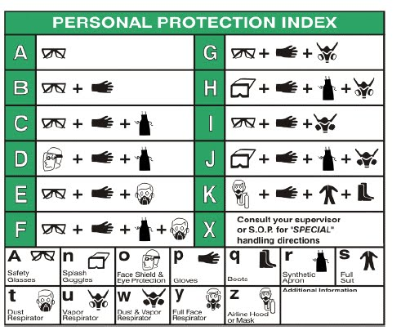

- National Fire Protection Association (NFPA)
The NFPA Fire Diamond labels provide an appropriate signal or alert for the protection of emergency response personnel, and assist in planning for effective fire and emergency control operations, including cleanup.

The system is characterized by the "diamond," and it identifies the hazards of a material and the degree of severity.
Hazard severity ranges from zero (0) indicating a minimal hazard, to four (4) indicating a severe hazard.
Each hazard is color‐coded as follows: blue for health, red for flammability, yellow for instability, and white for special hazards. The shades of red, blue and yellow are not regulated, but should be contrasting colors. An explanation of the NFPA ratings is as follows:
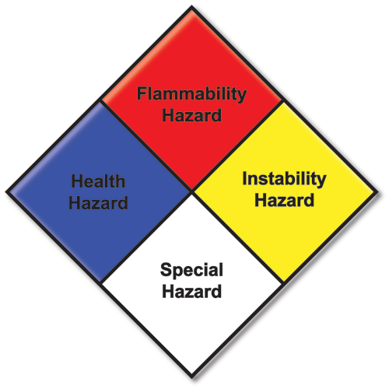

Health Hazard (Blue)
0- Minimal Hazard - No precautions necessary.
1- Slight Hazard - Breathing apparatus may be worn.
2- Moderate Hazard - Breathing apparatus and face mask must be worn.
3- Serious Hazard - Toxic, full protective suit and breathing apparatus should be worn.
4- Extreme Hazard - Highly toxic, may be fatal on short-term exposure.
Flammability Hazard (Red)
0- Minimal Hazard - Will not burn under normal conditions.
1- Slight Hazard - Slightly combustible, requires strong heating to ignite.
2- Moderate Hazard - Combustible, requires moderate heating to ignite, flash point below 200ºF.
3- Serious Hazard - Flammable, flash point 73ºF to 100ºF.
4- Extreme Hazard - Extremely flammable gas or liquid, flash point below 73ºF.
Instability Hazard (Yellow)
0- Minimal Hazard - Normally stable, does not reach with water.
1- Slight Hazard - May react if heated or mixed with water.
2- Moderate Hazard - Unstable, may react with water.
3- Serious Hazard - May detonate if shocked or heated under confinement or mixed with water.
4- Extreme Hazard - Explosive at room temperature.
Specific Hazard (White)
The only authorized symbols are the W, OX, and SA symbols. The number of symbols is kept to a minimum for emergency visibility and simplicity reasons.
W – Unusual reactivity with water; use caution with water.
OX – Oxidizer
SA – Asphyxiant
Other Common Symbols:

ACID – Acid
ALK – Alkali
COR – Corrosive
☢ – Radiation

Additional symbols such as "COR" for corrosive or "ACID" for acids are unnecessary since these hazards are already taken into account in the blue health section of the label. However, these symbols and a couple extra symbols have become mainstream.

- Global Harmonization Standard (GHS) or HazCom 2012
OSHA has adopted new hazardous chemical labeling requirements as a part of its recent revision of the Hazard Communication Standard, 29 CFR 1910.1200 (HCS), bringing it into alignment with the United Nations’ Globally Harmonized System of Classification and Labelling of Chemicals (GHS). The revised standard requires that information about chemical hazards be conveyed on labels using quick visual notations to alert the user, providing immediate recognition of the hazards. Labels must also provide instructions on how to handle the chemical so that chemical users are informed about how to protect themselves.
GHS labels must have these six key elements:
1. Signal Word: The signal word indicates the hazard level. There are only two:
"Danger" = most severe instances
"Warning" = less severe
2. GHS Symbols (Hazard Pictograms): These are used to identify hazardous products and are commonly grouped by:
a. Chemical/physical risk
b. Health risk
c. Environmental risk
3. Manufacturer Information. This identifies the manufacturer's company name, address and telephone number.
4. Precautionary Statements/First Aid: These are phrases that are tied to each hazard statement. They describe general preventive, response, storage, or disposal precautions. These statements will be found on the chemical's Safety Data Sheet. Precautionary Statements will be identified by a P-Code.
5. Hazard Statements: These are phrases that describe the nature of hazardous products and the degree of hazard. Hazard statements should be found on the chemical's Safety Data Sheet (SDS) and identified by an H-Code (like H100).
6. Product Name or Identifiers: Simply identifies the product or chemical name. Additional identifiers can be noted to the right of the Manufacturer's information (#1).
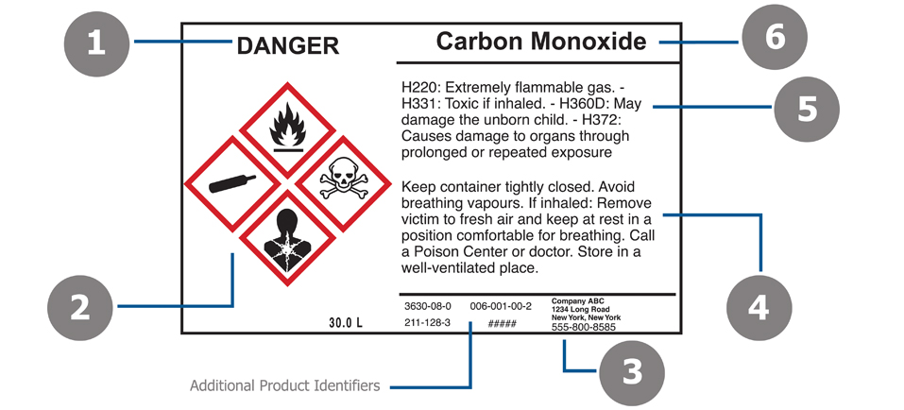
The biggest difference between HMIS/NFPA and GHS is the hazard ratings. For GHS, the hazard rating determines the information provided in items 1, 2, 4 and 5 on the label above. While HMIS/NFPA is rated 0 to 4, lowest hazard to highest respectively, the GHS ratings are 1-5 with 1 being the highest hazard and 5 being the lowest.

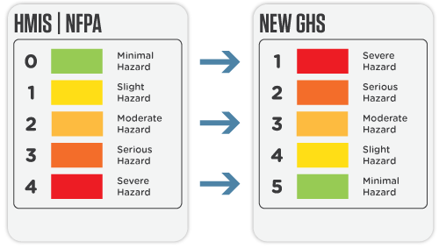
Do NOT mix these up. It is recommended to follow one labeling scheme or the other. Do not intermix labeling systems.

GHS pictograms are symbols with red diamond borders that are designed to provide hazard information to handlers of chemicals universally at a glance.
GHS pictograms
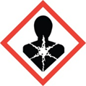  Health Hazard  May cause serious and prolonged health effects on short or long term exposure such as reproductive toxicity, mutagenicity, and target organ toxicity. | 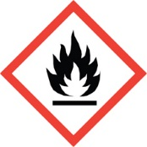Oxidizers  Flammables. Pyrophorics. Self-heating.Emits flammable gas. Self-reactives, Organic peroxides. | 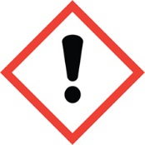  Irritant  Skin and eyes irritant. Skin sensitizer. Acute toxicity. Narcotic effects. Respiratory tract irritant. Hazardous to ozone layer.
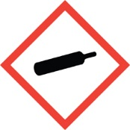  Gas Cylinder  Gases under pressure. Gas released may be very cold. Gas container may explode if heated. | 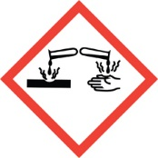Corrosives  Corrosive to metals. May cause skin damage and permanent eye damage. | 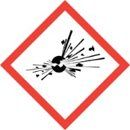Explosives  May explode if exposed to fire, heat, shock, and/or friction. May be self-reactive and/or organic peroxides.
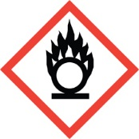Oxidizers  Oxidizers. Can burn without air, or can intensify fire in combustible materials. | 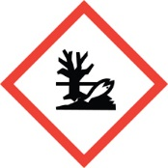Environmental Hazard  Aquatic toxicity. May cause long lasting effects on the environment. | 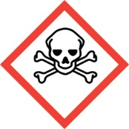  Toxic  Toxic material which may cause life threatening effects even in small amounts and with short exposure.

- Miscellaneous
Inspection Tags
Inspection tags include the date of the inspection, initials of inspector and a comment/remark section, either by an additional comments section/tag or repair tag. Tags must noticeably convey any damage or needed repairs. Tags must not be removed from equipment.
The following are examples of acceptable tags. image source 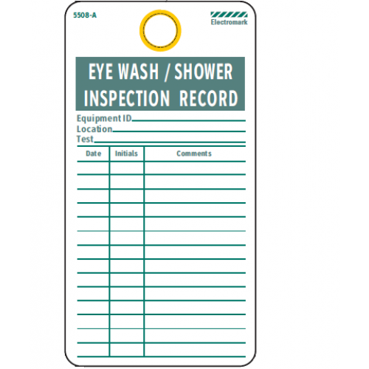

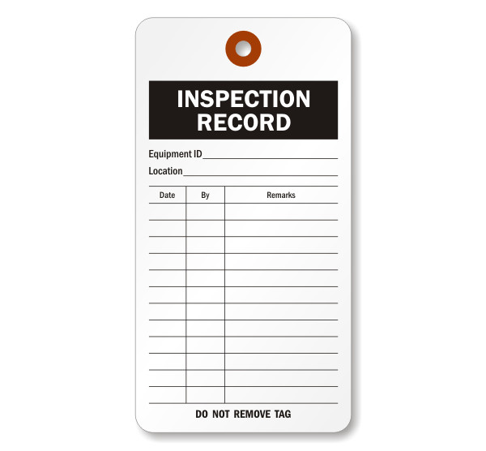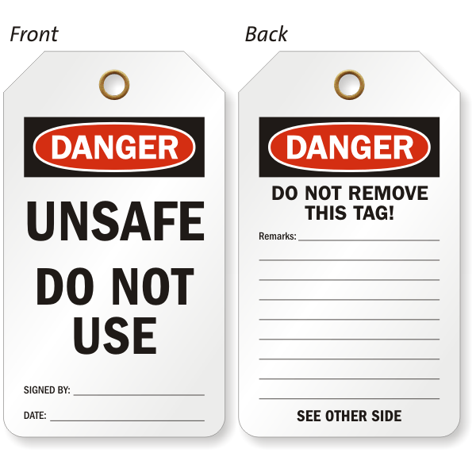
Container Labeling

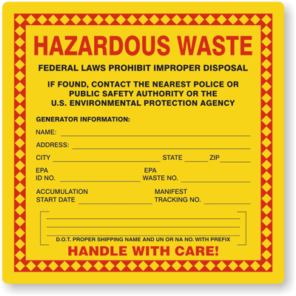

Containers containing hazardous waste must clearly state “Hazardous Waste” and must include the State and Federal Law prohibiting improper disposal. Labels must be clearly visible, with either penned or typed information, indicating the location of the generator, EPA ID number, accumulation information, and physical and hazardous properties. The more information that convey the contents, the better.

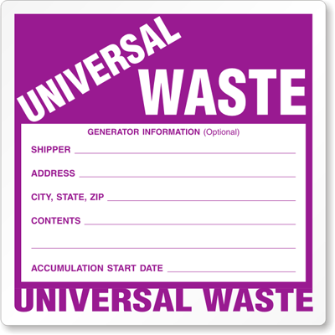

Universal waste containers must be labeled with the type of waste, for example:
“Universal Used Batteries” or “Used Antifreeze”
It must also clearly indicate the date the container was first put into service, and also warn and/or prohibit the mixing of waste.
See appendix B – Waste Management for further information on Universal Waste management and labeling practices.

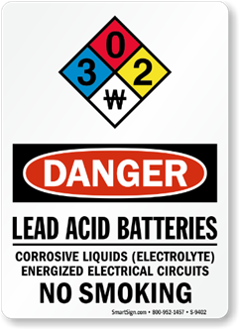
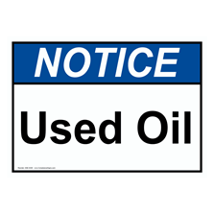

Safety Data Sheets

Safety Data Sheets
Safety Data Sheets (or SDSs) are part of the Global Harmonization Standard, and equivalent to OSHA’s HazCom 2012 Material Safety Data Sheets (or MSDSs). OSHA no longer follows the MSDS format and has adopted the GHS standard for hazard communication.
The following is an elaboration of each section of the SDS found in the Chemical Hygiene Plan.

- Identification
  - This section identifies the chemical on the SDS as well as the recommended uses. It also provides the essential contact information of the supplier. The required information consists of:
    - Product identifier used on the label and any other common names or synonyms by which the substance is known.
    - Name, address, phone number of the manufacturer, importer, or other responsible party, and emergency phone number.
    - Recommended use of the chemical (e.g., a brief description of what it actually does, such as flame retardant) and any restrictions on use (including recommendations given by the supplier).

- Hazard(s) Identification
  - This section identifies the hazards of the chemical presented on the SDS and the appropriate warning information associated with those hazards. The required information consists of:
    - The hazard classification of the chemical (e.g., flammable liquid, category1).
    - Signal word.
    - Hazard statement(s).
    - Pictograms (the pictograms or hazard symbols may be presented as graphical reproductions of the symbols in black and white or be a description of the name of the symbol (e.g., skull and crossbones, flame).
    - Precautionary statement(s).
    - Description of any hazards not otherwise classified.
    - For a mixture that contains an ingredient(s) with unknown toxicity, a statement describing how much (percentage) of the mixture consists of ingredient(s) with unknown acute toxicity. Please note that this is a total percentage of the mixture and not tied to the individual ingredient(s).

- Composition/Information on Ingredients
  - This section identifies the ingredient(s) contained in the product indicated on the SDS, including impurities, and stabilizing additives. This section includes information on substances, mixtures, and all chemicals where a trade secret is claimed. The required information consists of:
    - Substances.
      - Chemical name.
      - Common name and synonyms.
      - Chemical Abstracts Service (CAS) number and other unique identifiers.
      - Impurities and stabilizing additives, which are themselves classified and which contribute to the classification of the chemical.
    - Mixtures.
      - Same information required for substances.
      - The chemical name and concentration (i.e., exact percentage) of all ingredients which are classified as health hazards and are:
        - Present above their cut-off/concentration limits, or
        - Present a health risk below the cut-off/concentration limits.
      - The concentration (exact percentages) of each ingredient must be specified except concentration ranges may be used in the following situations:
        - A trade secret claim is made,
        - There is batch-to-batch variation, or
        - The SDS is used for a group of substantially similar mixtures.
    - Chemicals where a trade secret is claimed.
      - A statement that the specific chemical identity and/or exact percentage (concentration) of composition has been withheld as a trade secret is required.

- First Aid Measures
  - This section describes the initial care that should be given by untrained responders to an individual who has been exposed to the chemical. The required information consists of:
    - Necessary first-aid instructions by relevant routes of exposure (inhalation, skin and eye contact, and ingestion).
    - Description of the most important symptoms or effects, and any symptoms that are acute or delayed.
    - Recommendations for immediate medical care and special treatment needed, when necessary.

- Fire Fighting Measures
  - This section provides recommendations for fighting a fire caused by the chemical. The required information consists of:
    - Recommendations of suitable extinguishing equipment, and information about extinguishing equipment that is not appropriate for a particular situation.
    - Advice on specific hazards that develop from the chemical during the fire, such as any hazardous combustion products created when the chemical burns.
    - Recommendations on special protective equipment or precautions for firefighters.

- Accidental Release Measures
  - This section provides recommendations on the appropriate response to spills, leaks, or releases, including containment and cleanup practices to prevent or minimize exposure to people, properties, or the environment. It may also include recommendations distinguishing between responses for large and small spills where the spill volume has a significant impact on the hazard. The required information may consist of recommendations for:
    - Use of personal precautions (such as removal of ignition sources or providing sufficient ventilation) and protective equipment to prevent the contamination of skin, eyes, and clothing.
    - Emergency procedures, including instructions for evacuations, consulting experts when needed, and appropriate protective clothing.
    - Methods and materials used for containment (e.g., covering the drains and capping procedures).
    - Cleanup procedures (e.g., appropriate techniques for neutralization, decontamination, cleaning or vacuuming; adsorbent materials; and/or equipment required for containment/clean up)

- Handling and Storage
  - This section provides guidance on the safe handling practices and conditions for safe storage of chemicals. The required information consists of:
    - Precautions for safe handling, including recommendations for handling incompatible chemicals, minimizing the release of the chemical into the environment, and providing advice on general hygiene practices (e.g., eating, drinking, and smoking in work areas is prohibited).
    - Recommendations on the conditions for safe storage, including any incompatibilities. Provide advice on specific storage requirements (e.g., ventilation requirements)

- Exposure Controls/Personal Protection
  - This section indicates the exposure limits, engineering controls, and personal protective measures that can be used to minimize worker exposure. The required information consists of:
    - OSHA Permissible Exposure Limits (PELs), American Conference of Governmental Industrial Hygienists (ACGIH) Threshold Limit Values (TLVs), and any other exposure limit used or recommended by the chemical manufacturer, importer, or employer preparing the safety data sheet, where available.
    - Appropriate engineering controls (e.g., use local exhaust ventilation, or use only in an enclosed system).
    - Recommendations for personal protective measures to prevent illness or injury from exposure to chemicals, such as personal protective equipment (PPE) (e.g., appropriate types of eye, face, skin or respiratory protection needed based on hazards and potential exposure).
    - Any special requirements for PPE, protective clothing or respirators (e.g., type of glove material, such as PVC or nitrile rubber gloves; and breakthrough time of the glove material).

- Physical and Chemical Properties
  - This section identifies physical and chemical properties associated with the substance or mixture. The minimum required information consists of:
    - Appearance (physical state, color, etc.);
    - Upper/lower flammability or explosive limits;
    - Odor;
    - Vapor pressure;
    - Odor threshold;
    - Vapor density;
    - pH;
    - Relative density;
    - Melting point/freezing point;
    - Solubility(ies);
    - Initial boiling point and boiling range;
    - Flash point;
    - Evaporation rate;
    - Flammability (solid, gas);
    - Partition coefficient: n-octanol/water;
    - Auto-ignition temperature;
    - Decomposition temperature; and
    - Viscosity.
  - The SDS may not contain every item on the above list because information may not be relevant or is not available. When this occurs, a notation to that effect must be made for that chemical property. Manufacturers may also add other relevant properties, such as the dust deflagration index (Kst) for combustible dust, used to evaluate a dust's explosive potential

- Stability and Reactivity
  - This section describes the reactivity hazards of the chemical and the chemical stability information. This section is broken into three parts: reactivity, chemical stability, and other. The required information consists of:
    - Reactivity
      - Description of the specific test data for the chemical(s). This data can be for a class or family of the chemical if such data adequately represent the anticipated hazard of the chemical(s), where available.
    - Chemical stability
      - Indication of whether the chemical is stable or unstable under normal ambient temperature and conditions while in storage and being handled.
      - Description of any stabilizers that may be needed to maintain chemical stability.
      - Indication of any safety issues that may arise should the product change in physical appearance.
    - Other
      - Indication of the possibility of hazardous reactions, including a statement whether the chemical will react or polymerize, which could release excess pressure or heat, or create other hazardous conditions. Also, a description of the conditions under which hazardous reactions may occur.
      - List of all conditions that should be avoided (e.g., static discharge, shock, vibrations, or environmental conditions that may lead to hazardous conditions).
      - List of all classes of incompatible materials (e.g., classes of chemicals or specific substances) with which the chemical could react to produce a hazardous situation.
      - List of any known or anticipated hazardous decomposition products that could be produced because of use, storage, or heating. (Hazardous combustion products should also be included in Section 5 (Fire-Fighting Measures) of the SDS.)

- Toxicological Information
  - This section identifies toxicological and health effects information or indicates that such data are not available. The required information consists of:
    - Information on the likely routes of exposure (inhalation, ingestion, skin and eye contact). The SDS should indicate if the information is unknown.
    - Description of the delayed, immediate, or chronic effects from short- and long-term exposure.
    - The numerical measures of toxicity (e.g., acute toxicity estimates such as the LD50 (median lethal dose)) - the estimated amount [of a substance] expected to kill 50% of test animals in a single dose.
    - Description of the symptoms. This description includes the symptoms associated with exposure to the chemical including symptoms from the lowest to the most severe exposure.
    - Indication of whether the chemical is listed in the National Toxicology Program (NTP) Report on Carcinogens (latest edition) or has been found to be a potential carcinogen in the International Agency for Research on Cancer (IARC) Monographs (latest editions) or found to be a potential carcinogen by OSHA

- Ecological Information (non-mandatory)
  - This section provides information to evaluate the environmental impact of the chemical(s) if it were released to the environment. The information may include:
    - Data from toxicity tests performed on aquatic and/or terrestrial organisms, where available (e.g., acute or chronic aquatic toxicity data for fish, algae, crustaceans, and other plants; toxicity data on birds, bees, plants).
    - Whether there is a potential for the chemical to persist and degrade in the environment either through biodegradation or other processes, such as oxidation or hydrolysis.
    - Results of tests of bioaccumulation potential, making reference to the octanol-water partition coefficient (Kow) and the bioconcentration factor (BCF), where available.
    - The potential for a substance to move from the soil to the groundwater (indicate results from adsorption studies or leaching studies).
    - Other adverse effects (e.g., environmental fate, ozone layer depletion potential, photochemical ozone creation potential, endocrine disrupting potential, and/or global warming potential).

- Disposal Considerations (non-mandatory)
  - This section provides guidance on proper disposal practices, recycling or reclamation of the chemical(s) or its container, and safe handling practices. To minimize exposure, this section should also refer the reader to Section 8 (Exposure Controls/Personal Protection) of the SDS. The information may include:
    - Description of appropriate disposal containers to use.
    - Recommendations of appropriate disposal methods to employ.
    - Description of the physical and chemical properties that may affect disposal activities.
    - Language discouraging sewage disposal.
    - Any special precautions for landfills or incineration activities

- Transport Information (non-mandatory)
  - This section provides guidance on classification information for shipping and transporting of hazardous chemical(s) by road, air, rail, or sea. The information may include:
    - UN number (i.e., four-figure identification number of the substance).
    - UN proper shipping name.
    - Transport hazard class(es).
    - Packing group number, if applicable, based on the degree of hazard.
    - Environmental hazards (e.g., identify if it is a marine pollutant according to the International Maritime Dangerous Goods Code (IMDG Code)).
    - Guidance on transport in bulk (according to Annex II of MARPOL 73/783 and the International Code for the Construction and Equipment of Ships Carrying Dangerous Chemicals in Bulk (International Bulk Chemical Code (IBC Code)).
    - Any special precautions which an employee should be aware of or needs to comply with, in connection with transport or conveyance either within or outside their premises (indicate when information is not available).

- Regulatory Information (non-mandatory)
  - This section identifies the safety, health, and environmental regulations specific for the product that is not indicated anywhere else on the SDS. The information may include:
    - Any national and/or regional regulatory information of the chemical or mixtures (including any OSHA, Department of Transportation, Environmental Protection Agency, or Consumer Product Safety Commission regulations)

- Other Information
  - This section indicates when the SDS was prepared or when the last known revision was made. The SDS may also state where the changes have been made to the previous version. You may wish to contact the supplier for an explanation of the changes. Other useful information also may be included here.

Compressed Gas

Compressed Gases

Compressed gases must be constructed according to the Interstate Commerce Commission (ICC).
ICC definition of a compressed gas: Any material or mixture having in the container either an absolute pressure exceeding 40 pounds per square inch at 70 F, or an absolute pressure exceeding 104 pounds per square inch at 130 F, or both; or any liquid flammable material having a Reid vapor pressure exceeding 40 pounds per square inch absolute at 100 F.
General
- It is illegal to remove or to change the prescribed numbers or marks stamped into cylinders.
- Each cylinder must bear the proper ICC label required for the compressed gas contained.
- It is illegal to ship a leaking cylinder by common or contract carrier whether charged or partially charged. It is illegal to ship compressed gas in cylinders that have been exposed to fire.
- Do not deface or remove any markings, labels, decals, tags, and stencil marks used for identification of content attached by the supplier.
- Cylinders containing compressed gases should not be subjected to a temperature above 125 F. A flame should never be permitted to come in contact with any part of a compressed gas cylinder.
- Keep cylinder valve closed at all times, except when the cylinder is in active use.
- Never attempt to repair or to alter cylinders, valves, or safety relief devices.
- Never tamper with the safety relief devices in valves or cylinders.
- Do not place cylinders where they might become part of an electric circuit. When the cylinders are used in conjunction with electric welding, precautions must be taken against accidentally grounding compressed gas cylinders and allowing them to be burned by electric welding arc.
- Do not repaint cylinders unless authorized by the owner.
Moving
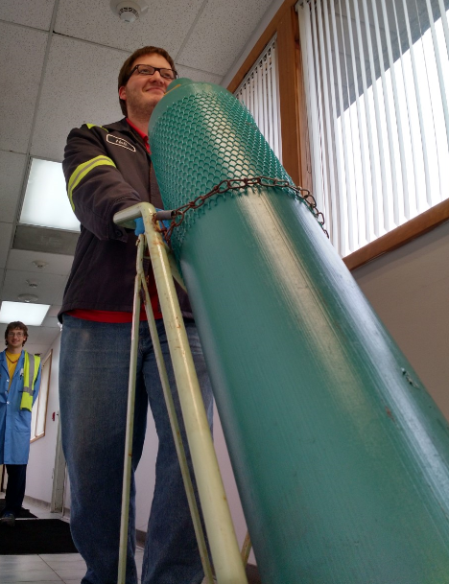
- Where removable caps are provided for valve protection, such caps should be kept on cylinders at all times except when cylinders are in use.
- Do not lift cylinders by the cap.
- Never drop cylinders nor permit them to strike against each other or against other surfaces violently.
- Avoid dragging or sliding cylinders. It is safer to move cylinders even short distances by using a suitable truck or by use of a hand truck.

Storing

- Cylinders should be stored in accordance with all local, state, and municipal regulations and in accordance with appropriate standards of the Compressed Gas Association and the National Fire Protection Association
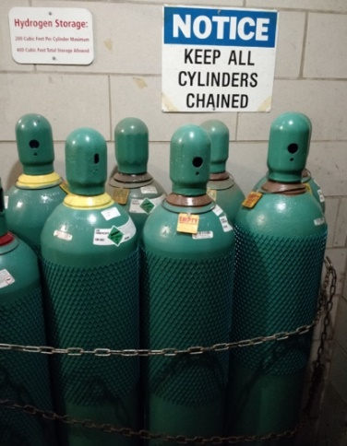
- Compressed gas containers, cylinders, and tanks in use or in storage shall be secured to prevent them from falling or being knocked over by corralling them and securing them to a cart, framework, or fixed object by use of a restraint.
- Cylinder storage areas should be prominently posted with the names of the gases to be stored.
- Where gases of different types are stored at the same location, cylinders should be grouped by types of gas, and the groups arranged to take into account the gases contained, e.g., flammable gases should not be stored near oxidizing gases.
- Charged and empty cylinders should be stored separately with the storage layout so planned that cylinders comprising old stock can be removed first with a minimum handling of other cylinders.
- Storage rooms should be dry, cool, and well ventilated. Where practical, storage rooms should be fire-resistant.
- Storage in subsurface locations should be avoided. Cylinders should not be stored at temperatures above 125 F, nor near radiators or other sources of heat.
- Do not store cylinders near highly flammable substances such as oil, gasoline or waste.
- Cylinders should not be exposed to continuous dampness and should not be stored near salt or other corrosive chemicals or fumes. Rusting will damage the cylinders and may cause the valve protective caps to stick.
- Protect cylinders from any object that will produce a cut or other abrasion in the surface of the metal. Do not store cylinders near elevators or gangways, or in locations where heavy moving objects may strike or fall on them. Where caps are provided for valve protection, such caps should be kept on cylinders in storage.
- Cylinders may be stored in the open but should be protected from the ground beneath to prevent rusting. Cylinders may be stored in the sun except in localities where extreme temperatures prevail, or in the case of certain gases where the supplier's recommendation for shading shall be observed. If ice or snow accumulate on a cylinder, thaw at room temperature, or with water at a temperature not exceeding 125 F.
- Cylinders should be protected against tampering by unauthorized individuals.
Withdrawing cylinder content

- Compressed gases should be handled only by experienced and properly instructed persons.
- The user responsible for the handling of the cylinder and connecting it for use should check the identity of the gas by reading the label or other markings on the cylinder before using. If cylinder content is not identified by marking, return cylinder to the supplier without using.
- Removable type valve protective caps should remain in place until ready to withdraw content, or to connect to a manifold.

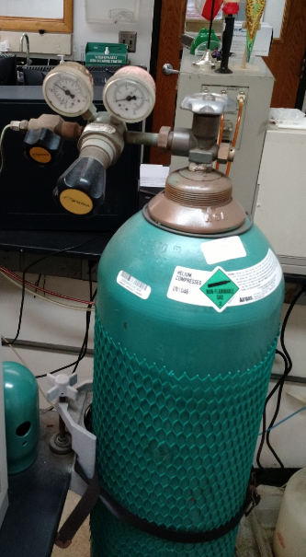

- Before using cylinder, be sure it is properly supported to prevent it from being knocked over.
- Suitable pressure regulating devices must be used in all cases where gas is admitted to systems having pressure rating limitations lower than the cylinder pressure.
- Never force connections that do not fit. Threads on regulator connections or other auxiliary equipment must be the same as those on cylinder valve outlet. Detailed, dimensioned drawings of standard cylinder valve outlet and inlet connections are published in the "American and Canadian Standard Compressed Gas Cylinder Valve Outlet & Inlet Connections."
- Where compressed gas cylinders are connected to a manifold, such a manifold and its related equipment, such as regulators, must be of proper design.
- Regulators, gages, hoses, and other appliances provided for use with a particular gas or group of gases must not be used on cylinders containing gases having different chemical properties unless information obtained from the supplier indicates that this can be done safely.
- Never use compressed gas to dust off clothing, as this may cause serious injury to the eyes or body, or create a fire hazard.
- Never use compressed gases where the cylinder is apt to be contaminated by the feedback of process materials unless protected by suitable traps or check valves.
- Connections to piping, regulators, and other appliances must always be kept tight to prevent leakage. Where a hose is used, it is to be kept in good condition.
- Before a regulator is removed from a cylinder, close the cylinder valve and release all pressure from the regulator.
Flammable gases
- Do not store cylinders near highly flammable solvents, combustible waste material and similar substances, or near unprotected electrical connections, gas flames or other sources of ignition.
- Never use a flame to detect flammable gas leaks. Use soapy water.
- Do not store reserve stocks of cylinders containing flammable gases with cylinders containing oxygen. They should be segregated. Inside of buildings, stored oxygen and fuel gas cylinders are to be separated by a minimum of 20 feet, or a fire-resistive partition is to be placed between the oxygen and fuel gas cylinders. This is in accordance with NFPA Standard No. 51. "Gas Systems for Welding and Cutting.”
Poison gases
- Personnel handling and using poison gases are to have available for immediate use gas masks or self-contained breathing apparatus of a design approved by U. S. Bureau of Mines for the particular service desired. Such equipment is to be located convenient to the place of work, but kept out of the area most likely to be contaminated.
- Poison gases are to be used only in forced ventilation areas or, preferably, in hoods with forced ventilation or out-of-doors. Poison gases emitted from equipment in high concentration are to be discharged into appropriate scrubbing equipment which will remove it from effluent streams.
- Before using, read all label information and data sheets associated with the use of the particular poison gas.
- Use poison gases in cylinder sizes that will insure complete usage of the cylinder content in a reasonable amount of time.
- The Interstate Commerce Commission requires that containers charged with the following materials when offered for transportation bear the poison gas label and be subject to all other regulations prescribed by the ICC for such materials:
- Bromoacetone
- Cyanogen
- Cyanogen Chloride (Containing less than 0.9% water)
- Diphosgene
- Ethyldichloroarsine
- Hydrocyanic Acid
- Lewisite
- Methyldichloroarsine
- Mustard Gas
- Nitric Oxide
- Nitrogen Peroxide (Nitrogen Tetroxide)
- Phenylcarbylamine Chloride
- Phosgene

- Because of the hazardous nature of poison gases, persons handling such gases are advised to contact the supplier for more complete information.
Pressurized liquid oxygen, nitrogen, and argon
- ICC specification cylinders containing pressurized liquid oxygen, nitrogen or argon must be transported, stored, and used in an upright position. These materials are maintained at extremely low temperatures, and cylinders must be kept upright to permit venting of vapor periodically to maintain safe internal pressures.
- Persons handling these pressurized liquids are advised to contact the supplier for more complete handling information.

Chemical Storage Compatibility Table

Chemical Storage Compatibility Table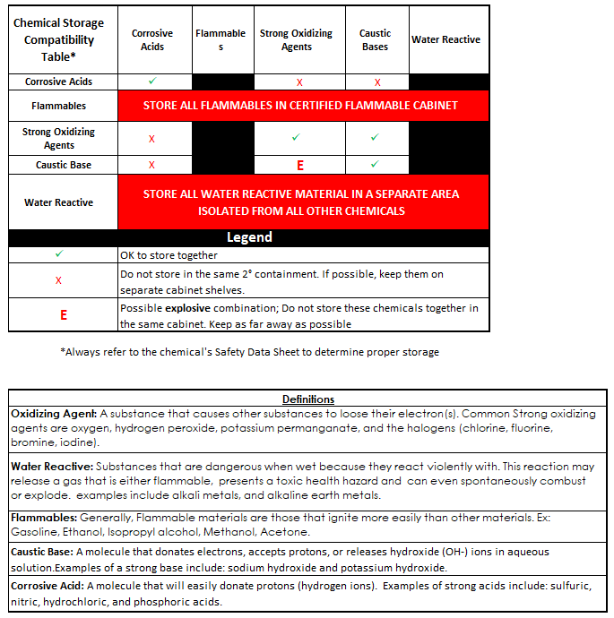
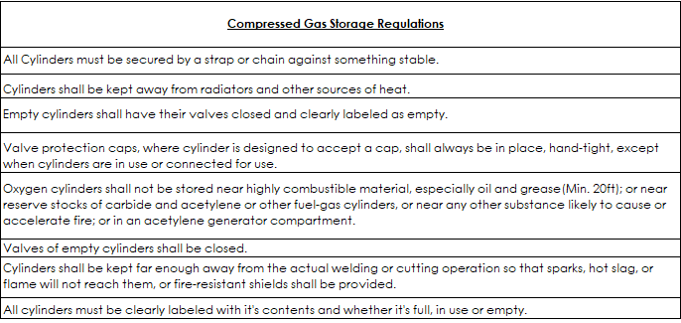

Emergency Eyewash/ Shower Inspection Procedure

Emergency Eyewash/Shower Inspection Procedure

Routine flushing of eyewashes and showers helps ensure proper function in the event of an emergency situation. Routine function tests also help ensure that OSHA requirements are being met.
Perform the following steps Weekly:
- Remove obstructions
  - Ensure that the eyewash and showers are easily accessible by removing any object that impedes access to them (obstructions in the sink, carts or chairs blocking the eye wash/shower station).

- Visually inspect the eyewash/shower component
  - Inspect the outer appearance of the eyewash/shower station (corroded metal, leaks etc).

- Activate the eyewash/shower
  - Activate slowly to avoid spattering. Run full flush height and allow to run for 1-3 minutes.

- Observe water stream(s)
  - Streams should be symmetrical (arches of water meeting in the middle for eye wash or arches are at the same height; shower streams should be at a constant flow)
  - Water should run clear / free of debris.

- Record information on the inspection tag
  - Record the date, all observed conditions and include your initials.
    - Ex: 8/11/21, clear/even, BLB
Submit a work request for any malfunctioning emergency equipment.

Asphyxiation Symptoms

Asphyxiation symptoms

The following chart explains symptoms of being in an oxygen deficient environment:

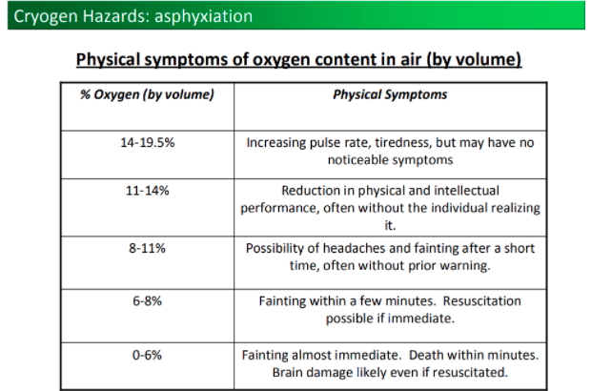

See appendix C for PPE requirements.
See appendix F for handling requirements for compressed gases
See appendix B for disposal regulations
See Appendix H for detailed inspection procedures
(See appendix C on PPE requirements)
Cited from OSHA Code of Federal Regulations
References and Resources OSHA Personal Protective Equipment DOJ Personal Protective Equipment for Emergency First Responders General Respiratory Protection Guidance for Employers and Workers. ISO.org Grainger
*RCRA stands for the Resource Conservation and Recovery Act; DEQ is the Department of Environmental Quality.
ANSI facilitates the development of American National Standards (ANS) by accrediting the procedures of standards developing organizations (SDOs) and approving their documents as American National Standards (ANS)
Source: 29 CFR 1910.95, Table G-16
Image source
Image source
Image courtesy of Safety and Risk.
Image source
Image source
Image Source
Resources and References Chem Safety PRO Brady OSHA NFPA American Coatings Association ILPI
Image source
Image source
Image source
Image source
Image Source
SDS Resource The information provided in this appendix can be obtained in greater detail at the following website: OSHA Brief – Hazard communication Standard: Safety Data Sheets
source: https://www.ncnr.nist.gov/equipment/cryostats/CryogenSafety.pdf

