Unit Plan Format
1. Unit Author: William Bowles
Library Media/Western International High School:
2. Introduction/General Information
- Unit Title/Theme: Library Media supplemental resource instruction in the African diaspora to Brazil.
- Number of Lessons w/in Unit (Unit Timetable Template): Two lessons per subject
- Subject Areas of Interdisciplinary Integration: Visual and performing arts, social studies, Literature and Exceptional Education
- Grade Levels: 9-12
- Unit Summary and Rationale: Multi-media library resource instruction across disciplines.
3. Standards/Anchors
- Integration of Knowledge and Ideas: Integrate and evaluate multiple sources of information presented in diverse formats and media (e.g., quantitative data, video, multimedia) in order to address a question or solve a problem.
- CE I.4.4 Interpret, synthesize, and evaluate information/ findings in various print sources and media (e.g., fact and opinion, comprehensiveness of the evidence, bias, varied perspectives, motives and credibility of the author, date of publication) to draw conclusions and implications.
- CE 2.2.3 Interpret the meaning of written, spoken, and visual texts by drawing on different cultural, theoretical, and critical perspectives.
4. Unit Goals – Learning Objectives and Student Learning Outcomes
Learning Objectives | - List and identify the key dates of Afro-Brazilian history chronologically.  - Locate and critically evaluate symbols and practices of the Afro-Brazilian indigenous religion, Candomblé.  - Describe the contribution of Afro-Brazilians to Brazilian art, music and dance.  - Recognize the economic contributions of Afro-Brazilians and identify products and services performed by slaves.  - Compare and contrast slavery in Brazil and the United States.
Student Learning Outcomes | - SWBT: Describe the African slave diaspora to Brazil from its origin, and list and explain its development to the present.  - Evaluate the importance of Candomblé to Afro-Brazilians and its contributions to Brazil’s identity. Describe important Candomblé figures.  - List and describe specific genres and aspects of Afro-Brazilian art, music and dance and relate them to Candomblé.  - Formulate an economic model in which slavery operated and describe its legacy.  - List and describe reasons why slavery in Brazil differed from slavery in the United States.

5. Essential Question for the Unit: Identify African influences in each subject area.
6. Pre-Assessment: Students will take a 10-question survey on basic facts and themes of Afro-Brazilian culture and history.
7. Content—Daily Lesson Plans See attached.
8. Integration of Resources and Technology: Library computer lab; projector; printer; speakers; Afro-Brazilian music; books on Afro-Brazilian culture and history; website designated for the unit that includes links to websites, video, images and other digital resources.
9. Differentiated Learning Activities: Include research-based strategies that challenge all learners. Include context of the learners as a rationale for differentiation:
Western International High School
- Ninety percent of student body of 1,700 receives free lunch.
- Seventy percent of student body is of Hispanic/Latino heritage
- For 10 percent of student body English is not their first language
- Five percent of student body is classified as special needs
- Gender of student body is half male, half female.

Principles of differentiated instruction will be followed in all subject areas. ESL students will be provided audio and or transcription services to the level or their academic need. Students with an IEP will be provided with accommodations according to their eligibility and academic need. Special needs students will receive individualized instruction, audio of assignments and material and translations of assignments and material.
10. Summative Assessment/Post-Assessment - Students will retake pretest to show progress in knowledge base. Students will create a theme-based project using text and visuals that will demonstrate their acquired knowledge.
11. Reflection—Completed after implementation of unit plan: Utilize pre-assessment data to assist your reflection. Provide questions you may pose to yourself for evaluating student learning and your instructional decisions.
- ANALYSIS OF STUDENT LEARNING: Analyze assessment data and documented evidence of lesson results and explain to what degree instructional decisions made an impact on student learning and achievement of unit goals and lesson objectives.
- ANALYSIS OF TEACHING: Include modifications/recommendations of current instruction for future application on 1) planning and preparation, 2) classroom environments, 3) instruction, and 4) professional responsibilities as related to instructional objectives or standards.
African Diaspora to Brazil – Pre-assessment
- T/F: The numbers of slaves sent to Brazil and the southern United States was about the same.
- T/F: Only one island in the Caribbean received slaves.
- The term “racial democracy” means _________________ in Brazil.
- T/F: Candomblé is an Afro-Brazilian religious practice that in corporates elements of African and Christian beliefs.
- T/F: Candomblé deities are invoked to communicate with ancestors.
- T/F: Afro-Brazilian music is closely related to African dance and African religious practice.
- Capoeira was once an Afro-Brazilian martial art that incorporated what other two elements of performance?
- T/F: Capoeira, along with Afro-Brazilian music and dance, originated in East Africa.
- Name two agricultural products that slaves produced in Brazil.
- Name one region or settlement in Brazil where folk art was produced.

Answers
- F. Brazil imported 11 times as many slaves as did the United States.
- F. Several islands in the Caribbean received slaves, including Haiti, Cuba, Puerto Rico, the Dominican Republic, and many more.
- Equal rights for all people in Brazil, especially for decedents of African slaves. “Racial Democracy” is a term meant to imply that there is legal and social equality and equal opportunity in Brazil for Afro-Brazilians. This is not true, however, and is referred to as a “myth” by many of its critics.
- T. African deities (orixas) include Oxossi, who is associated with the Christian Saint George. There are many more.
- T. Each candomblé practitioner has been given an orixa. Orixas are related to ancestors of the living.
- T. African music and dance are essential components of Candomblé and other Afro-Brazilian religious practices.
- Music and dance.
- F. It originated in Angola in West Africa.
- Sugar cane and tobacco.
- Quilombos

Lesson Design Format
Lesson number and title: 1. African Diaspora to Brazil
Lesson Description: Compare and contrast slavery in Brazil and the United States
Learning Outcomes: Students will interpret and formulate differences between slavery in Brazil and the United States.
Activation
Description (What is the student going to see, hear, watch, do or read?) | Resources/Media Notes
Students will view and discuss map: “Overview of slave trade out of Africa.” | Materials: Map #1: Overview of slave trade out of Africa.
Demonstration
Description (What is the student going to see, hear, watch, do or read?) | Resources/Media Notes
Students will read and discuss handout: “Slavery Compared: Brazil and the United States.” | Materials:  Handout #1: “Slavery Compared: Brazil and the United States,” R. Finkenbine, personal communication May 7, 2016
Application
Description (What is the student going to do? How are they going to receive guidance and feedback?) | Resources/Media Notes
Students will use visuals to show patterns of slave movement geographically and chronologically. | Materials: poster board; makers; glue
Integration
Description (How will the student demonstrate the learning outcome?) | Resources/Media Notes
Students will utilize a rubric to evaluate all presentations. | Rubric: #1 (See attached rubric).
Map #1
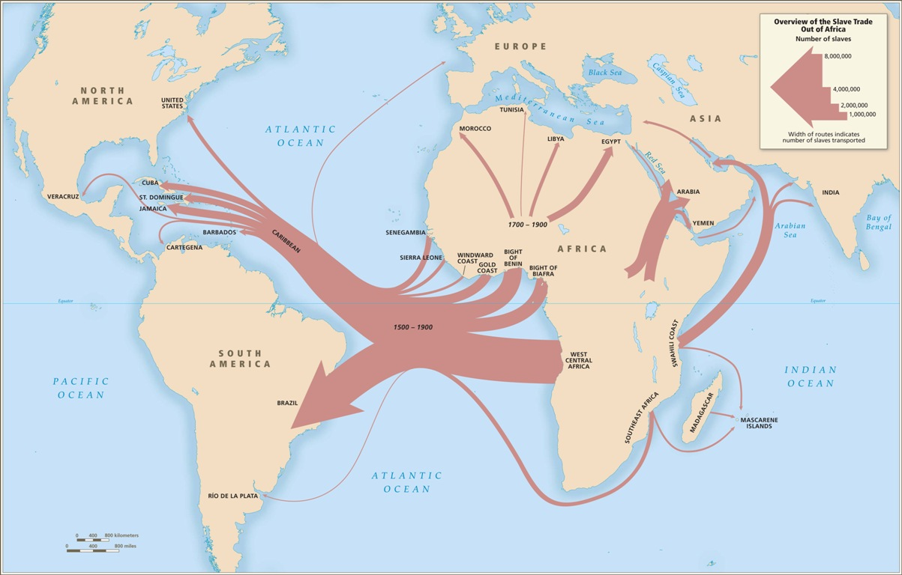
Handout #1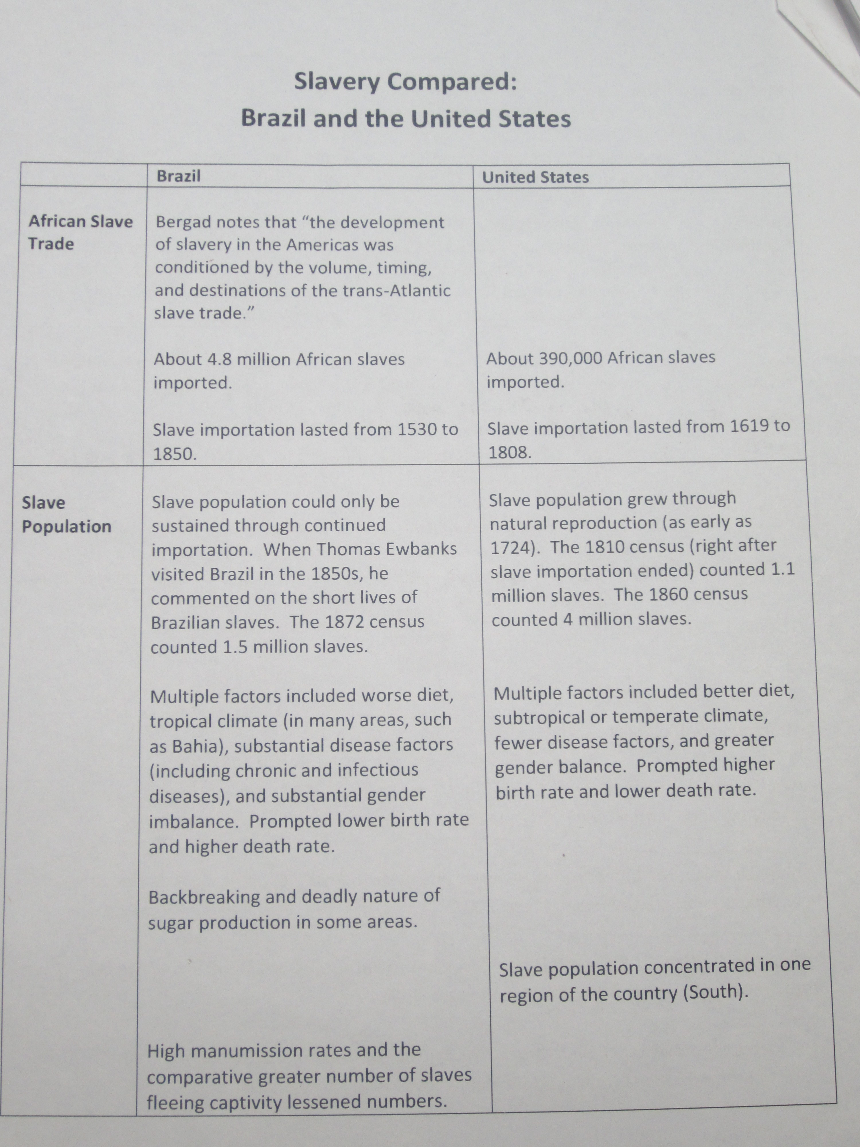
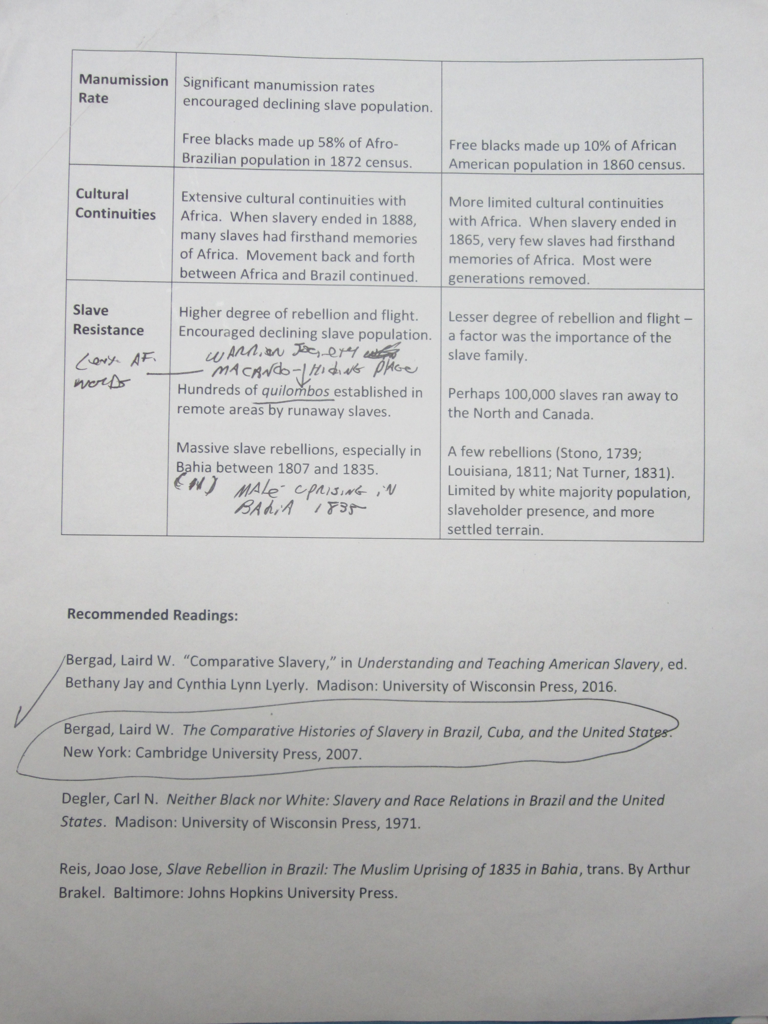`
Rubric #1
Elements | Distinguished (3) | Proficient (2) | Basic (1) | Unsatisfactory (0)
Quality of Poster:  Clarity, Organization, Thoroughness | Slave movement clearly defined by time period and comparative numbers of slaves. | Partially complete geographical information or inaccurate comparative slave numbers. | Incomplete geographical information or comparative slave numbers. | Inaccurate geographical representations and inaccurate slave numbers.
Oral Presentation  Clarity, Organization, thoroughness | Chronological pattern explained with emphasis on much greater slave numbers to Brazil. | Inaccuracies in dates of events or geographical data. | Inaccurate dates of events or geographical data. | Does not demonstrate knowledge of slave movement; does not distinguish differences in slave numbers between regions.
Use of Technology  Visuals | Clear representation of geographical regions and differences in slaves to these regions. | Representations missing labels or dates of events. | Visuals lack organization and clarity. | Unclear visuals; inaccurate information.

Lesson Design Format
Lesson Number and Title: 2. African Diaspora to Brazil
Lesson Description: Compare and Contrast slavery in Brazil and the United States.
Learning Outcomes: Students will interpret and formulate differences between slavery in Brazil and the United States with respect to the term “racial democracy.”
Activation
Description (What is the student going to see, hear, watch, do or read?) | Resources/Media Notes
Students will identify countries and regions in Latin America where the African slave diaspora took place. | Materials: paper and overhead maps of Latin America; projector; computer; Map #2.
Demonstration
Description (What is the student going to see, hear, watch, do or read?) | Resources/Media Notes
Students will view selections from the documentary, Black in Latin America (Episode 3) Brazil A Racial Paradise, take notes and discuss in class. | Materials: Black in Latin America (Episode 3 ) Brazil A Racial Paradise [Video file]. (n.d.). Retrieved from https://www.youtube.com/watch?v=1SqubC7jIH4
Application
Description (What is the student going to do? How are they going to receive guidance and feedback?) | Resources/Media Notes
Students will work in groups and complete the handout of key concepts about racial democracy in Brazil. | Materials: computers; projector; speakers; handout #2.
Integration
Description (How will the student demonstrate the learning outcome?) | Resources/Media Notes
Students will evaluate each other according to attached rubric. | Assignment: Rubric #2 (see attached rubric)

Map #2
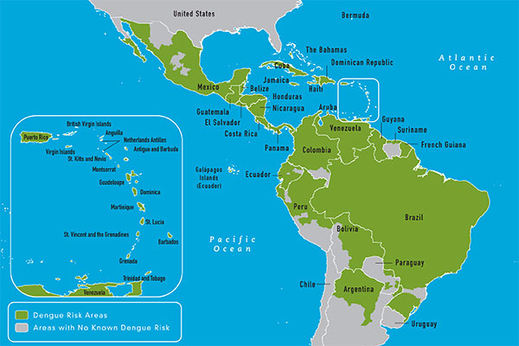
Handout #2
Discussion questions:
1. Describe what is meant by “racial democracy.”

2. Who is Carmen Miranda, and who is Pele, and why are they so widely known? How have they contributed to the idea of “racial democracy?”

3. Name one large indigenous group living in Brazil when the Portuguese arrived.

4. Describe the importance of football (soccer) in Brazilian society and its racial dimensions.

Rubric #2
Elements | Distinguished (3) | Proficient (2) | Basic (1) | Unsatisfactory (0)
Quality of definition of racial democracy:  clarity, organization, thoroughness | Demonstrates understanding of the contrast between the ideal of democracy and the reality of inequality in Brazil. | Partially complete geographical and/or demographic understanding of the key concept. | Incomplete geographical and/or demographic understanding of concept. Lacks understanding of the word “democracy.” | Inaccurate geographical, demographic or conceptual understanding of racial democracy.
Understanding of facts of inequality in Brazil. | Able to name facts of demographic and economic disparity between Afro-Brazilians and white Brazilians. | Demonstrates partial understanding of demographic and economic disparity between Afro-Brazilians and white Brazilians. | Demonstrates partial understanding of demographic and economic disparity between Afro-Brazilians and white Brazilians. | Does not demonstrate knowledge of inequality in Brazil.

Lesson Design Format
Lesson Number and Title: 3. African Diaspora to Brazil
Lesson Description: Compare and Contrast Slavery in Brazil and in the United States
Learning Outcomes: Outline and interpret key causes for differences in Slavery in Brazil and the United States
Activation
Description (What is the student going to see, hear, watch, do or read?) | Resources/Media Notes
Class discussion responding to the term “racial paradise” and the “myth of racial democracy” used in Brazil. Describe differences in racial identity in Brazil and the United States based in prior knowledge and from previous two lessons. | Materials: Computer, projector
Demonstration
Description (What is the student going to see, hear, watch, do or read?) | Resources/Media Notes
Review reading and highlight key points to prepare for essay homework paper listed below. | Reading: Selections from Bergad, L. W. (2007). The comparative histories of slavery in Brazil, Cuba, and the United States. Cambridge: Cambridge University Press, pgs. 23-24; 47-48.
Application
Description (What is the student going to do? How are they going to receive guidance and feedback?) | Resources/Media Notes
Write a two-page essay responding to the term “racial paradise.” Describe differences in racial identity in Brazil and the United States. Cite data in above reading. | Materials: Computer; paper; printer.
Integration
Description (How will the student demonstrate the learning outcome?) | Resources/Media Notes
Students will complete comparison slavery comparison chart. | Template #1 (attached)
Template #1 | Slavery in Brazil | Slavery in the United States
Numbers
Life span
Legal framework
Types of work
Family and childrearing
End to slavery
Lesson Design Format
Lesson Number and Title: 4 African Diaspora to Brazil

- Lesson Description: Locate and critically evaluate symbols and practices of the Afro-Brazilian indigenous religion, Candomblé.
Learning Outcomes: Students will be able to identify key orixas and explain their role in the practice of Candomblé.
Activation
Description (What is the student going to see, hear, watch, do or read?) | Resources/Media Notes
Students will list two key orixas in the Candomblé initiation ceremony. They will explain the purpose of the ceremony. | Materials (video):  ORISHA INITIATION - CANDOMBLE KETO - BRAZIL [Video file]. (n.d.). Retrieved from https://www.youtube.com/watch?v=ATgNzwHSfjw  Reading
Demonstration
Description (What is the student going to see, hear, watch, do or read?) | Resources/Media Notes
Students will explain the importance of Exu, a key orisha, as described in a selection from the video and website. | Exu_The Divine Messenger. (n.d.). Retrieved from http://www.swarthmore.edu/Humanities/ychirea1/Exu2.html
Application
Description (What is the student going to do? How are they going to receive guidance and feedback?) | Resources/Media Notes
Students will analyze the orixa, Exu, using the template as a guide. | Materials: Template #2 (see attached)
Integration
Description (How will the student demonstrate the learning outcome?) | Resources/Media Notes
Students will write a one-page analysis of Exu based on their research.

Template #2
Exu : List other names for Exu | When is Exu first invoked? | Describe a “personality trait” of Exu | Describe the relationship between Exu and other orixa | Describe two different forms by which Exu can be represented

Lesson Design Format
Lesson Number and Title: 5. African Diaspora to Brazil

Lesson Description: Students will identify and formulate cultural links between Afro-Brazilian ancestor worship and Orixa ceremonies.
Learning Outcomes: Students will be able to explain the action and concept of “possession” in a Candomblé ceremony and identify its significance.
Activation
Description (What is the student going to see, hear, watch, do or read?) | Resources/Media Notes
Students will watch a selection of video of Yoruba religions practices that relate to Candomblé. | Materials Video: Nigeria Final [Video file]. (n.d.). Retrieved from https://www.youtube.com/watch?
Demonstration
Description (What is the student going to see, hear, watch, do or read?) | Resources/Media Notes
Students will explain comparisons between Yoruba religious practices and those of Candomblé in Brazil.
Application
Description (What is the student going to do? How are they going to receive guidance and feedback?) | Resources/Media Notes
Students will read selection of City of Women, discuss religious comparisons and relate to video. | Materials: Copies of book selection; computer  Reading: Landes, R. (1994). The city of women. Albuquerque, N.M: University of New Mexico Press pgs. 36-37; p. 72; pgs. 132-133.
Integration
Description (How will the student demonstrate the learning outcome?) | Resources/Media Notes
Students will be able to explain the action and concept of “possession” in a Candomblé ceremony and identify its significance. | Assignment: Write a one-page paper than explains the cultural and historical links between Candomblé and ancestor worship.

Lesson Design Format
Lesson Number and Title: 6. African Diaspora to Brazil
Lesson Description: Students will explore and identify similarities between Brazilian and African Art
Learning Outcomes: Students will be able to identify Candomblé imagery in Brazilian art and explain its significance.
Activation
Description (What is the student going to see, hear, watch, do or read?) | Resources/Media Notes
Students will identify African images in Afro-Brazilian art. | Material: Bowles, W., Western International High School, (2009, September 10). African indigenous religions in Benin [Video file].
Demonstration
Description (What is the student going to see, hear, watch, do or read?) | Resources/Media Notes
Students will view and examine Carybé´s orixa carvings and read and compare the museum’s descriptive notes of several of the orixas. | Materials: Handouts #3-#10 Afro-Brazilian Museum, & Carybé, H. J. (2016). [photograph].  Reading: Exu; Ogum; Orlorun; Xango; Ifa; Carybé; Orixa, Afro-Brazilian Museum, Salvador, Bahia
Application
Description (What is the student going to do? How are they going to receive guidance and feedback?) | Resources/Media Notes
Students will label 4 Candomble orixas with short descriptive notes. | Materials: Computers; paper; printer; projector.  Handout #11
Integration
Description (How will the student demonstrate the learning outcome?) | Resources/Media Notes
In groups of two, students will present characteristics of the Orixas. They will also submit their presentation. | Assignment (see rubric #3 attached)

Handout #3 (Exu)
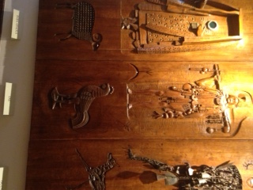

Handout #4 (Ogum)
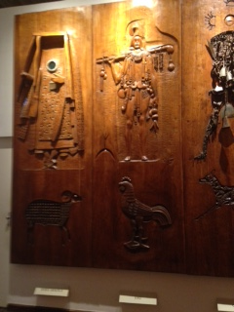

Handout # 5 (Xango Onile)
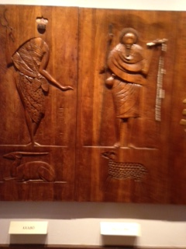

Handout #6 (Ifa)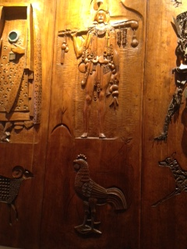
Handout #7 (text Exu and Orixas)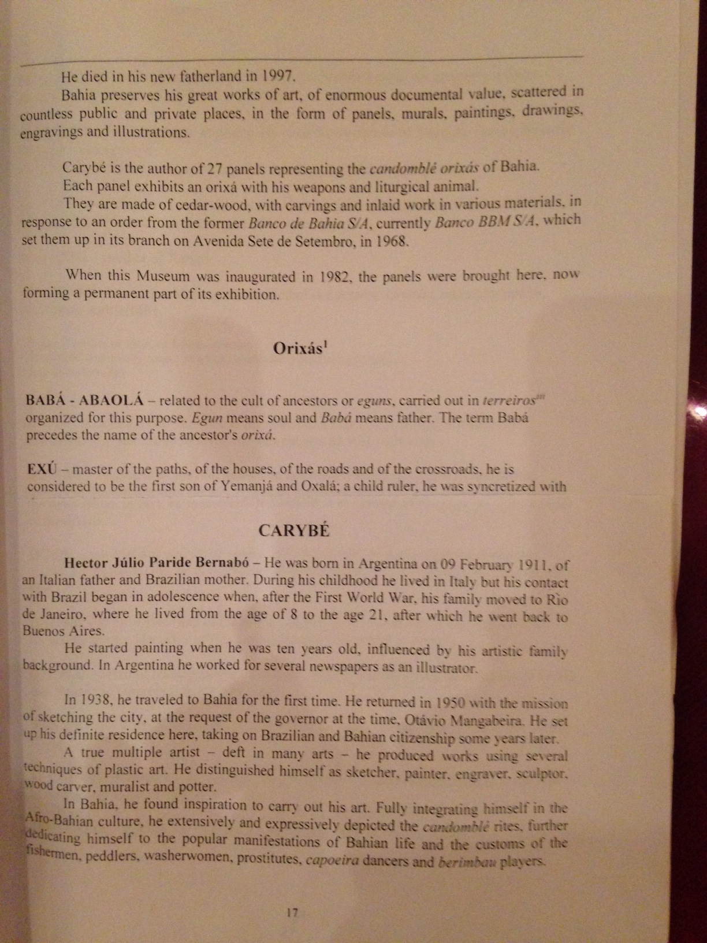
Handout #8 (text Xango)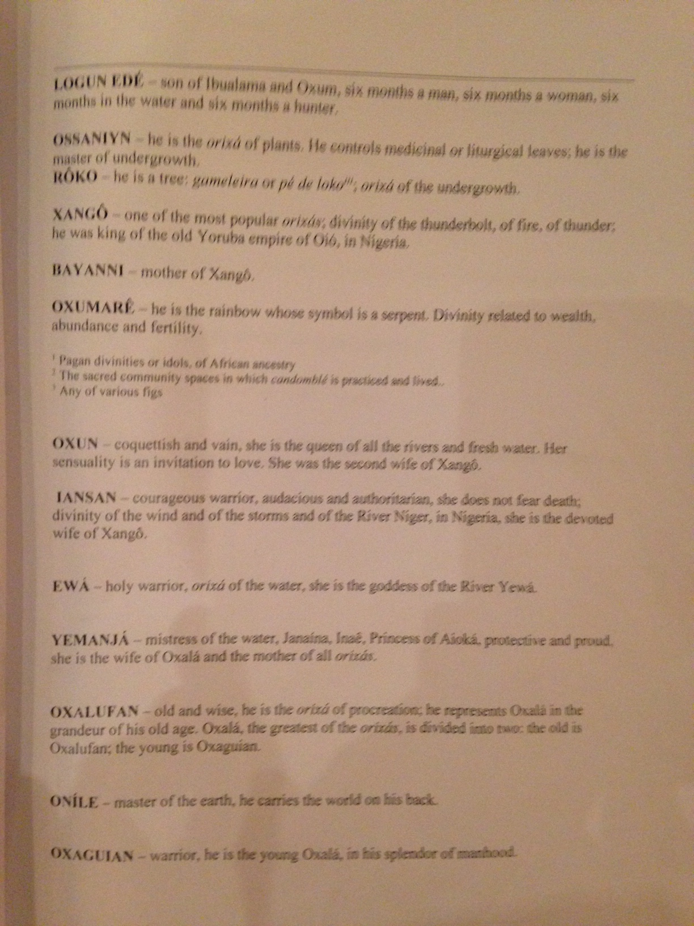
Handout #9 (text Ifa)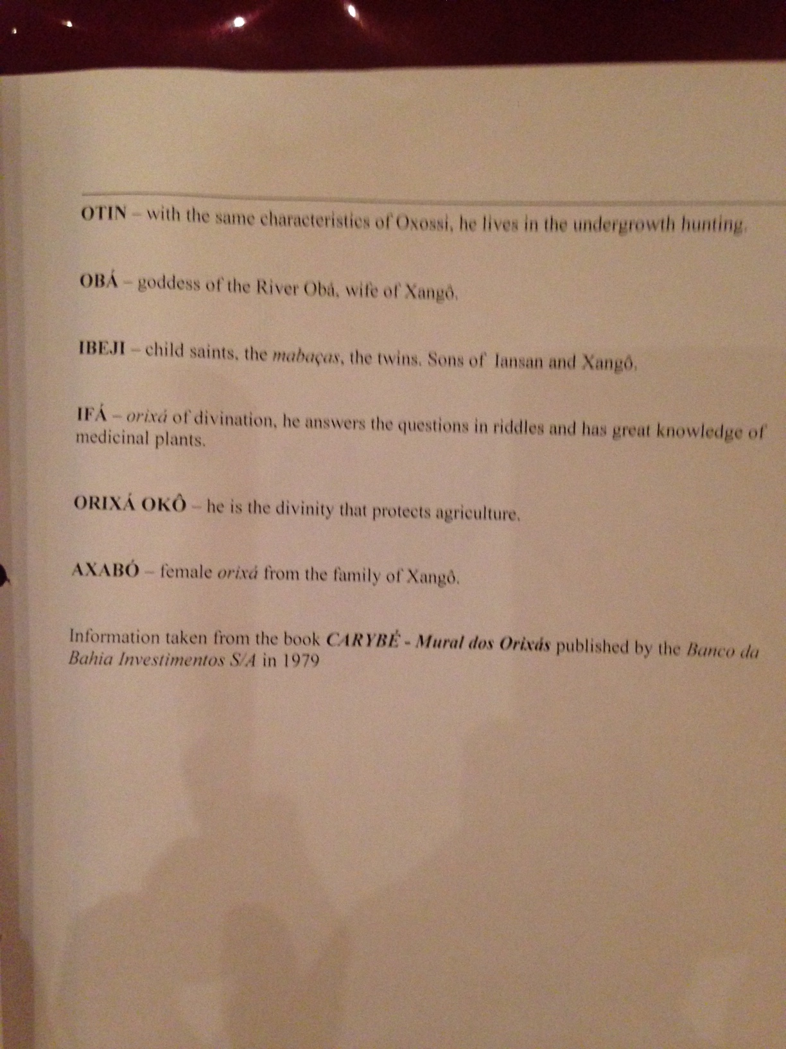
Handout #10 (Ifa, Ogum)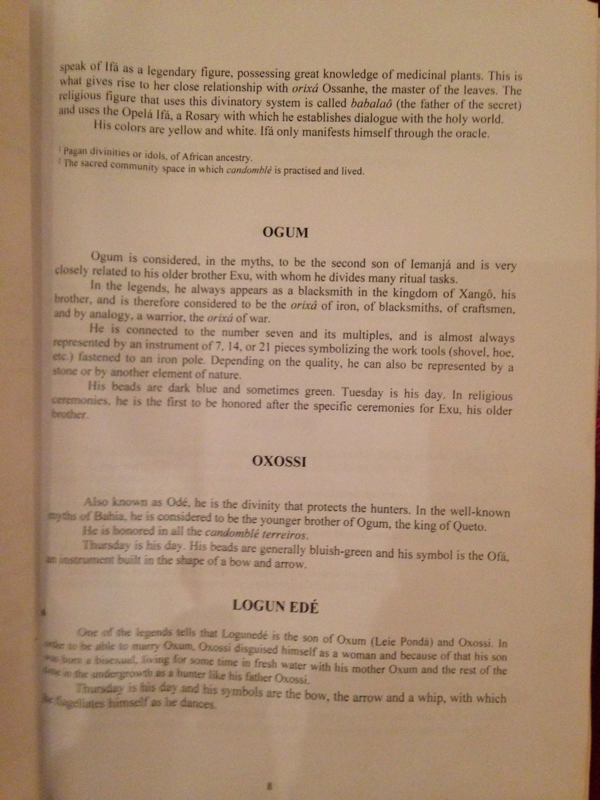
Handout #11 | When is Exu first invoked? | Describe a “personality trait” of Exu | Describe the relationship between Exu and other orixa
 | When is Ogum invoked? | Describe a “personality trait” of Ogum. | Describe the relationship between Ogum and other orixa.
 | When is Xango invoked? | List and describe professions that adopt Xango. | Does Xango direct other orixas? If so, how?
 | Who is Ifa? Describe his origins. | Where can Ifa be found? Explain. | Do other orixas invoke Ifa? Explain.

Rubric #3
Elements | Distinguished (3) | Proficient (2) | Basic (1) | Unsatisfactory (0)
Quality of poster:  Clarity, organization, thoroughness | Orixa origin clear; “personality traits” well defined; relationships to other orixas clear. | Orixa origin partially described; “personality traits” incomplete; relationships to other orixas unclear. | Incomplete description of orixa.  Omitted personality traits or inaccurate descriptions. | Inaccurate information associated with image with orixas
Oral presentation:  Clarity, organization, thoroughness | Precise descriptions used to describe aspects of orixas. | Imprecise descriptions used to describe aspects of orixas | Orixa descriptions, relations and purpose unclear. | Does not demonstrate knowledge of orixas or does not link criteria to selection.
Use of technology and  visuals | Clear representation of orixas and link to Candomblé. | Partial representation of orixas and link to Candomblé | Visuals lack organization and clarity. | Unclear visuals; inaccurate information.

Lesson Design Format
Lesson Number and Title: 7 African Diaspora to Brazil

Lesson Description: Students will explore, examine and critique various African influences in Afro-Brazilian music.
Learning Outcomes: Students will be able to identify and critically evaluate African themes and influences in Afro-Brazilian music.
Activation
Description (What is the student going to see, hear, watch, do or read?) | Resources/Media Notes
Students will view five different aspects of samba music. | Materials: Bowles, W., videos of Conceiação Giba, Indigenous Musical Instruments of Brazil; workshop Salvador, Bahia, Brazil; July 2, 2016.
Demonstration
Description (What is the student going to see, hear, watch, do or read?) | Resources/Media Notes
Students will read about the different types of samba music, discuss and compare with the watched video clips. | Reading: Great Brazilian Music - Samba. (n.d.). Retrieved from http://www.greatbrazilianmusic.com/samba.html
Application
Description (What is the student going to do? How are they going to receive guidance and feedback?) | Resources/Media Notes
In small groups, students will reproduce the music heard and read about. | Materials: berimbau, tambourines, conga drums, rain stick
Integration
Description (How will the student demonstrate the learning outcome?) | Resources/Media Notes
A recording of students’ groups “performances” will be made | Materials: video camera; computer; projector

Lesson Design Format
Lesson Number and Title: 8 African Diaspora to Brazil

Lesson Description: Students will integrate the Afro-Brazilian cultural practice of capoeira into the Brazilian historical narrative.
Learning Outcomes: Students will distinguish the key features of capoeira and explain its historical role in Bahia, Brazil.
Activation
Description (What is the student going to see, hear, watch, do or read?) | Resources/Media Notes
Students will read attached selection and participate in a short discussion of the history of capoeira. | Reading: Capoeira Angola Center of Mestre João Grande. (n.d.). Retrieved from http://www.joaogrande.org/capoeira_angola.htm
Demonstration
Description (What is the student going to see, hear, watch, do or read?) | Resources/Media Notes
Students will view the world maps of Angola and Brazil and view the video clip of capoeira. | Materials: Map #3; computers; projector; speakers  Video: Capoeira Muzenza Mundial 2015 | Roda M Busca-Longe [Video file]. (n.d.). Retrieved from https://www.youtube.com/watch?v=fEN3-pi0ZGw
Application
Description (What is the student going to do? How are they going to receive guidance and feedback?) | Resources/Media Notes
Students will participate in a guided discussion of the history of capoeira. | Reading: Retrieved from capoeiraabolicao.com/origins-and-history-of-capoeira/
Integration
Description (How will the student demonstrate the learning outcome?) | Resources/Media Notes
Students will complete capoeira quiz. | Assignment: quiz Capoeira: The Martial Art Quiz | 10 Questions. (n.d.). Retrieved from http://www.funtrivia.com/playquiz/quiz2130071863c10.html

Map #3
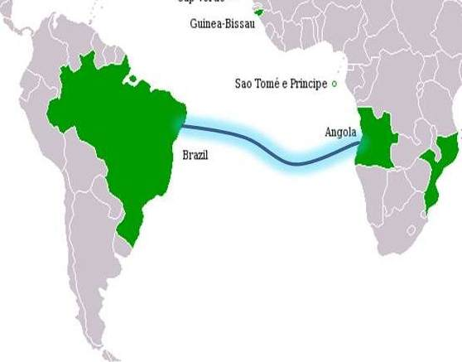

Lesson Design Format
Lesson Number and Title: 9 African Diaspora to Brazil

Lesson Description: Students will formulate a chart of the Brazilian slave trade that prioritizes the economic factors specific to Brazil.
Learning Outcomes: Students will be able to identify and explain key economic factors that incentivized slavery in Brazil.
Activation
Description (What is the student going to see, hear, watch, do or read?) | Resources/Media Notes
Students will examine maps of products produced in Brazil during the slave trade. | Materials: computers; projector; databases; Map #4.  Reading: Bergad, L. W. (2007). The comparative histories of slavery in Brazil, Cuba, and the United States. Pgs. 143-147; and 151-152. Cambridge: Cambridge University Press.
Demonstration
Description (What is the student going to see, hear, watch, do or read?) | Resources/Media Notes
Students will view short video on the Atlantic slave trade and discuss the time period and context in which slavery operated. | Material: The Atlantic slave trade: What too few textbooks told you - Anthony Hazard [Video file]. (n.d.). Retrieved from https://www.youtube.com/watch?v=3NXC4Q_4JVg
Application
Description (What is the student going to do? How are they going to receive guidance and feedback?) | Resources/Media Notes
Each student will selected a product from the Brazilian slave trade to examine, analyze and prepare for presentation. | Reading: redThe Atlantic Slave Trade: Crash Course World History #24 [Video file]. (n.d.). Retrieved from https://www.youtube.com/watch?v=dnV_MTFEGIY
Integration
Description (How will the student demonstrate the learning outcome?) | Resources/Media Notes
Students will identify specific products slavery produced for export from Brazil and situate each product in its respective time period and evaluate its relationship to the slave trade. | Assignment: Students will present their findings to the class in a PowerPoint presentation according to attached handout #12

Map #4
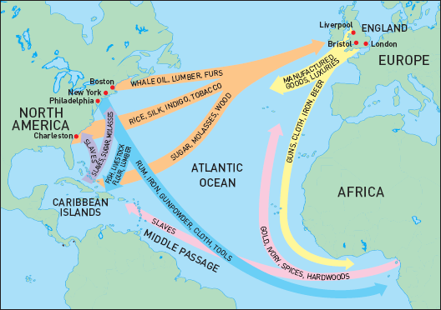
Handout #12
First important export product. | Describe where this took place Brazil. | Describe one other type of work performed by slaves.
Second important export product. | Describe where this took place Brazil. | Describe one other type of work performed by slaves.
Third important export product. | Describe where this took place Brazil. | Describe one other type of work performed by slaves.
Fourth important export product. | Describe where this took place Brazil. | Describe one other type of work performed by slaves.

Lesson Design Format
Lesson Number and Title: 10 African Diaspora to Brazil

Lesson Description: Special needs students will explore themes of popular art in Northeast Brazil and identify historical links in each theme.
Learning Outcomes: Students will be able to identify religious, secular and musical imagery in Brazilian folk art of the Northeast of Brazil.
Activation
Description (What is the student going to see, hear, watch, do or read?) | Resources/Media Notes
Students will view examples of popular Brazilian folk art from Northeastern Brazil. | Materials: website Retrieved from www.banditsandheroes.org
Demonstration
Description (What is the student going to see, hear, watch, do or read?) | Resources/Media Notes
Students will view and read about several examples of popular Brazilian folk art from Northeast Brazil in their historical and cultural contexts. | Reading: Con/Vida- Popular arts of the Americas, Con/Vida- Popular arts of the Americas, & Charles H. Wright Museum of African American History. (2013). Bandits & heroes, poets & saints: Popular art of the Northeast of Brazil. Detroit, MI: Con/Vida- Popular Arts of the Americas
Application
Description (What is the student going to do? How are they going to receive guidance and feedback?) | Resources/Media Notes
In groups of two, students will recreate an example of popular Brazilian folk art. | Materials: poster board; makers, glue; glitter; cardboard, colored paper.
Integration
Description (How will the student demonstrate the learning outcome?) | Resources/Media Notes
Students will present and explain at least three examples cultural and historical imagery found in each work. | Assignment (Rubric #4 - attached).

Rubric #4
Elements | Distinguished (3) | Proficient (2) | Basic (1) | Unsatisfactory (0)
Quality of Poster:  Clarity, Organization, Thoroughness | Cultural image clearly defined by time period, location and purpose. | Cultural image partially defined by time period, location and purpose. | Incomplete cultural image; lack of definition by cultural group, time period and location. | Inaccurate information associated with image.
Oral Presentation  Clarity, Organization, thoroughness | Precise descriptive terms used explain folk art. | Incomplete or inaccurate information associated with selected work. | Lack of understanding of assignment reflected in missing components. | Does not demonstrate knowledge of folk art or does not link criteria to selection.
Use of Technology  Visuals | Clear representation of cultural image clearly defined by time period, location and purpose | Representations missing labels or dates of events. | Visuals lack organization and clarity. | Unclear visuals; inaccurate information.
African Diaspora to Brazil – Post-assessment
- T/F: The numbers of slaves sent to Brazil and the southern United States was about the same. What respective percentages of total slaves brought from African did each country receive?
- List four more locations in the Caribbean that received slaves.
- The term “racial democracy” means _________________ in Brazil. Describe how the term is problematic.
- T/F: Candomblé is an Afro-Brazilian religious practice that incorporates elements of African and Christian beliefs. Describe how this came about.
- Why are Candomblé deities are invoked to communicate with ancestors?
- T/F: Afro-Brazilian music is closely related to African dance and African religious practice. Describe the instruments played.
- Capoeira was once an Afro-Brazilian martial art that incorporated what other two elements of performance?
- T/F: Capoeira, along with Afro-Brazilian music and dance, originated in East Africa. Name the regions where salves originated in chronological order.
- Name four agricultural products that slaves produced in Brazil. List other professions and trades practiced by slaves.
- Name one region or settlement in Brazil where folk art was produced. Describe quilombos, how they formed and where they are today.
Answers
- F. Brazil imported 11 times as many slaves as did the United States. Brazil: 40 percent; The United States: 5 percent.
- Several islands in the Caribbean received slaves, including Haiti, Cuba, Puerto Rico, the Dominican Republic, and many more.
- Equal rights for all people in Brazil, especially for decedents of African slaves. “Racial Democracy” is a term meant to imply that there is legal and social equality and equal opportunity in Brazil for Afro-Brazilians. It is not true, and is referred to as a “myth” by many of its critics.
- T. African deities (orixas) include Oxossi, who is associated with the Christian Saint George. There are many more. Because slaves were often prohibited from practicing Candomble, they included Christian saints in their pantheon and synthesized other elements of Christianity in part to “give cover” to the practice of their traditional African-based religious practices. Adherence to Candomblé formed an important part of their identity.
- Each candomblé practitioner has been given an orixa, or spirit. Orixas are related to ancestors of the living. For Afro-Brazilian practitioners of Candomblé, communication with their ancestors is essential. It is believed that ancestors have the power to affect the lives of the living.
- T. African music and dance are essential components of Candomblé and other Afro-Brazilian religious practices. Essential instruments include various drums, tambourines and the berimbau. Singing is also important.
- Music and dance.
- F. It originated in Angola in West Africa. In chronological order, slaves left Africa for Brazil from Angola, Dahomey (Benin) and Yorubaland (Nigeria).
- Sugar cane, tobacco, coffee and cotton. Slaves worked in mines and in many other trades, such as construction, furniture making and iron working.
- Quilombos are usually self-governing smaller settlements of descendants of African slaves in the countryside living on subsistence agriculture and away from colonial authorities. They have nominal legal status to exist.

